Making Health Services Better in Bristol
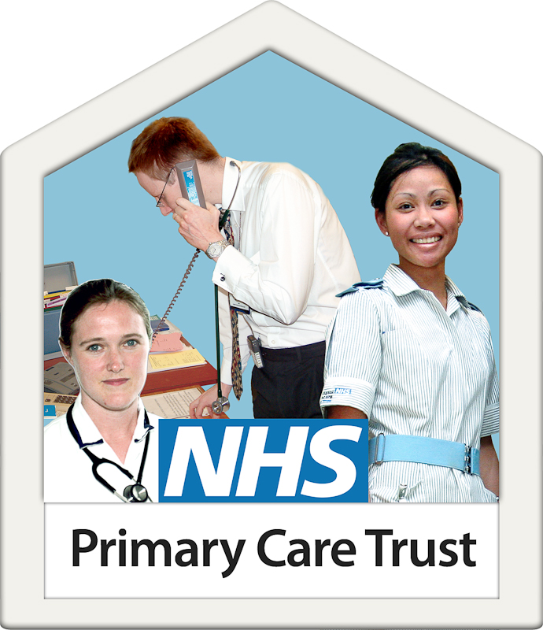

A Sexual Health Needs Assessment for People with Learning Difficulties

What is a health needs assessment?

A needs assessment is a way to find out if health services are the best they can be for everyone.
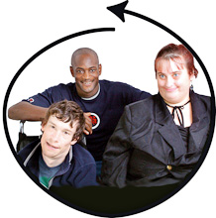

We do this by looking at written reports, talking to the people who use the services and the people who work for them.

This health needs assessment was about sexual health services and sex and relationships education.

Why did we do a health needs assessment?
We were asked by NHS Bristol to find out if people with learning difficulties are getting the best sexual health services in Bristol.
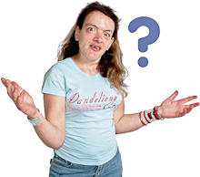
We were also asked to find out if people with learning difficulties are learning enough about sex and relationships in Bristol.

What are Sexual Health Services?
Sexual Health Services are a type of health services. Everyone can go and see the doctors and nurses who work for sexual health services.
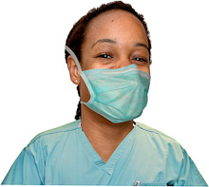
Sexual health services can;
- Help people to stay healthy when they are having sex.

- People can have a sexual health test.
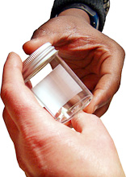

Different tests can find out if people have a sexually transmitted infection so that it can be treated.

- Help people to choose a type of contraception.

Contraception can stop women getting pregnant from having sex.

Men can use condoms and women can take the contraceptive pill.

There are lots of other types of contraception to choose from.

- Talk to people about anything to do with sex or the sexual parts of the body.

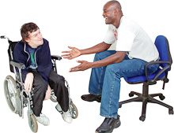

Why is it important that sexual health services are good?
Everybody has the right to be healthy when they are having sex or are thinking about having sex.

Some people don’t know where they can get help with this.

This means that they might be at risk of having a sexual infection that they don’t know about.
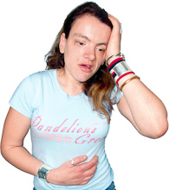

Or they might get pregnant and have a baby that they didn’t plan.

We need to make sure that everybody can visit sexual health services if they want to.
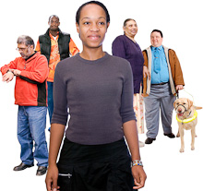

What is Sex and Relationships education?
Sex and Relationships Education teaches people about sex and relationships.

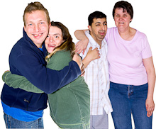
Some people learn about sex and relationships at school or at college in lessons.

Some people learn about sex and relationships by talking to their parents, family or carers.

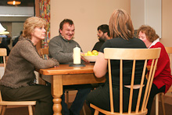

Sex and relationships education also teaches people about:

- Puberty. This means body changes when you become an adult.

- Being Pregnant

- Relationships such as having a boyfriend or girlfriend

Why is it important to make sure that Sex and Relationships education is good?
Everybody has the right to have sex and to have relationships such as a boyfriend or a girlfriend.

But there are lots of choices to make when people want to have sex or want to have a relationship.
There is a lot of information that people need to know about their bodies and sex.

People need to choose how to stay healthy and safe when they are having sex.

People need to understand about relationships and emotions.
People need to know about different relationships, such as same sex relationships.

We all need to know this information so that we can make our own choices
What did we do in writing the sexual needs report?
We talked to with people with learning difficulties, the people who support them and people who work in sexual health services.
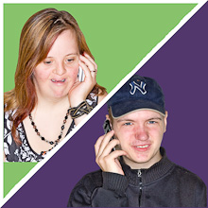

We sent questionnaires to schools and colleges.
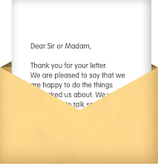
We put adverts in newsletters.

We asked everyone about sexual health services and sex and relationships education. We asked them what was good and what could be better.

What did we find out?
There are lots of people who work in sexual health services who are doing good work across Bristol.

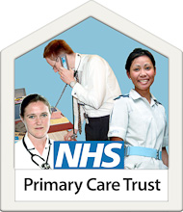

They told us that they would like to work much more with people with learning difficulties and the people who work with them. Services in Bristol need to be the best they can be for everyone.
People with learning difficulties told us that they would like people who work in sexual health to come to drop in centres, day centres and other places.
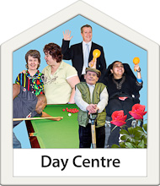

People with learning difficulties told us that sexual health services need to advertise themselves so that everyone knows where they are.
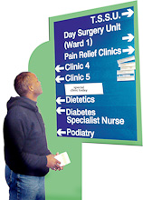

People who work with people with learning difficulties would like to learn more about sex and relationships.

Lots of people told us that we need to talk more about people who are gay, lesbian or bisexual.

Sometimes Learning Difficulty nurses or organisations like Guideposts run courses in colleges and day centres
Not many people with learning difficulties get to go on these courses.

What happens now?
NHS Bristol will listen to what people told us about sexual health services and sex and relationships education.

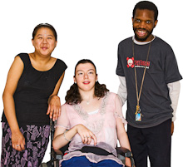

They will decide how to make them better for everyone in the future
Where can you find out more information?

You can telephone Lesley Russ
Lesley works for NHS Bristol

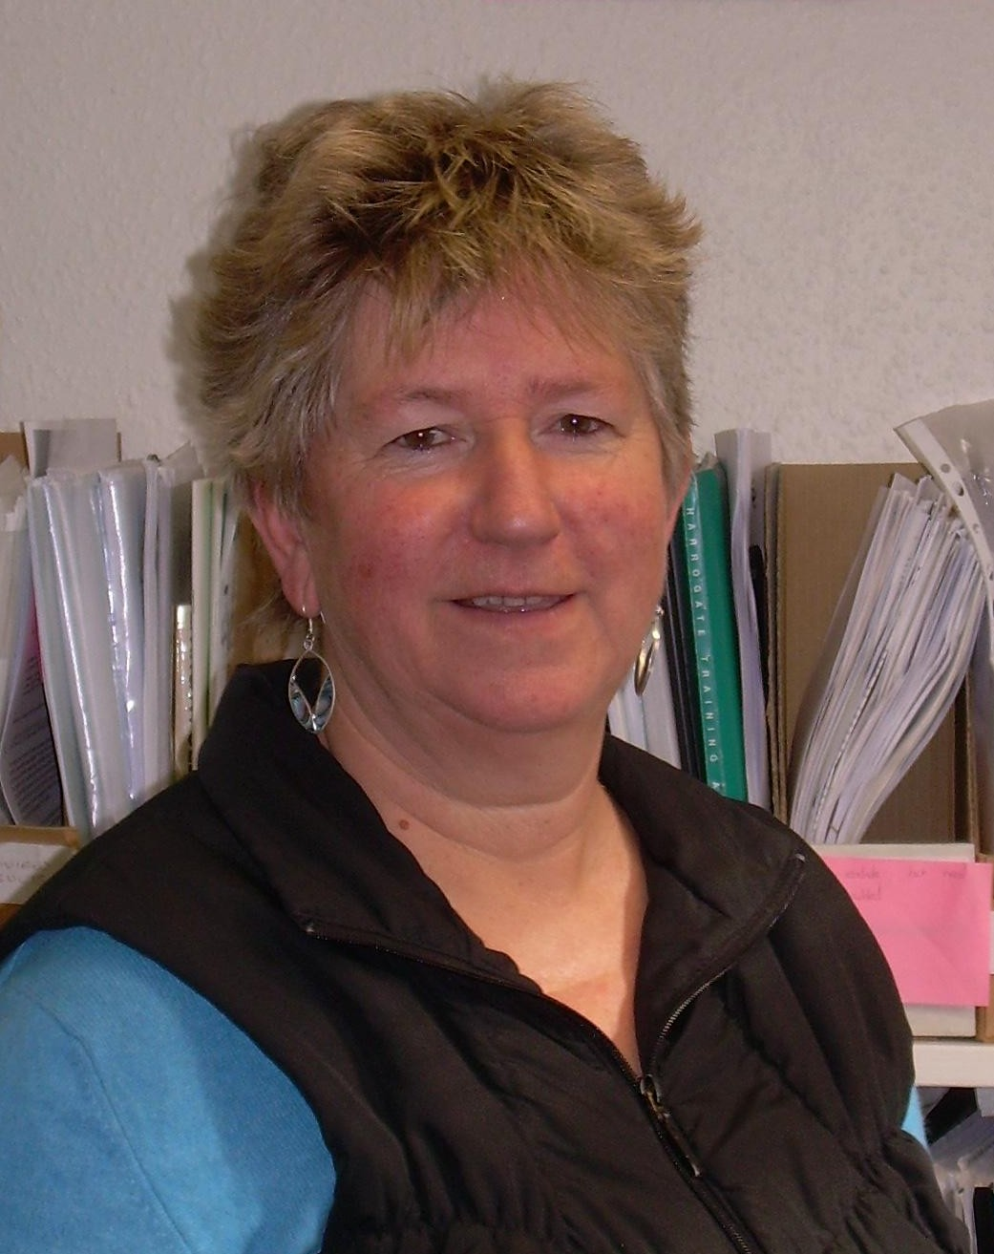
Telephone number: 0117 9841552

Or

You can E Mail her

Email: lesley.russ@bristol.nhs.uk

Accessible report written by Noshin Emamiaeimaini , with the support of NHS Bristol Learning Difficulty Health Trainers and David Goodhind. This report uses Photosymbols.

