Payment details

I enclose payment of £ by cheque made payable to The Royal Society of Medicine

or by Mastercard   Visa AMEX   Switch Delta
Card/Switch number

Expiry date Issue date Issue No.* CSV**

Cardholder’s name and address (if different from other side)

Cardholder’s signature

*Switch only **The Card Security Code is the last 3 digits (4 for AMEX) on the signature strip on the back of your card.

Please invoice my employer/organisation
(please note that registrations WILL NOT be accepted without payment unless your employer is to be invoiced)

Please return your form to or for further information contact:
Ruth Threadgold
Academic Department,
Royal Society of Medicine,
1 Wimpole Street,
London W1G 0AE
Email: intellectual.disability@rsm.ac.uk
Fax: +44 (0) 20 7290 2989
Tel: +44 (0) 20 7290 3942
www.rsm.ac.uk/intellectual-disability
Please return form by Tuesday 24 November 2009
 If you are not a member of the RSM please tick here if you do not wish to receive future mailings
from the Royal Society of Medicine.

Places are only guaranteed upon written confirmation. If, after sending us your payment you decide to cancel, you have 7 days in which to do so in writing, by fax or email and a full refund will be given. After this time refunds will incur a 15% administration charge. We regret no refunds will be given for cancellations received 4 days or less prior to the meeting. Substitutions may be made at any time without charge. Cheques must be in sterling drawn on a UK bank account. Acceptance is at the discretion of the event organiser. Registrations will not be accepted over the telephone. In the event that the RSM cancels the meeting, our liability will be limited to registration fees already paid to the Society for the meeting. The programme was correct at the time of print but may be subject to change.

Charity number 206219 • VAT reg no 524 4136 71

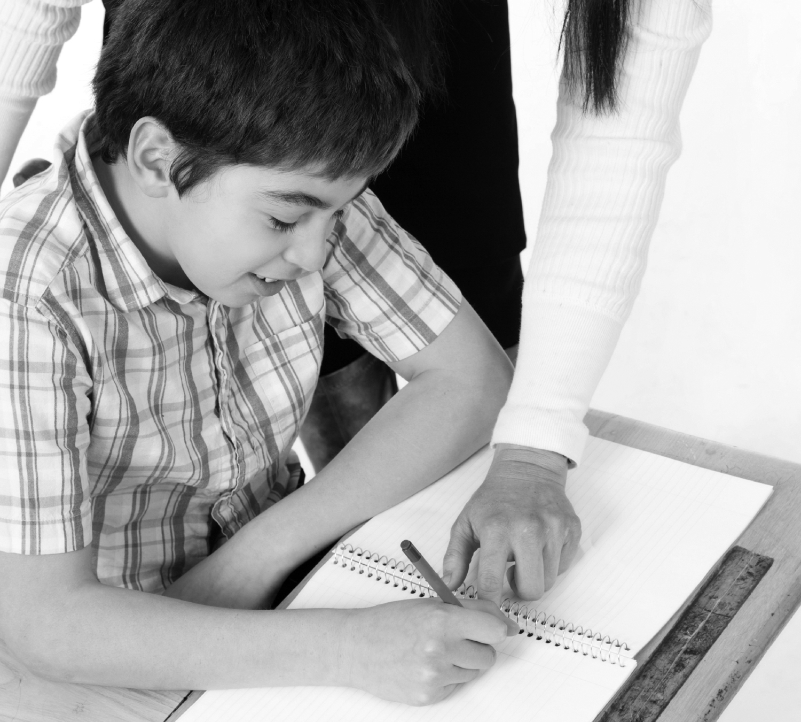

Name
Address
Postcode

Daytime tel.

Email

 •

ORGANISED BY THE INTELLECTUAL DISABILITY FORUM

The place of new media in the care and education of people with intellectual disabilities The Royal Society of Medicine, 1 Wimpole Street, London, WIG 0AE Thursday 3 December 2009 • CPD: 5 credits (Applied for)
www.rsm.ac.uk/intellectual-disability

The place of new media in the care and education of people with intellectual disabilities

Programme:

9.30 am Registration, tea and coffee

Mapping

Chair: Professor Steve Trevillion, Dean of the School of Humanities and Social Science, University of East London

10.00 am Welcome and introduction

10.10 am New media and intellectual
disability - mapping of the
‘multimedia advocacy’ field
Andy Minnion, Director, The Rix Centre

Demonstrations

10.40 am Hear what we have to say
Presenters will include Gill and James Aspey, Ajay Choksi and Patricia Charlesworth, supported by Deborah Williams

11.10 am Make information easy for us
to understand
Presenters will include Miles Leonard, Ellingham Employment Services

11.40 am Tea, coffee and IT displays

ANALYSIS - PERSONAL IMPACT

12.00 pm Impacts of new media
methods on the individual for
self advocacy and self
determination
Dr Karen Bunning, Leader of the Allied Health Professions Graduate Programme at University of East Anglia

ANALYSIS - ORGANISATIONAL CHALLENGES
12.30 pm Implementing new media
practice
Gosia Nowicka, The Rix Centre Barnaby Harris, Robert Owen Communities

1.00 pm Lunch and IT displays

FUTURE POSSIBILITIES

Chair: Professor Steve Trevillion, Dean of the School of Humanities and Social Science, University of East London

2.00 pm 'Developing technology use
together: inter-disciplinary
working and the future of
assistive technology
Chris Abbott, Reader in e-inclusion, Department of Education and Professional Studies at King's College, University of London

2.30 pm Almost there – future
classrooms today
Kieron Sheehy, Senior Lecturer, Open University, Centre for Childhood, Development and Learning

3.00 pm Innovations for inclusion
Nick Weldin, Senior Technologist, The Rix Centre

3.15 pm Panel discussion - ways ahead,
opportunities and solutions to
overcoming barriers

3.40 pm Completion of evaluation forms

3.45 am Evaluations and access to
displays and demonstrations

4.35 pm Close of meeting

9.30 amRegistration, tea and coffee

Mapping

Chair:Professor Steve Trevillion, Dean of the School of Humanities and Social Science, University of East London

10.00 amWelcome and introduction

10.10 amNew media and intellectual
disability - mapping of the
‘multimedia advocacy’ field
Andy Minnion, Director, The Rix Centre

Demonstrations

10.40 amHear what we have to say
Presenters will include Gill and James Aspey, Ajay Choksi and Patricia Charlesworth, supported by Deborah Williams

11.10 amMake information easy for us
to understand
Presenters will include Miles Leonard, Ellingham Employment Services

11.40 amTea, coffee and IT displays

ANALYSIS - PERSONAL IMPACT

12.00 pmImpacts of new media
methods on the individual for
self advocacy and self
determination
Dr Karen Bunning, Leader of the Allied Health Professions Graduate Programme at University of East Anglia

ANALYSIS - ORGANISATIONAL CHALLENGES
12.30 pmImplementing new media
practice
Gosia Nowicka, The Rix Centre Barnaby Harris, Robert Owen Communities

1.00 pmLunch and IT displays

FUTURE POSSIBILITIES

Chair:Professor Steve Trevillion, Dean of the School of Humanities and Social Science, University of East London

2.00 pm'Developing technology use
together: inter-disciplinary
working and the future of
assistive technology
Chris Abbott, Reader in e-inclusion, Department of Education and Professional Studies at King's College, University of London

2.30 pmAlmost there – future
classrooms today
Kieron Sheehy, Senior Lecturer, Open University, Centre for Childhood, Development and Learning

3.00 pmInnovations for inclusion
Nick Weldin, Senior Technologist, The Rix Centre

3.15 pmPanel discussion - ways ahead,
opportunities and solutions to
overcoming barriers

3.40 pmCompletion of evaluation forms

3.45 amEvaluations and access to
displays and demonstrations

4.35 pmClose of meeting

Registration form
Register online at www.rsm.ac.uk/intellectual-disability

The place of new media in the care and education of people with intellectual disabilities
Thursday 3 December 2009
Please photocopy this form for additional delegates

Name* (title, forename, surname)
Present appointment*
Present institute*
Postcode

GMC Number
Email address

Any special needs or diet

Address or RSM membership No.

*Please complete as you would like your details to appear on name badge, delegates list and attendance register

Daytime tel.

Male  Female 
Payment details (please tick the appropriate box(es)

Standard rate
RSM Members
Fellow £65
Associate £55
Trainee £45
Student £35
Council members £35
Non – RSM Members
Non-Fellow £150
Allied Health Professional £80
Trainee £80
Voluntary Sector/Service user/Carer £60
Student £45
Please complete both sides

Office use only
Delegate:
Campaign code: A0763
Event code: 5881

