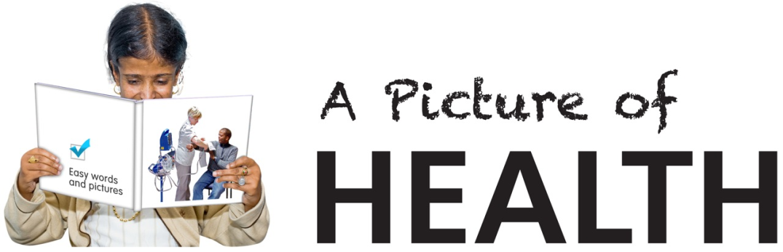C:\Users\Jo\AppData\Local\Microsoft\Windows\Temporary Internet Files\Content.IE5\DHIB3MRU\MC900105190[1].wmf

**A Picture of Health website is continuing to help health practitioners across the country by providing easy read health information documents.**

**Did you know……On average 1,000 people visit the website each month. 95% of visitors are UK based but we also have had visitors from; America, Ireland, Philippines, India, Australia, New Zealand, Europe and Bangladesh.**

**We are about to start updating the website with a refreshed Home Page, new ‘Search’ feature and a ‘Contact’ page, which will allow people in the future to e-mail documents directly to the website.**

**Call for new documents for Version 3!! If you have easy read health documents which you would like to share on the website please contact Jo Hogg Tel: 07866 768509 or e-mail:** [**tonyandjohogg@aol.com**](mailto:tonyandjohogg@aol.com)

**Thanks for everyone’s support.**

**www.apictureofhealth.southwest.nhs.uk**