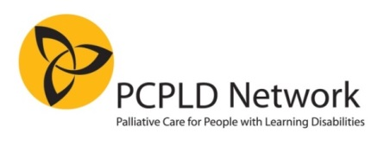
BOOKING FORM

End-of-life care planning for people with learning disabilities
One Day Annual Conference, Palliative Care for People with Learning Disabilities Network

26th November 2014, 9.30am-4.30pm
Venue: Radisson BLU Hotel, 301 Argyle Street, Glasgow G2 8DL

Name:
Job title:
Organisation/company name:
Tel:
Email:

PAYMENT

□I enclose a cheque for £100 (payable to “PCPLD Network”)

□please send an invoice to: (write clearly)

Name:

Email:

Telephone:

Purchase Order number (if available:)

Please indicate any special requirements (e.g. vegetarian diet; disabled access)

Please scan the completed form and email to: annegarley@gmail.com
or print out and return to:
Anne Garley, 66 Castle Street, Portchester, Fareham, Hampshire PO16 9PX

PLEASE NOTE: deadline for registration: 12/11/2014. Places cannot be guaranteed unless payment is received by this date. Cancellations: 80% refund before 12/11/2014; no refunds after this date. Bookings may be transferred to someone else at no extra cost. Final confirmation details will be sent to delegates on 13/11/2014.

