Intellectual (Learning) Disability
Open Meeting
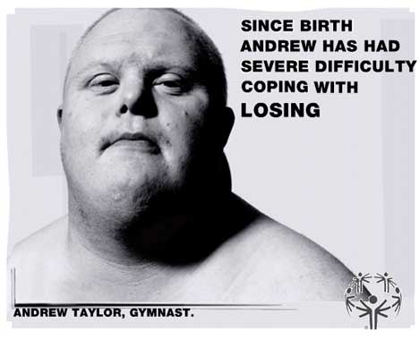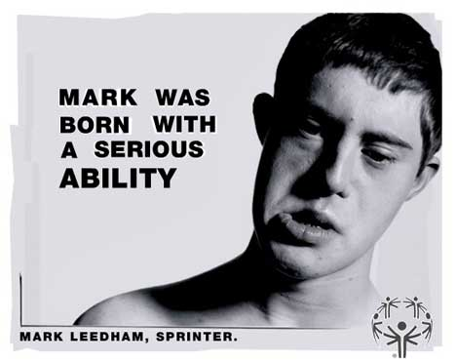
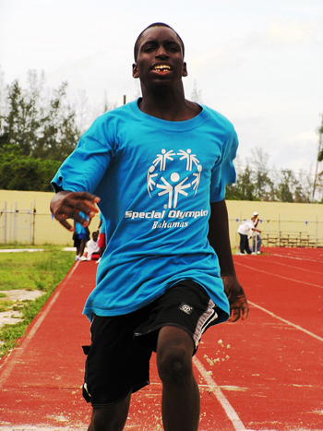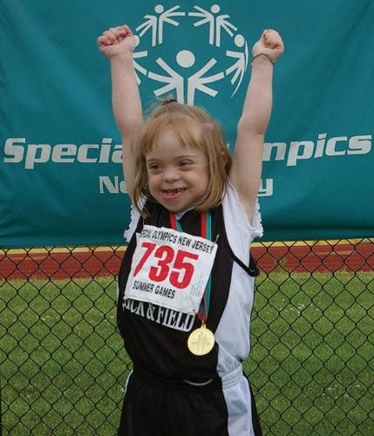
Special Olympics – Why SO special?
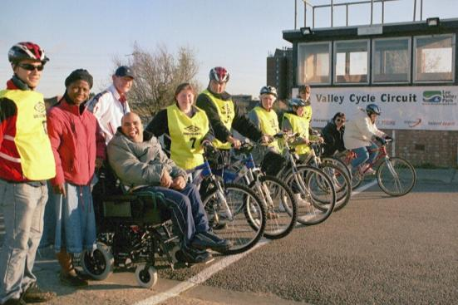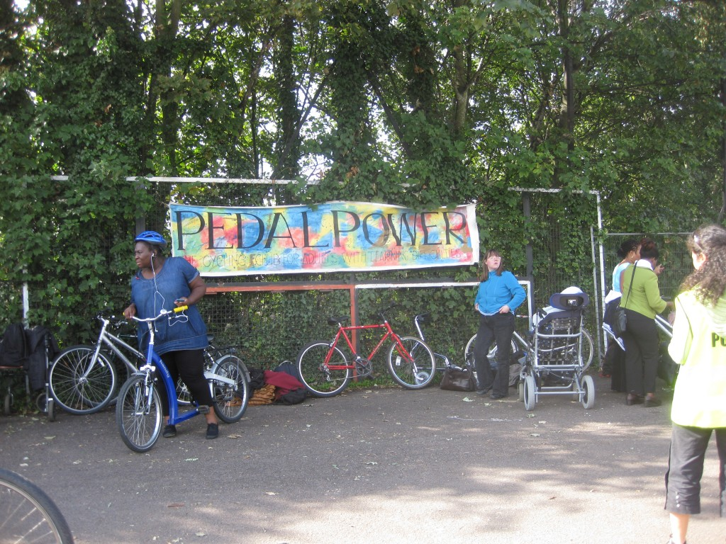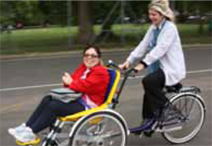
Pedal Power cycling club for teenagers & adults with intellectual (learning) disabilities
FREE - EVERYONE IS WELCOME

Date: FRIDAY 18th May 2012
Time: 2.00 - 4.00pm
Place: Lecture Theatre B, Ground Floor Grovesnor Wing
St. George’s Hospital, Tooting London SW17 ORE

If you would like to attend or find out more please contact:
JIM BLAIR - Email: Jim.Blair@stgeorges.nhs.uk
Tel: 020 8725 2155 (Debs Bunyan)




