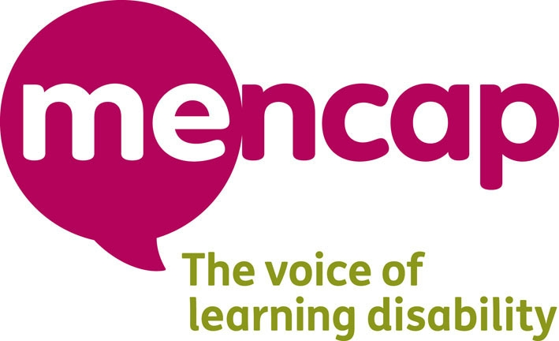
The job Regional learning disability consultant for the Inspire Me Project

This is a job description. It tells you about job.

 | The job | jjjj  The job, Regional learning disability consultant for the Inspire Me project
 | The manager for this job | Youth Worker for the Inspire Me project
 | Place where the jobs will be based | Bristol, Birmingham, London, Manchester and Liverpool
 | How many hours a week is the job for? | Up to 16 hours but can be less
 | How much money does the job pay? | £7,090 a year or £8.52 an hour.  If this will affect your benefits we can talk about it.
 | This job description was written | May 2011

The main things you will have to do in the job

 | Run training workshops to groups of young people about the topics below:  - Volunteering  - Work  - Community  - Confidence  - Money  - Action Planning
 | Give talks and presentations on learning disability, how to speak up, what matters to young people and about Inspire Me
 | Help the other Inspire Me staff to make training presentations and information about the project
 | Record what you do and give ideas to help make the project better
Give training about Inspire Me
•
Give talks about the Inspire Me project at events and meetings with other young people and groups

 | Help to make easy read information for presentations, conferences, events and meetings
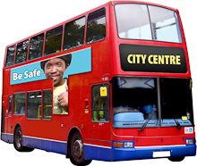  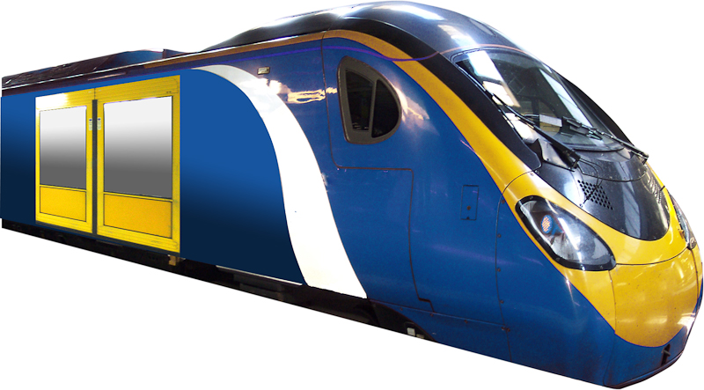 | Is able to travel independently on public transport  Happy to travel around the area
 | To do any other jobs that the Inspire Me Youth Worker might ask you to as part of your job

