
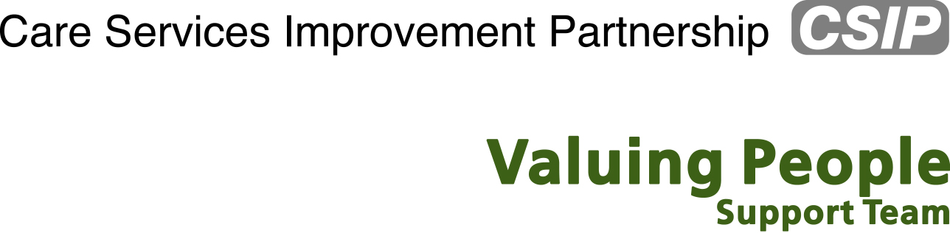

A Life Like No Other: breaking the cycle

Agenda for the day

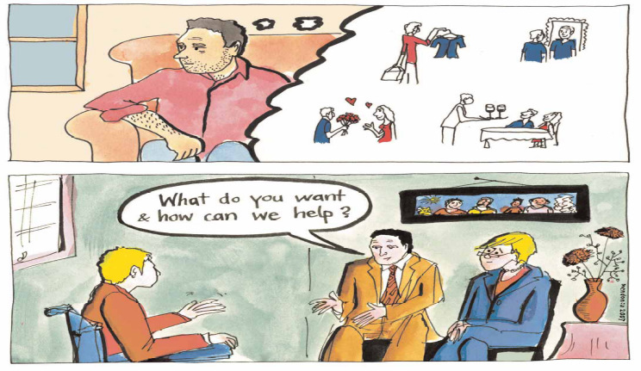

Today’s workshop aims to update and forward plan with senior commissioners, professionals and managers on specialist learning disabilities health services. This is an important event to set the scene and change current practice outlined in the recent publication by the Healthcare Commission.

10:00 – Coffee and registration

10:30 – Welcome
National learning difficulty audit of inpatient services overview
Fiona Ritchie, Learning disabilities lead, Healthcare Commission

11:15 – On being a peer reviewer (to be confirmed)
Refreshments

11:45 – Workshop 1
How dies this relate to your service?
What questions does it raise?

13:00 – Lunch

13:45 – Key messages from policy
Deborah Moore, Valuing People

14:00 – Workshop 2
What needs to change?
Who needs to support this?
How are we going to do it?

3:30 – Close

