WHAT IS LEARNING DISABILITIES

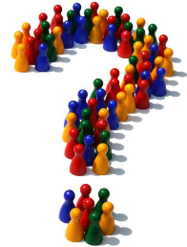

A DISTANCE LEARNING WORKBOOK

CONTENTS

About this workbook

Section 1 Definitions of learning disabilities

Section 2 The broad range of learning disabilities

Section 3 Labelling

Section 4 Causes

Section 5 Social and adaptive dysfunction

Section 6 Support needs

Section 7 Workbook exercises

Section 8 Confirmation

ABOUT THIS WORKBOOK

OBJECTIVES

The aim of this workbook is to ensure that on completion you should be able to demonstrate an understanding of:

- The different levels of learning disabilities

- Possible causes

- The importance of identifying the level of support needed for each service user

- The difficulties service users may encounter when learning new skills and in social functioning

SECTION 1
WHAT IS LEARNING DISABILITIES?

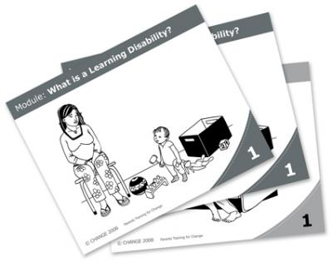
The World Health Organisation defines learning disabilities as,
‘A state of arrested or incomplete development of mind’

Valuing People say that learning disabilities include the presence of:

- A significantly reduced ability to understand new or complex information, to learn new skills (impaired intelligence), with;
- A reduced ability to cope independently (impaired social functioning)
- which started before adulthood, with a lasting effect on development

This definition covers adults with autism who have learning disabilities, but not those with a higher level autistic spectrum disorder who may be of average or even above average intelligence – such as some people with Asperger’s Syndrome.

‘Learning disabilities’ does not include all those who have a ‘learning difficulty’ which is more broadly defined in education legislation.
- Attention deficit disorder
- Dyslexia – a difficulty with words

SECTION 2
THE BROAD RANGE OF LEARNING DISABILITIES

All levels of learning disabilities are points on a spectrum and there are no clear dividing lines between them, or between people with mild learning disabilities and the general population.

MILD LEARNING PROFOUND LEARNING
DISABILITIES DISABILITIES

Some people with mild learning disabilities may not even be diagnosed because they can function and adapt well socially and are able to work unassisted, marry and have a family.

People with mild learning disabilities can communicate well, have reasonable skills and given the chance can manage well with lower level but appropriate support.

People with profound learning disabilities need a good deal more care and support. This frequently includes special help with communication, a higher degree of risk assessment and protection and more physical help with mobility, continence, and eating.

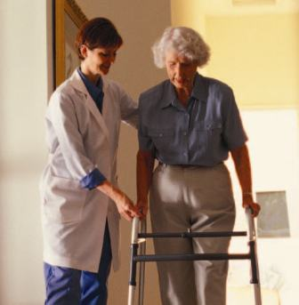

The term ‘complex needs’ can include as well as learning disabilities
- multi sensory impairment 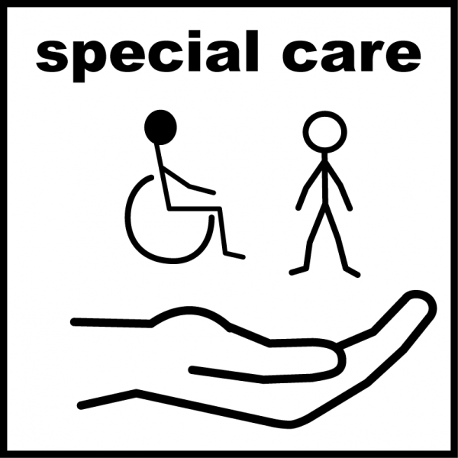
- physical impairment
- autistic spectrum disorder
- complex health needs

Special care to enable them to live safely

IQ is one way of classifying learning disabilities

- 50-70 Mild learning disabilities
- 35-50 moderate learning disabilities
- 20-35 Severe learning disabilities
- below 20 Profound learning disabilities

IQ measurement can grow during a person’s growth and development. Many people may have individual strengths and abilities which do not show up well in IQ tests.
It is important to take into account the persons ability in social functioning and adaptation. {How they cope in social settings and use their skills to adapt in different situations}.

SECTION 3
LABELLING

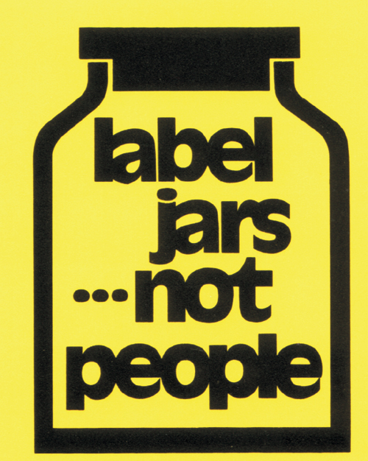

‘A LABEL DESCRIBES ONE ASPECT OF A PERSON, BUT DOES NOT CAPTURE THE WHOLE PERSON’.

The term learning disabilities is convenient in discussion and planning services.

Learning disabilities can be a useful term in that it indicates an overall impairment of intellect and functioning.

When using this term it should be clear, inclusive, and positive.

The positive aspect of the term learning disabilities enables the service user to obtain the services they require at the right level through links with learning disability community teams such as

- consultant psychiatry
- speech and language
- occupational therapy
- outreach services
- acute health services
- GP services
- Education
- Employment
- Housing
- Social and leisure activities

Remember that people with learning disabilities wear many other labels

- friend
- neighbour
- relative
- employee
- fellow citizen

SECTION 4
CAUSES OF LEARNING DISABILITIES

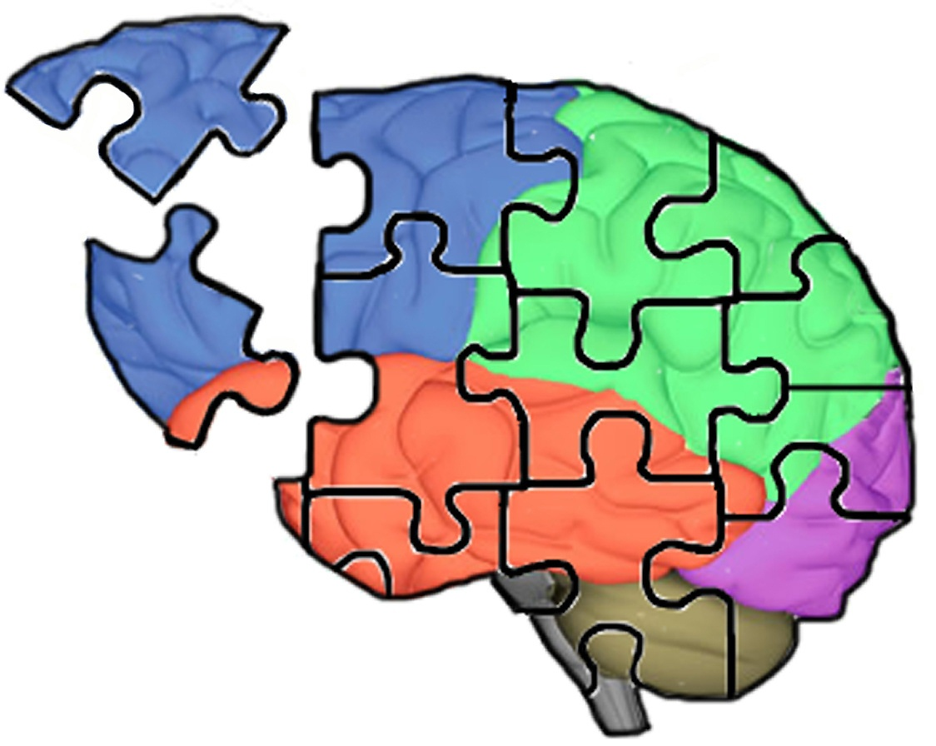

MILD LEARNING DISABILITIES

Among people who have mild learning disabilities, in about 50% of cases no cause has been identified.

Research increasingly points to organic causes such as exposure to alcohol, drugs and other toxins prior to birth and other problems at the time of birth e.g. lack of oxygen.

Chromosome abnormalities e.g. Downs syndrome

Environmental and genetic factors in 5% of people

Higher rates in some classes suggest that factors such as large families, overcrowding and poverty are important.

PROFOUND LEARNING DISABILITIES

Chromosome abnormalities causes about 40% of cases

Genetic factors account for 15%

Prenatal (during pregnancy) and perinatal (shortly before or after birth) 10%

Postnatal issues 10% (just after birth)

Cases which are unknown cause are fewer, but still high at 25%

Learning disability impairments can be identified in the development period of life and are present from childhood



SECTION 5
SOCIAL OR ADAPTIVE DYSFUNCTION

People with learning disabilities may have difficulty at various levels that restrict their social ability to adapt in different social settings.

Some of these social impairments may be life threatening for the person for e.g.

- Poor eating and drinking skills
- The importance of keeping safe and warm

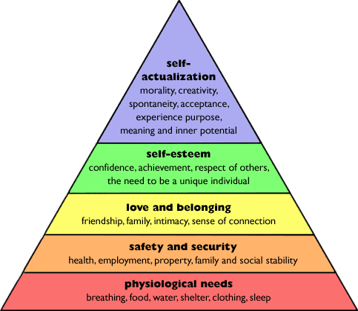

Modern society expects people to have the social ability to communicate at all levels by reading, writing and verbally communicating.

People with a learning disability may lack these abilities, therefore making it difficult to gain acceptance in society, gain friends and maintain relationships.

To be able to be understood can be a complex task with their perception of socialising difficult to understand e.g.

- When to speak
- What to say
- Listening
- Actions
- Body language
- Personal space
- Appropriate touching



Learning and remembering new things can also add to the frustrations and difficulties in social functioning.

Learning new skills is part of development but learning how to use these new skills in different settings/situations can prove to be an extra challenge.

Social functioning can be different for each individual and taken into account should be

- Where the person is living and circumstance
- Age
- Gender
- Culture
- Religion

SECTION 6
SUPPORT NEEDS

With the decline of the use of the medical model in learning disabilities, the focus of support has shifted to:

HEALTH AND SOCIAL CARE, AND EDUCATION

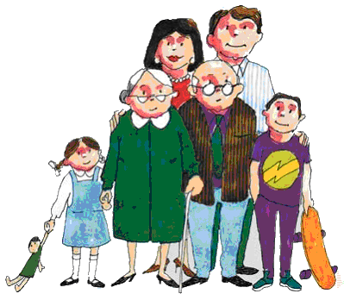

THE MEDICAL MODEL

Talks mainly of the absence and cure of disease, it does not look at the wider picture of the persons’ life.

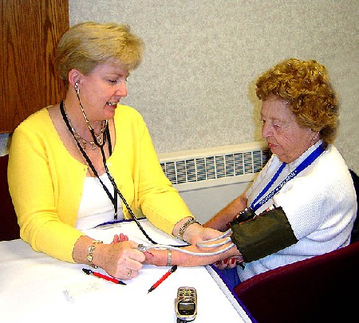

THE SOCIAL MODEL

Is about looking at the wider picture, a person’s culture, beliefs, income, access to housing, education, work and social opportunity and community networks



The emphasis is now on;

- inclusive approaches
- community integration
- advocacy services
- greater supported choice
- control of their own lives
- direct payments
- person centred approaches

SECTION 7
WORKBOOK EXCERCISES

QUESTION 1

In your own words what is your understanding of what learning disabilities is?

QUESTION 2

Name 3 possible causes of learning disabilities

1 _______________________________________________

_________________________________________________

2________________________________________________

3________________________________________________

_________________________________________________

QUESTION 3

What is the difference between mild learning disabilities and profound disabilities?

QUESTION 4

What difficulties might people with complex needs encounter in everyday activities and accessing social activities?

QUESTION 5

What are the positive benefits of being diagnosed with learning disabilities?

QUESTION 6

Give 2 examples that people with learning disabilities may have in gaining social acceptance

QUESTION 7

Remembering confidentiality, give 2 examples of difficulties service users have encountered accessing community services e.g. social events, shopping, G.P. appointments and how did you support them?

SECTION 8
CONFIRMATION

I confirm that I have read the workbook and have demonstrated an understanding of ‘What is Learning Disabilities’ as requirements of Accept Care Limited.

Name……………………………………………………………………..

Signature………………………………………………………………..

Date……………………………………………………………………….

Marked as completed

Name………………………………………………………………………

Signature…………………………………………………………………

Designation……………………………………………………………..

Date………………………………………………………………..........

COMMENTS:

REFERENCES

Fact sheet – learning disabilities
British Institute of Learning Disabilities

Valuing People: A New Strategy for Learning Disability for the 21st Century D.O.H. (2001)

Valuing People Now From progress to transformation D.O.H. (2007)



Accept Care Limited
A Company limited by guarantee.
Company number N147633
Registered Office
97 Orby Drive,
Belfast
BT5 6AG

