 | 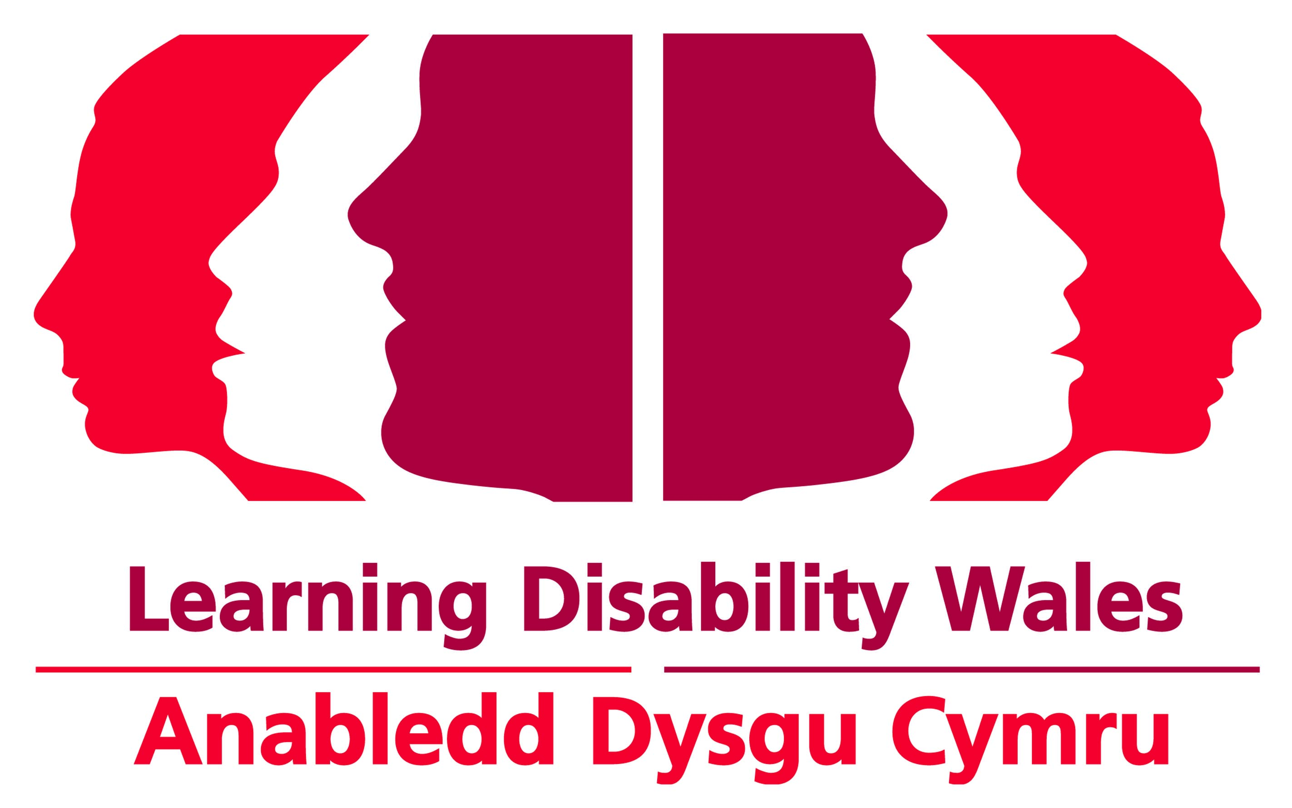 | Key to Your Home  Learning Disability Wales Annual Conference  Booking Form |  |  | 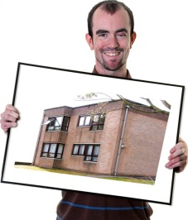
Name
Position
Organisation Name
Address
Town
Postcode
Phone number
Email
Any dietary / special
requirements
In which language will you be contributing to the event? |  |  |  | Welsh English
Will you require translation equipment to understand any contribution made in Welsh? |  |  |  | Yes No
Which language would you prefer your delegate pack in? |  |  |  | Welsh English
Conference Fees Please tick

 | 13 November | 14 November | Both Days
Non members | £97.50 | £97.50 | £195.00
Learning Disability Wales members | £75.00 | £75.00 | £150.00
People with a learning disability | £26.40 | £26.40 | £52.80
Family Carer or Paid Carer supporting person with a learning disability | £26.40 | £26.40 | £52.80

Group Discount Available: 10% discount available on conference fees for all bookings made for 5 or more people.
(Prices include VAT)

Payment Options Please tick

By Cheque: Payable to Learning Disability Wales. Please ensure delegate name(s) and organisation name are written on the back.
By BACS: Bank: Barclays Bank Plc. Sort Code: 20-18-27, Account No.: 80803146, Account Name: Learning Disability Wales, include Ref: AC2012 and delegate’s name. BACS remittance forms required as payment confirmation.
By Invoice: Please invoice me at the following address (if different from above). A £6.00 administration charge is applied per invoice sent.
Alternative Invoice Address or Email

Workshops Tuesday 13 November

Workshops will be repeated in the morning and afternoon. Please mark the workshops you would like to attend in order of preference,  your first (1), second (2) and third (3) choice. |  | Choice
1 | Designing Housing for People who have Autism
2 | Getting the life you want
3 | Homes for Wales – An overview of the Housing White Paper
4 | Legal Pointers to Protect You and Your Family
5 | My Dream Home
6 | Renting from a Private Landlord
7 | Tenancy Rights and Responsibilities
8 | Welfare Reform Awareness
9 | What are the housing choices for older people with a learning disability?

Annual General Meeting Tuesday 13 November

You are welcome to join us for our AGM which will be held from 9:15–10:00am in the same venue as Key to Your Home.
Full Members will have voting rights at our AGM but anyone can attend as an observer.
Would you like to attend the Annual General Meeting? | Yes No

Workshops Wednesday 14 November

Workshops will be repeated in the morning and afternoon. Please mark the workshops you would like to attend in order of preference,  your first (1), second (2) and third (3) choice. |  | Choice
1 | Community Mapping
2 | Cooking made fun and easy
3 | Keeping you and your home safe
4 | Making your home energy efficient
5 | Money Skills
6 | Positive Risk Taking
7 | Welfare Reform Awareness
8 | Who Supports Me and How

Confirmation: Confirmation will be sent via email or post. If you have not received confirmation 10 working days before the conference please contact us immediately.
Cancellation policy: Cancellations MUST be made 10 working days before the event takes place. Failure to do so will result in the full amount being charged. Exceptional circumstances will be considered.
Photography: Please note photographs may be taken at the event and used in future publications or marketing. Please make the Learning Disability Wales staff aware if you do not want to be photographed.
Your details: Learning Disability Wales would like to keep your details on record for future events and training. If you do not wish to receive any further information from us please tick the box

Please return completed booking form to
Learning Disability Wales, 41 Lambourne Crescent, Cardiff Business Park,
Llanishen, Cardiff CF14 5GG

harriett.johnson@learningdisabilitywales.org.uk
029 2068 1160 029 2075 2149

