

Do you want to use your experience to make learning disability services better?


The Healthcare Commission is doing a national audit of learning disability services.

We need your help.

We are looking for people who use these services, family carers, clinicians and managers to work as part of our peer review teams.

About the Healthcare Commission

Our job is to check healthcare services in England to make sure they are being run well.

We are going to check healthcare services for people with a learning disability everywhere in England.

We will check them to see how well they are being run.

This check is called a national audit.

Why are we going to check learning disability services in England?

There was an investigation into NHS learning disability services in Cornwall. The investigated showed that some people had been treated very badly and services were not being run well.

One service, not run by the NHS, has closed down.

We want to make sure services are safe for people with a learning disability to use. We also want to help make
services better for everyone.

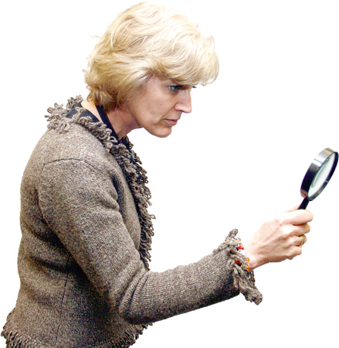
What services will we check?

We will check services for adults and young people (from 12-19 years old) run by the NHS and other groups that are not part of the NHS.

You can help

This is your chance to help to make learning disability services in England better.


To help us with the audit, we will be setting up peer review teams.

Each team will be led by a member of Healthcare Commission staff and will have up to 3 people.

The teams will be made up of people with a learning disability, family carers, and some staff.


About the audit

You will get 1 day of training.

You will take part in at least 3 audits.
- The audits will start in 2007.
- Each audit will take about 12 hours. This includes time to prepare.


Paid work
Service users (people with a learning disability) and family carers will get £5.50 per hour and expenses for things like travel and so on.

For clinicians and managers (staff), a secondment agreement with your organisation will be arranged on a voluntary basis.

How to apply for a job with the Peer Review Teams


If you are service user or a family carer you will need to fill in the contact details and equal opportunities forms.


If you are a clinician or manager, you will need to provide a written statement of no more than 500 words showing why you can do this work. You will also need to complete the contact details and equal opportunities forms.

Return your completed application forms to
Nazneen Chowdhury


Post
Resource Advisor
Healthcare Commission
14th floor, 103–105 Bunhill Row

London EC1Y 8TG

Email
nazneen.chowdhury@healthcarecommission.org.uk

Fax 020 7448 9481


For more information visit our website
www.healthcarecommission.org.uk
and go to the recruitment section.


If you have any questions, please contact Nazneen

telephone 020 7448 9274

email
nazneen.chowhury@healthcarecommission.org.uk





You must have your application to us by 5.00pm on Friday January 26th 2007.

The Healthcare Commission welcomes applicants from all sections of the community, regardless of gender, race, disability, sexuality or age.
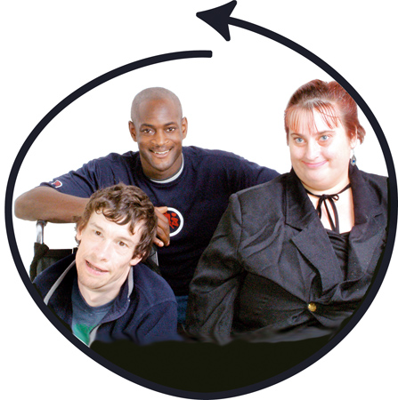
Mencap and Photosymbols helped to make this easy read.

