CHANGE has been given some money from the Department of Health to write some accessible booklets about cancer for people with learning disabilities, their carers, families and professionals. The project will last for two years.

CHANGE are looking to employ a

**Project Worker**

**with Learning Disabilities**

**£12,952 per year – 22.5 hrs per week**

**For 2 years only**

If you are interested in this job, contact Jacqui Fellows and ask for a recruitment pack.

Tel No: 0113 2430202

Mini-Com: 0113 2432225

E-mail: [info@change-people.co.uk](mailto:info@change-people.co.uk)

We need to have your finished application form by 12 o’clock on Friday 30 May 2008.

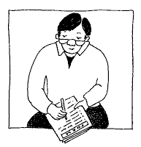

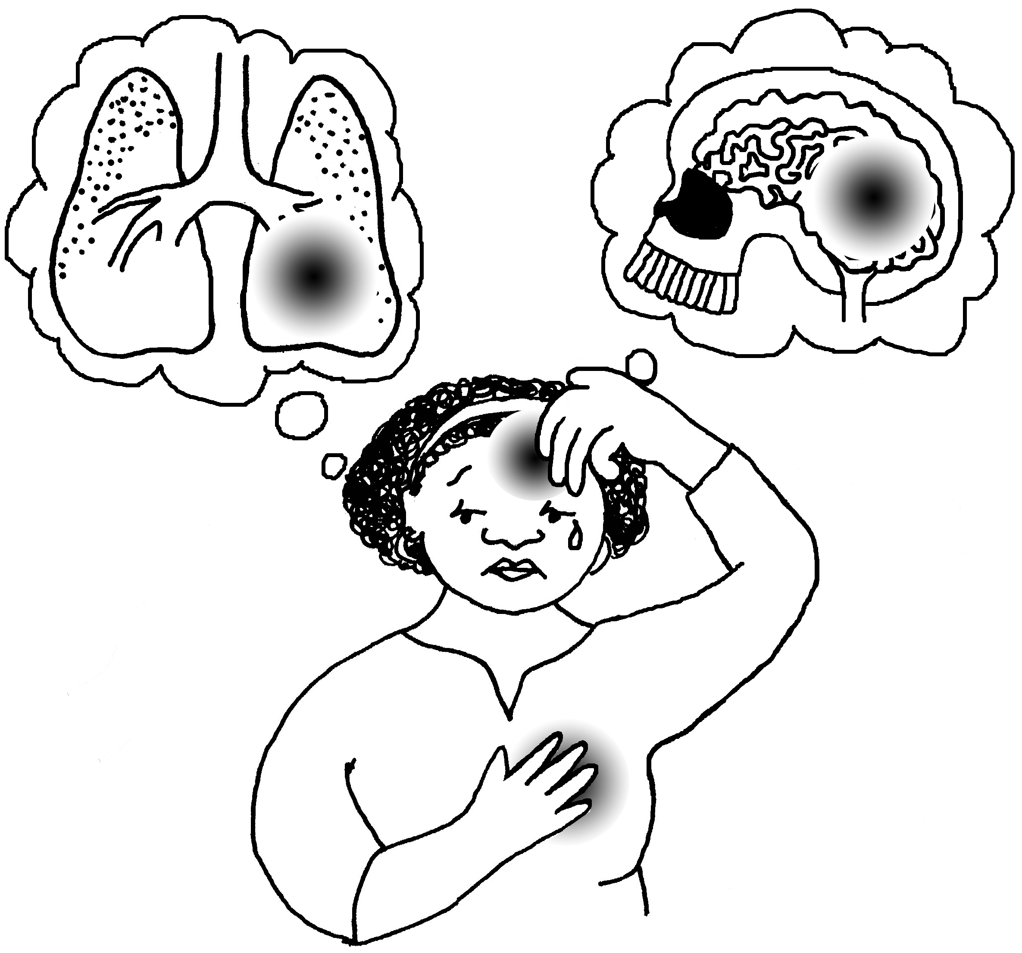

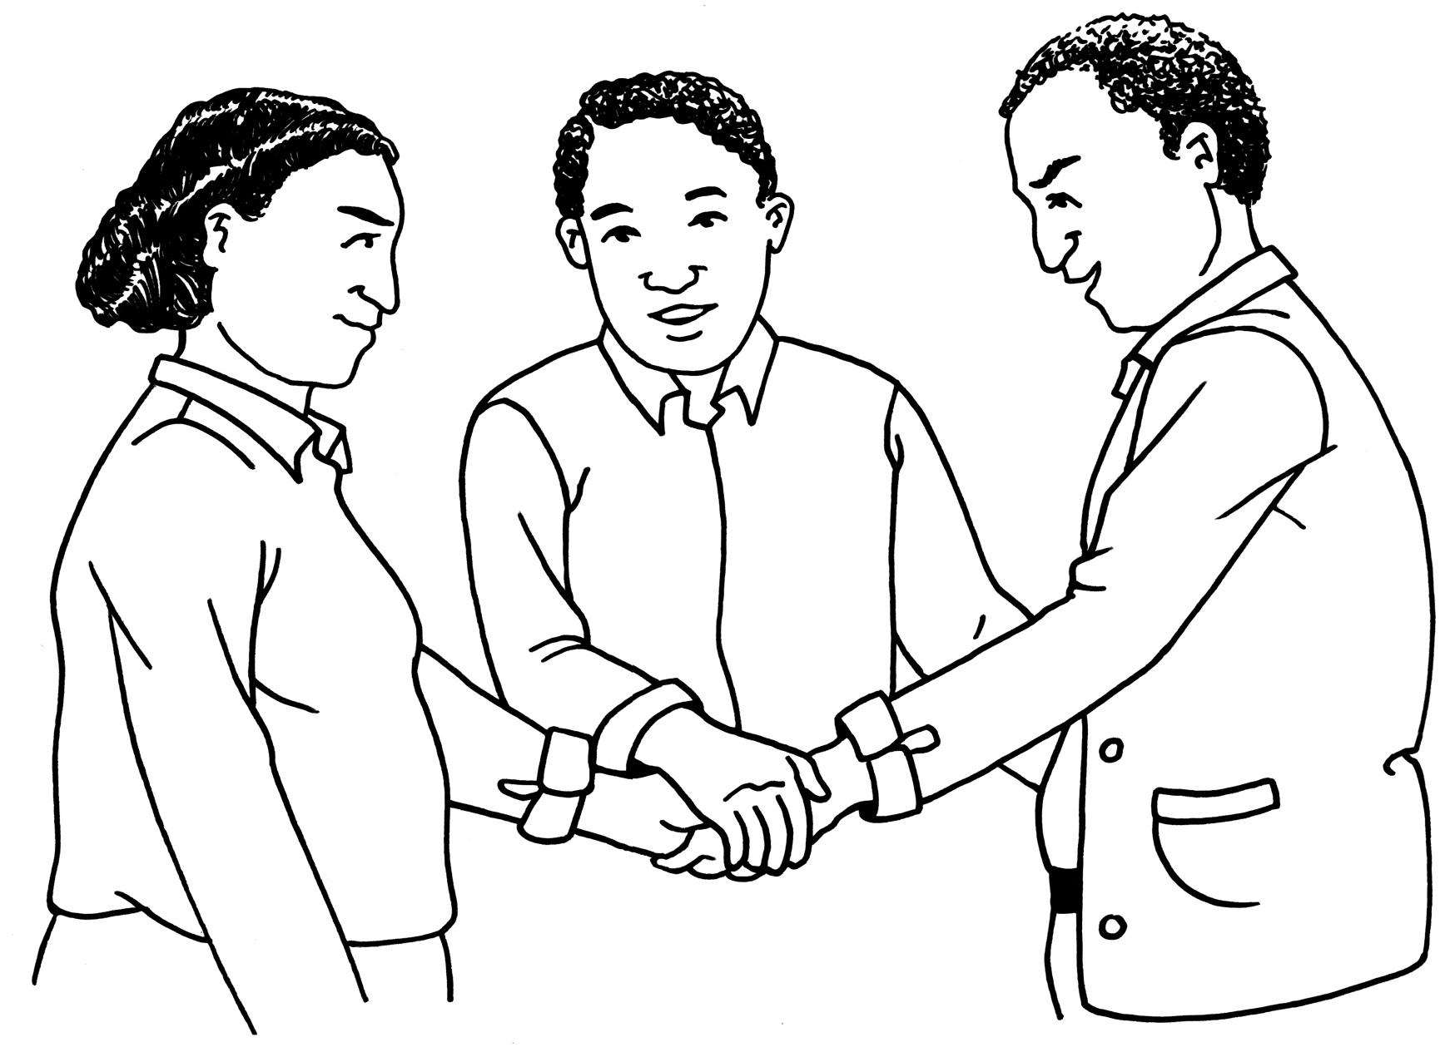



**CHANGE is a national organisation run by Disabled People working for equal rights for all people with learning disabilities.**

