Inpatient Survey – 2007/08

Ward:

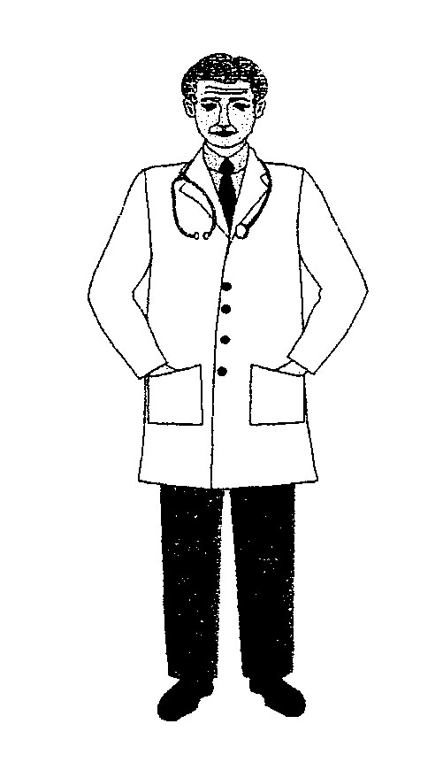 DOCTORS

1. How do you rate the politeness of your doctors?
  Brilliant   |   Not bad   |   Poor  

2. When you asked the doctor a question did you
understand what they told you?
Yes   | No   | Don’t know  

3. Did the doctor talk in front of you as if you weren’t
there?
Yes   | No   | Don’t know  

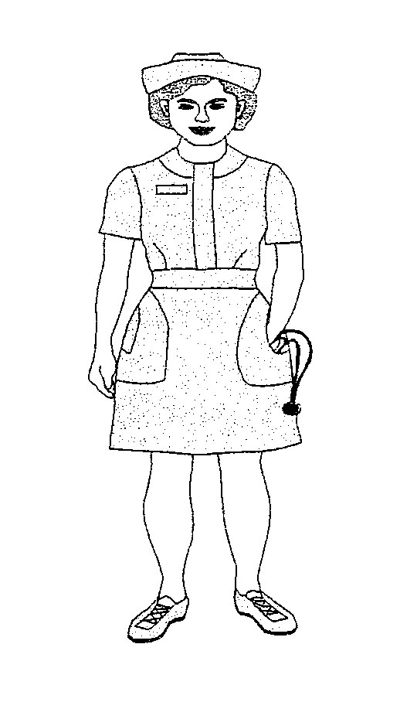NURSES

4. How do you rate the politeness of your nurses?
Brilliant   | Not bad   | Poor  

5. When you asked the nurse a question did you
understand what they told you?
Yes   | No   | Don’t know  

6. When you wanted to talk to a nurse, were you
always able to?
Yes   | No   | Don’t know  

7. Did the nurse talk in front of you as if you weren’t
there?
Yes   | No   | Don’t know  

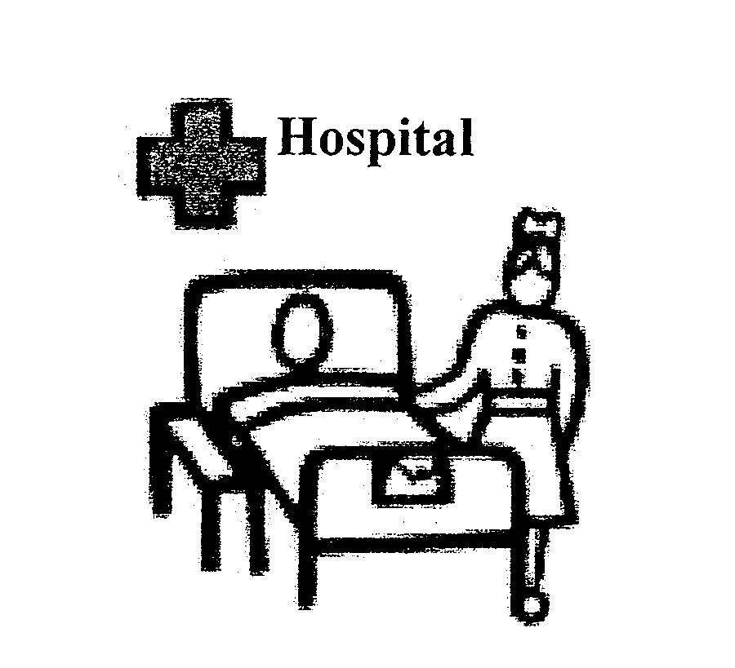 CARE AND TREATMENT

8. If you called for help by using the button at the side
of your bed how long did it take for the nurse to come?
Right away   | I waited a bit   | I waited a long time 

9. While you were in hospital, did you have any tests?
Yes   | No   | Don’t know  
If you didn’t have any tests, please go to question 14

10. Did a doctor or a nurse tell you why you were having
tests?
Yes   | No   | Don’t know  

11. Did a doctor or a nurse tell you the results of your
tests?
Yes   | No   | Don’t know  

12. Did you understand the results of your tests?
Yes   | No   | Don’t know  
13. Were you given enough privacy when being
cared for by the doctors and nurses?
Yes   | No   | Don’t know  

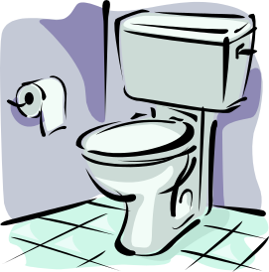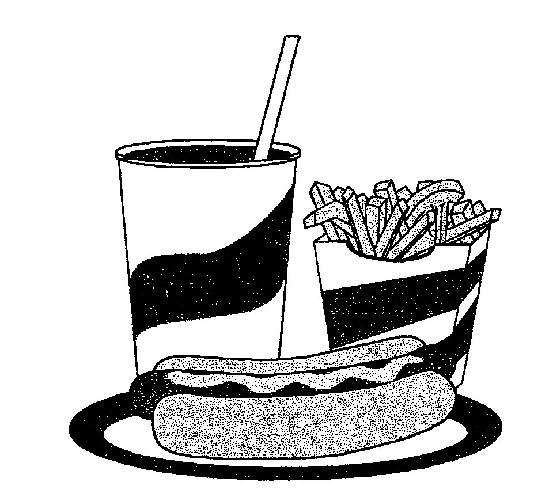
Help and support

14. Do you know where the toilets/bathrooms are?
Yes   | No   | Don’t know  

15. Do you get the help you need to move around the ward?
Yes   | No   | Don’t know  
16. Do you get the help you need to wash/bath, shave, dress, clean teeth/mouth?
Yes   | No   | Don’t know  

17. Do you get the help you need to go to the toilet?
Yes   | No   | Don’t know  

18. Do you know where the T.V is?
Yes   | No   | Don’t know  

19. Do you know how to use the T.V?
Yes   | No   | Don’t know  

20. Do you choose your food to eat at mealtimes?
Yes   | No   | Someone else chooses  

21. Are you happy with what you get to eat and drink?
Yes   | No   | Don’t know  

22. Do you need any help to feed yourself?
Yes   | No   | If No, please move on to Q 24

23. Did you get enough help to eat your meals?
Yes   | No   | Don’t know  

24. Were you able to get enough sleep?
Yes   | No   | Don’t know  

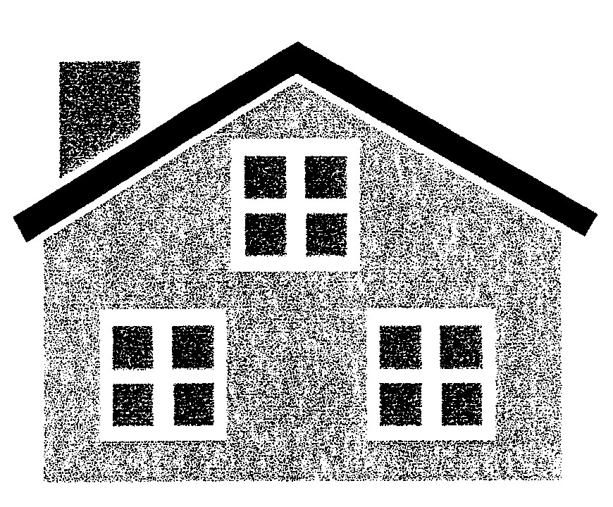 LEAVING HOSPITAL

25. Did the staff tell you or someone close to you
how you should look after yourself once you get
home?
Yes   | No   | Don’t know  

26. Did the staff tell you who to contact if you had any worries about your illness once you were home?
Yes   | No   | Don’t know  

27. Have you been given any medicines to take home?
Didn’t need any Yes  Go to Q 29    | No   | Don’t know  

28. Have you been told how to take your medicines once you are at home?
Yes   | Yes, but I don’t understand it   | No  

OVERALL

29. Is there anything about your stay that made you
unhappy?
Yes   | No   | Don’t know  
If yes, please say what it was?

30. Do you know what to do if you are unhappy about your hospital stay in any way?
Yes   | No   | Don’t know  

31. Is there anything about your stay that made you
happy?
Yes   | No   | Don’t know  
If yes, please say what it was?

32. Overall what one thing would you change about the ward?

Any other comments?

Who has completed the survey?
Please tick as a many as apply:
Auditor | ◻
Please specify below
Thank you for completing this survey. Your answers are important to us.

