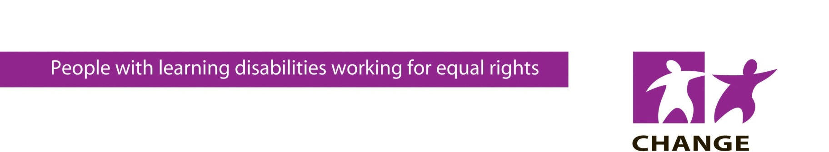
Is Your Information Accessible?

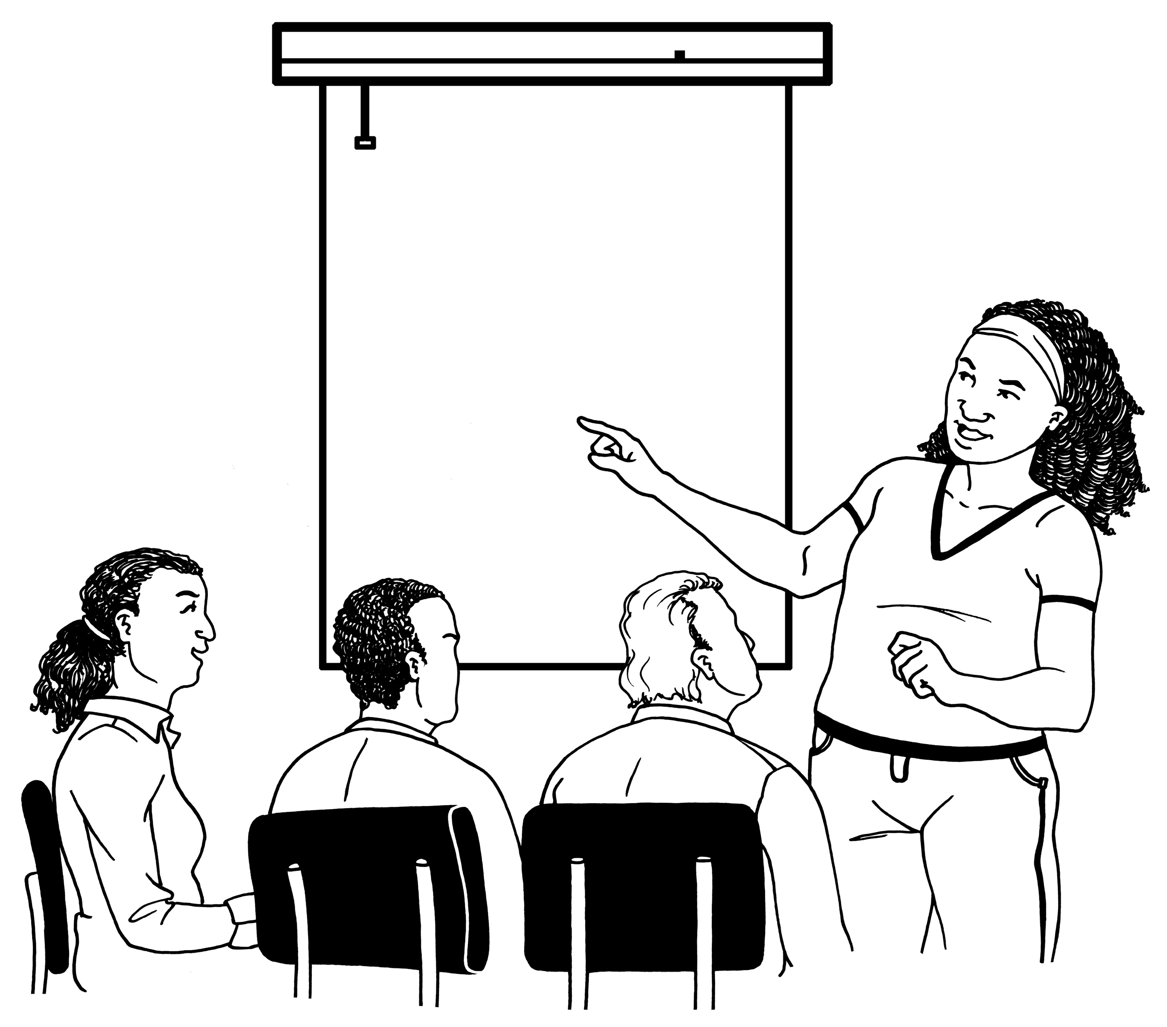

On the last Friday of every month our much acclaimed Making Information Accessible training is run from our offices in Leeds by our professional team of learning disabled trainers, Trainers for CHANGE. The next available date is Friday 24th September.
Join us and discover what accessible information really means and how to create your own accessible documents.
Places are strictly limited so book now to avoid disappointment!
“Being involved in a training session delivered by people who have learning disabilities was excellent. I will take this information back to my employers and encourage this learning.”

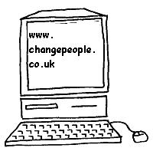
info@change-people.co.uk
0113 388 0011
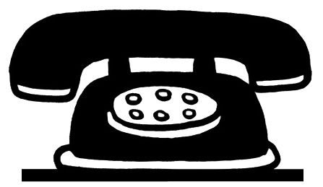
CHANGE Picture Bundles
Picture bundles are available from our website shop
on the following topics:

- Supporting Parents with Learning Disabilities
- Mental Health
- Pregnancy
- Healthy Foods and Healthy Eating
- Abuse – Sexual, Bullying & Emotional, Physical
Each picture bundle contains 30-50 clear illustrations which can be downloaded from the website immediately after payment.

Your websites, leaflets, guides, care plans and documents can all be made accessible using the pictures, and you can use them as many times as you like.
For more information please visit www.changepeople.co.uk. You can contact us on 0113 388 0011 or email info@change-people.co.uk.
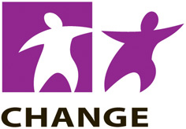
CHANGE employs people with learning disabilities to produce and
deliver training packages and a range of accessible resources using
easy words and pictures.

