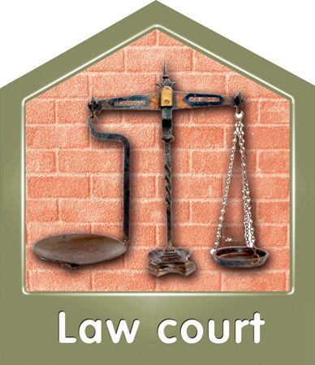 | A court has ruled that Hounslow council failed to give the right support to a family.
 £ | The council has been fined 100,000
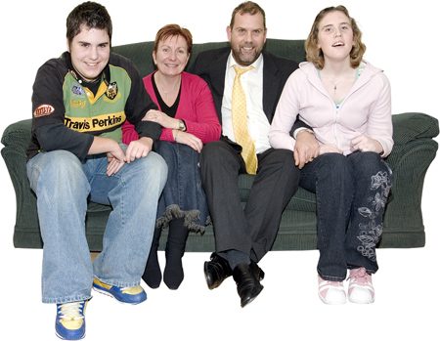 | The parents in the family had a learning disability. One of their two children also had a learning disability.
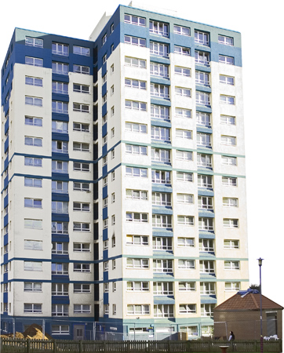 | The family were taken advantage of by a group of young people, who attacked them and abused them. They took over their home.
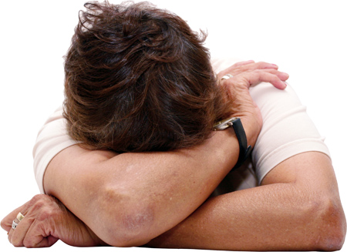 | The family were left scared and in danger. They wanted to leave the area where they lived.
 | They lived in a council house and had a social worker. The council knew that the family were at risk of danger.
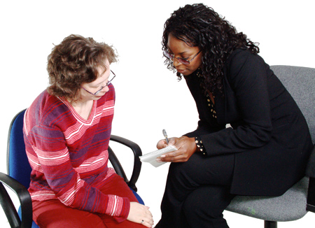 | The judge said that this meant that the council had a ‘duty of care’ to the family. This meant it was their job to protect the family from abuse.
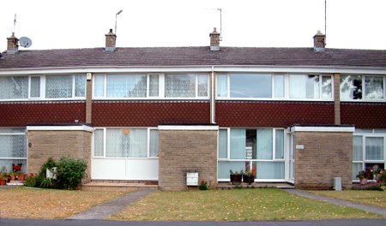 | He said that the council should have protected them by finding them somewhere else to live when they needed it.
 | This ruling might mean that all councils now have a ‘duty of care’ to protect vulnerable people from abuse.

