Bulletin 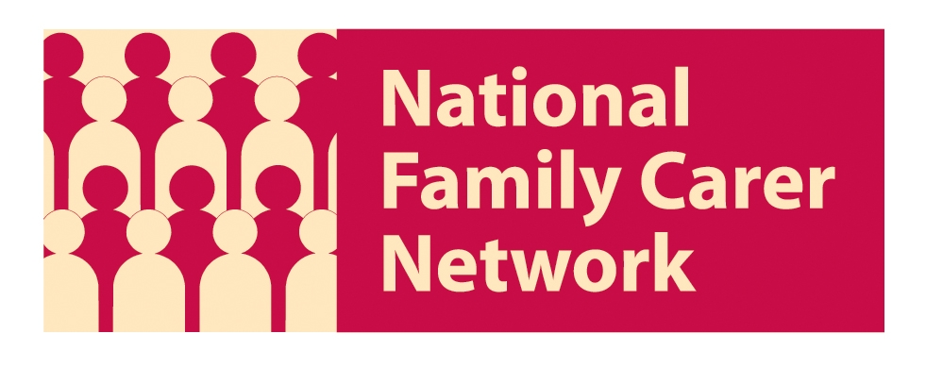

07747 460727
www.familycarers.org.uk

19 December 2011

Welcome to this week’s Bulletin from the National Family Carer Network. You are receiving this because you are members of our organisation. If you no longer wish to subscribe please contact info@familycarers.org.uk.

Contents:
1. CQC - its review of services for people with learning disabilities
2. Users to shape new online care ratings system
3. Top 10 Tips
4. Cutting Legal Aid: Denying Access to Advice
5. New approaches to supporting carers' health and well-being
6. Jean Willson receives an OBE

1. CQC - its review of services for people with learning disabilities

The Care Quality Commission (CQC) has published the first five reports from a targeted programme of 150 inspections of hospitals and care homes that care for people with learning disabilities.

Only one of the five services inspected was found to be fully compliant with the government’s essential standards of quality and safety required by law.

If you would like to speak to someone after reading the reports, a list of independent organisations providing independent support to families with disabled relatives is available at the end of the press release.

To read the reports, please Click here

To read the CQC press release Click here..

And the easy read version is here:


2. Users to shape new online care ratings system

Paul Burstow says that “Users and carers' opinions on care services will be published alongside ratings of their quality on an online "good care guide" designed to replace the star ratings scrapped last year. Click here to read more.

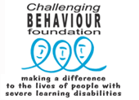

3. Click here to read Professor Luke Clements Top 10 Tips for families carers on ensuring good support and services for adults with severe learning disabilities whose behaviour is described as challenging.

4. Cutting Legal Aid: Denying Access to Advice

Read Rachel Taylor’s report on cutting legal aid. She is a member of the Young Legal Aid Lawyers.



5. New approaches to supporting carers' health and well-being

This report, New Approaches to Supporting Carers' Health and Well-being, presents the findings of an independent evaluation of the national carers' strategy demonstrator sites programme. It was funded by the Department of Health who commissioned CIRCLE, University of Leeds to undertake the evaluation of 25 demonstrator sites around the country. These sites either developed new and innovative services for carers or extended existing provision where effective arrangements were already in place.

Click here for the full report and here for the summary.

6. Jean Willson receives an OBE

Many congratulations to Jean Willson who received her OBE from the Queen recently in recognition of her 40 years of work, fighting for the rights of her daughter Victoria and other families and people with learning disabilities at a time when there was little support. Amongst her many roles, Jean is Chair of Centre 404 in Islington, London and Adviser to the National Family Carer Network.


This will be our final newsletter until the New Year. We would like to wish all our members a very merry Christmas and a happy New Year.

National Family Carer Network
07747 460727
www.familycarers.org.uk
NFCN is an umbrella organisation that aims to promote the voice and rights of family carers supporting a person with a LD. Its membership comprises both organisations and individuals but we cannot be responsible at any time for the views expressed by our members unless explicitly promoted by us.

