 | Easy read questions
 | For people with learning disabilities
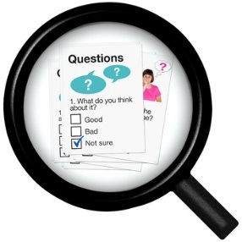 | We want to ask you some questions…
 | …about a time when you felt sad or unhappy.
 | We want to know what help you got.
 | Thank you for helping us!

(Please tick as many boxes as you want) |  | Question 1  Have you ever felt any of these things for a month or longer?
 |  | Sad
 |  | Unhappy
 |  | Angry
 |  | Scared
 |  | Confused
 |  | Lonely

 | 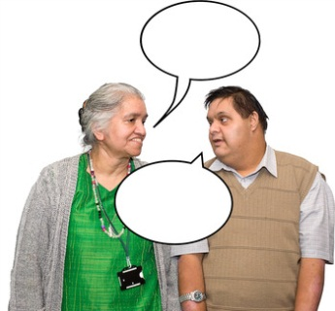 | Question 2  Did you tell anyone how you felt?
 |  | Yes
 |  | No

(Please tick as many boxes as you want) | 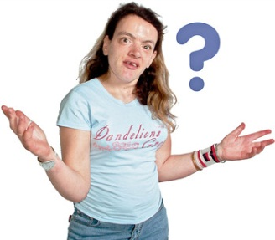 | Question 3  Who did you tell?
 |  | A Doctor/nurse
 |  | A Care manager/social worker
 | 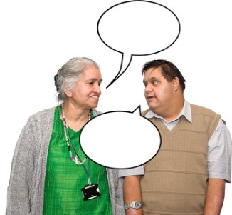 | A friend or family member
 |  | Someone at school
 | ? | Someone else – can you tell us who?

Question 4
Did they help you?
Yes
No

(Please tick as many boxes as you want) | ? | Question 5  What help did you get?
 |  | I talked to a counsellor (someone who talks to you about how you feel)
 |  | I met other people like me
 |  | They gave me tablets or medicine
 | 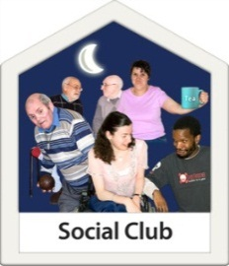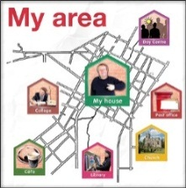 | They told you about activities or clubs where you live
 |  | They found some people who could help me
 |  | Something else? What did they do?

Question 6
Did you have to wait to get help from them?
 | 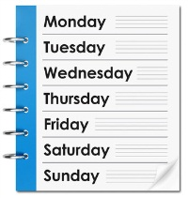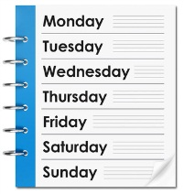 | Yes I had to wait 1 or 2 weeks
 |  | Yes I had to wait one or 2 months
 |  | Yes I had to wait more than 3 months
 |  | Yes I had to wait more than 6 months
 |  | No I got the help very soon

Question 7
Did it help you feel better?
Yes
No

A bit

Question 8
What other help would you have liked to have?
Counselling (talking to someone about how you feel)
Tablets or medicine
A buddy or volunteer to support you for a while
Something else? What else would you have liked?

……………………

……………………

Question 9
We are writing some ideas to help people feel happier and get better support

What information would help you when you feel sad or unhappy?

For example, hearing other people’s stories, or knowing more about where you can go for help?

Please write any ideas in the box below.
……………………………

……………………………

……………………………

……………………………

……………………………..

………..……………………

Question 10
Is there anything else we should know?

Please write it in the box below.
………………………………

………………………………

………………………………

………………………………

………………………………

………………………………

………………………………

………………………………

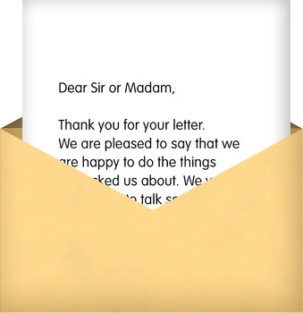 | Please send this to:  Christine Burke  Foundation for People with Learning Disabilities  Colechurch House  1st Floor  1 London Bridge Walk  London  SE1 2SX  For more information phone  020 7803 1142
Or email it to:
cburke@fpld.org.uk

We need the surveys by
Friday 24th May 2013

