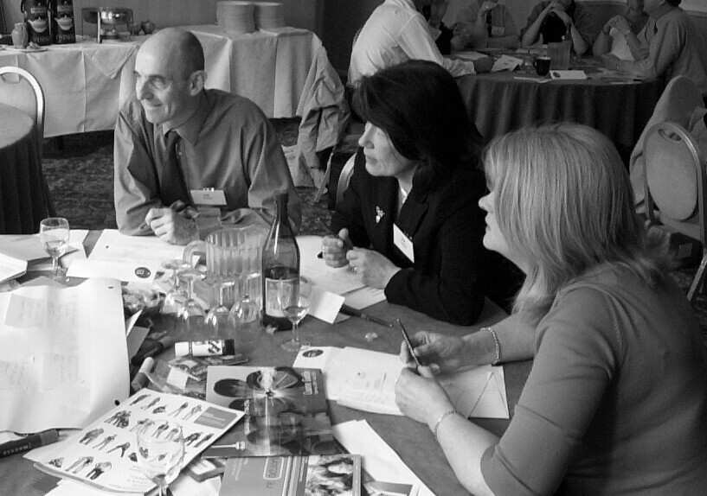
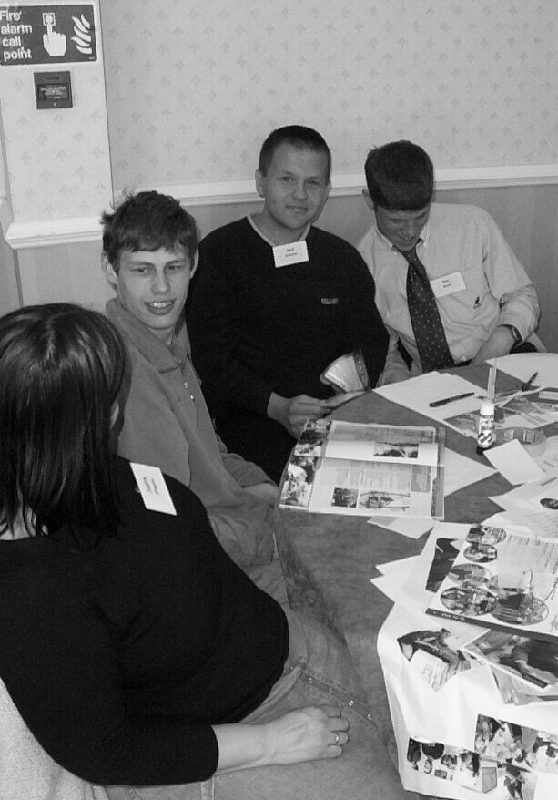

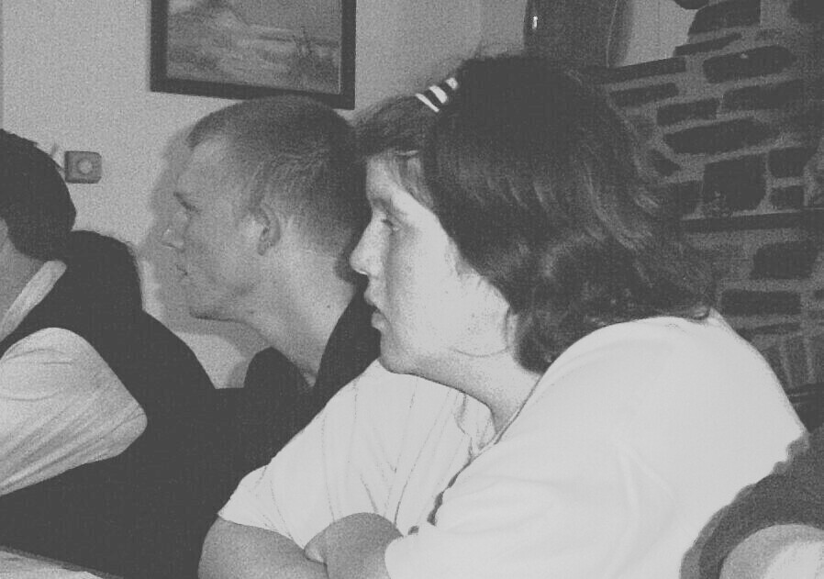

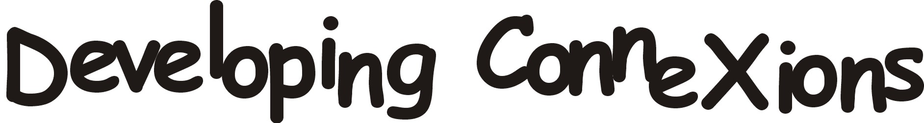

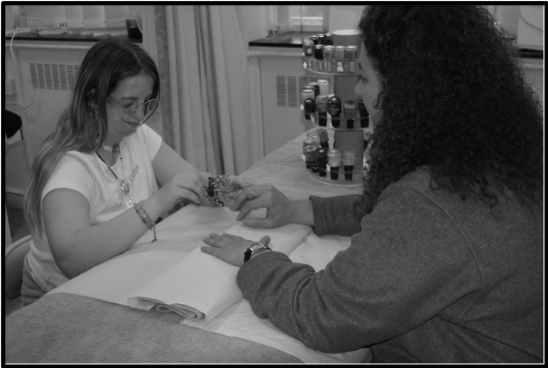
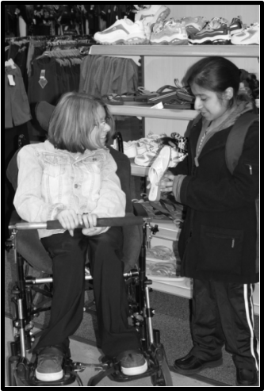

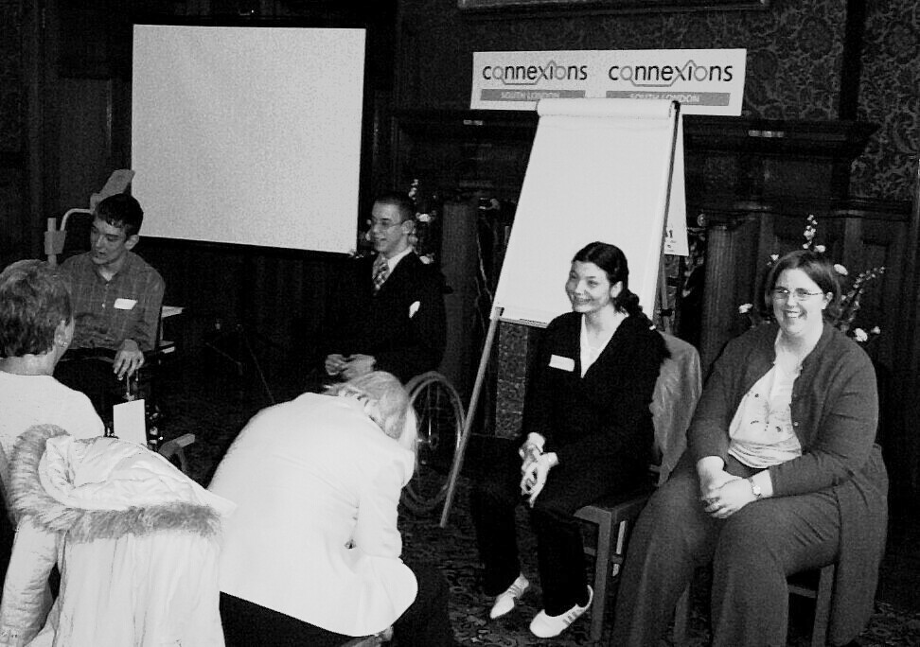

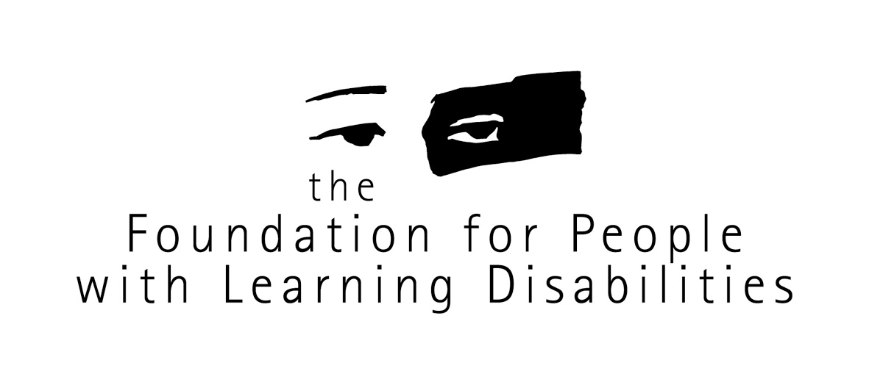
Funded by
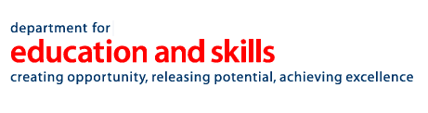

Young people with disabilities, mental health needs or autistic spectrum disorders

Nic Rowland-Crosby
Alison Giraud-Saunders
Paul Swift

May 2004

A two and half year project evaluating the support offered by the new Connexions Service to young people with learning difficulties, physical impairments, to young deaf people, those with visual impairments, young people experiencing mental health problems or those with autistic spectrum disorders.

For further information about this project, newsletters, web based materials and past interim reports please contact fpld@fpld.org.uk or telephone 020 7802 0345
For further information about the work of the Foundation for People with Learning Disabilities please visit our website
www.learningdisabilities.org.uk
email: fpld@fpld.org.uk
or telephone 020 7802 0300
Contents

Each Chapter starts with an easier to read summary of the key points

- Chapter 1 - The Project (Page 7 of 25)
- The Final Report 9
- The Connexions Service 10
- Description of the Project 14
- Making the project work 16
- Recruiting Young People 18
- Involving and consulting with young people 23
- Consulting with Connexions Services, Personal Advisers and partner agencies 25

Chapter 2 - The Evidence (Page 1 of 52)
- Young people, parents and carers 2
  - What young people said 3
  - The experience of growing up and leaving school 3
    - Thinking about the future: aspirations and dreams
    - Thinking about the future: concerns and fears
    - Work experience
    - Transport
    - Opportunities and choice
    - Qualifications
    - Disclosure
    - Information
  - What young people know about Connexions and Personal Advisers 12
  - What makes good help and support 14
  - How Connexions could do a better job for young people 17
  - Conclusion 18
  - What parents and carers said 19
  - Feelings about children growing up and leaving school 19
  - Transport 20
  - Work experience 21
  - Opportunities and choice 23
  - What parents and carers know about Connexions and Personal Advisers 24
  - What makes good help and support 26
  - How Connexions could do a better job for young people 27
  - Conclusions 28
- The Connexions Service and Personal Advisers 29
  - The view of Connexions Services providers 30
  - Linking with other agencies 30
  - Important Characteristics 32
  - The role of Connexions 33
  - Outcomes 34
  - Talking to Personal Advisers 37
  - Background Information 37
  - Working practices 40
  - Outcomes 45
  - Training 46
  - Conclusions 47
- What partners said about the new Connexions Service and the work of Personal Advisers 48
  - Colleges 49
  - CAMHS / Mental Health professionals 50
- The Evidence Conclusion 51

Chapter 3 - The Learning (Page 1 of 37)
- The Role of the Personal Adviser 7
- Involving young people 10
  - Communication 10
  - Accessible Information 11
  - Consultation 12
- Information 16
  - Collecting Information 16
    - The Connexions Service and the Local Education Authority
    - Connexions and the local Learning and Skills Council
  - Storage of Information 19
  - Strategic use of information by Connexions Services and partner agencies 21
- Working with partners 23
  - Expectation versus Reality 23
  - The Connexions Service 26
  - Duplication –Working together to cut individuals
Workloads 28
  - Other services need to do their job as well 29
  - Work experience and linking with college 30
  - Opportunities and choice 31
  - Transport 35
  - Moving on after college 36
- The Learning Conclusion 37

Chapter 4 - The Future (Page 1 of 9)
- Independence 3
- The Personal Adviser 5
- Involving young disabled people and their families/carers 6
- Conclusion 7

References (Page 1 of 7)

Appendices (Page 3 of 7)

Glossary
ASD Autistic Spectrum Disorder
AUT Autism
ASP Aspergers Syndrome
CAMHS Child and Adolescent Mental Health Services
DDA Disability Discrimination Act
DRC Disability Rights Commission
DfEE Department of Education and Employment
DfES Department for Education and Skills
DoH Department of Health
DWP Department for Work and Pensions
CSNU Connexions Service National Unit
LDD Learning Difficulties and/or Disabilities
LSC Learning and Skills Council
PA Personal Adviser
RNIB Royal National Institute of the Blind
RNID Royal National Institute for Deaf people
SEN Special Educational Needs

