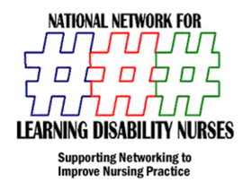
ANNUAL Continuing Practice Development Day
& NNLDN AGM
University of Hertfordshire July 2nd 2012
COSTS
£100.00 per delegate
£50.00 per student
Exhibition Stands
£500 Private & Corporate
£250 Charity
Inserts for Delegate packs
£50
Event Sponsorship Available
Seminar Section £100 (includes Slide on stage Sponsored By & logo on Sponsor Page of Delegate Pack)
Exhibition £250 0r £500(includes 1 Delegate entry)
Main Sponsor (Includes Five Delegate Entry) Logo on main Stage/Pull Up on Stage/ Free Exhibition/Delegate Pack Entry
£2,000

Please contact Mark Gray on 07970369827
Please book using booking form attached and send to mark@markgrayassociates.co.uk

There are 100 Students & 100 Qualified Nurses attending this Event

