No Going Back:
Psychodynamic perspectives on community living for people with learning disabilities.

4th October 2013 9.30-4
The Fielder Centre, Hatfield Business Park,
Hatfield Avenue, Hatfield, Herts AL10 9TP
www.conferencehertfordshire.co.uk

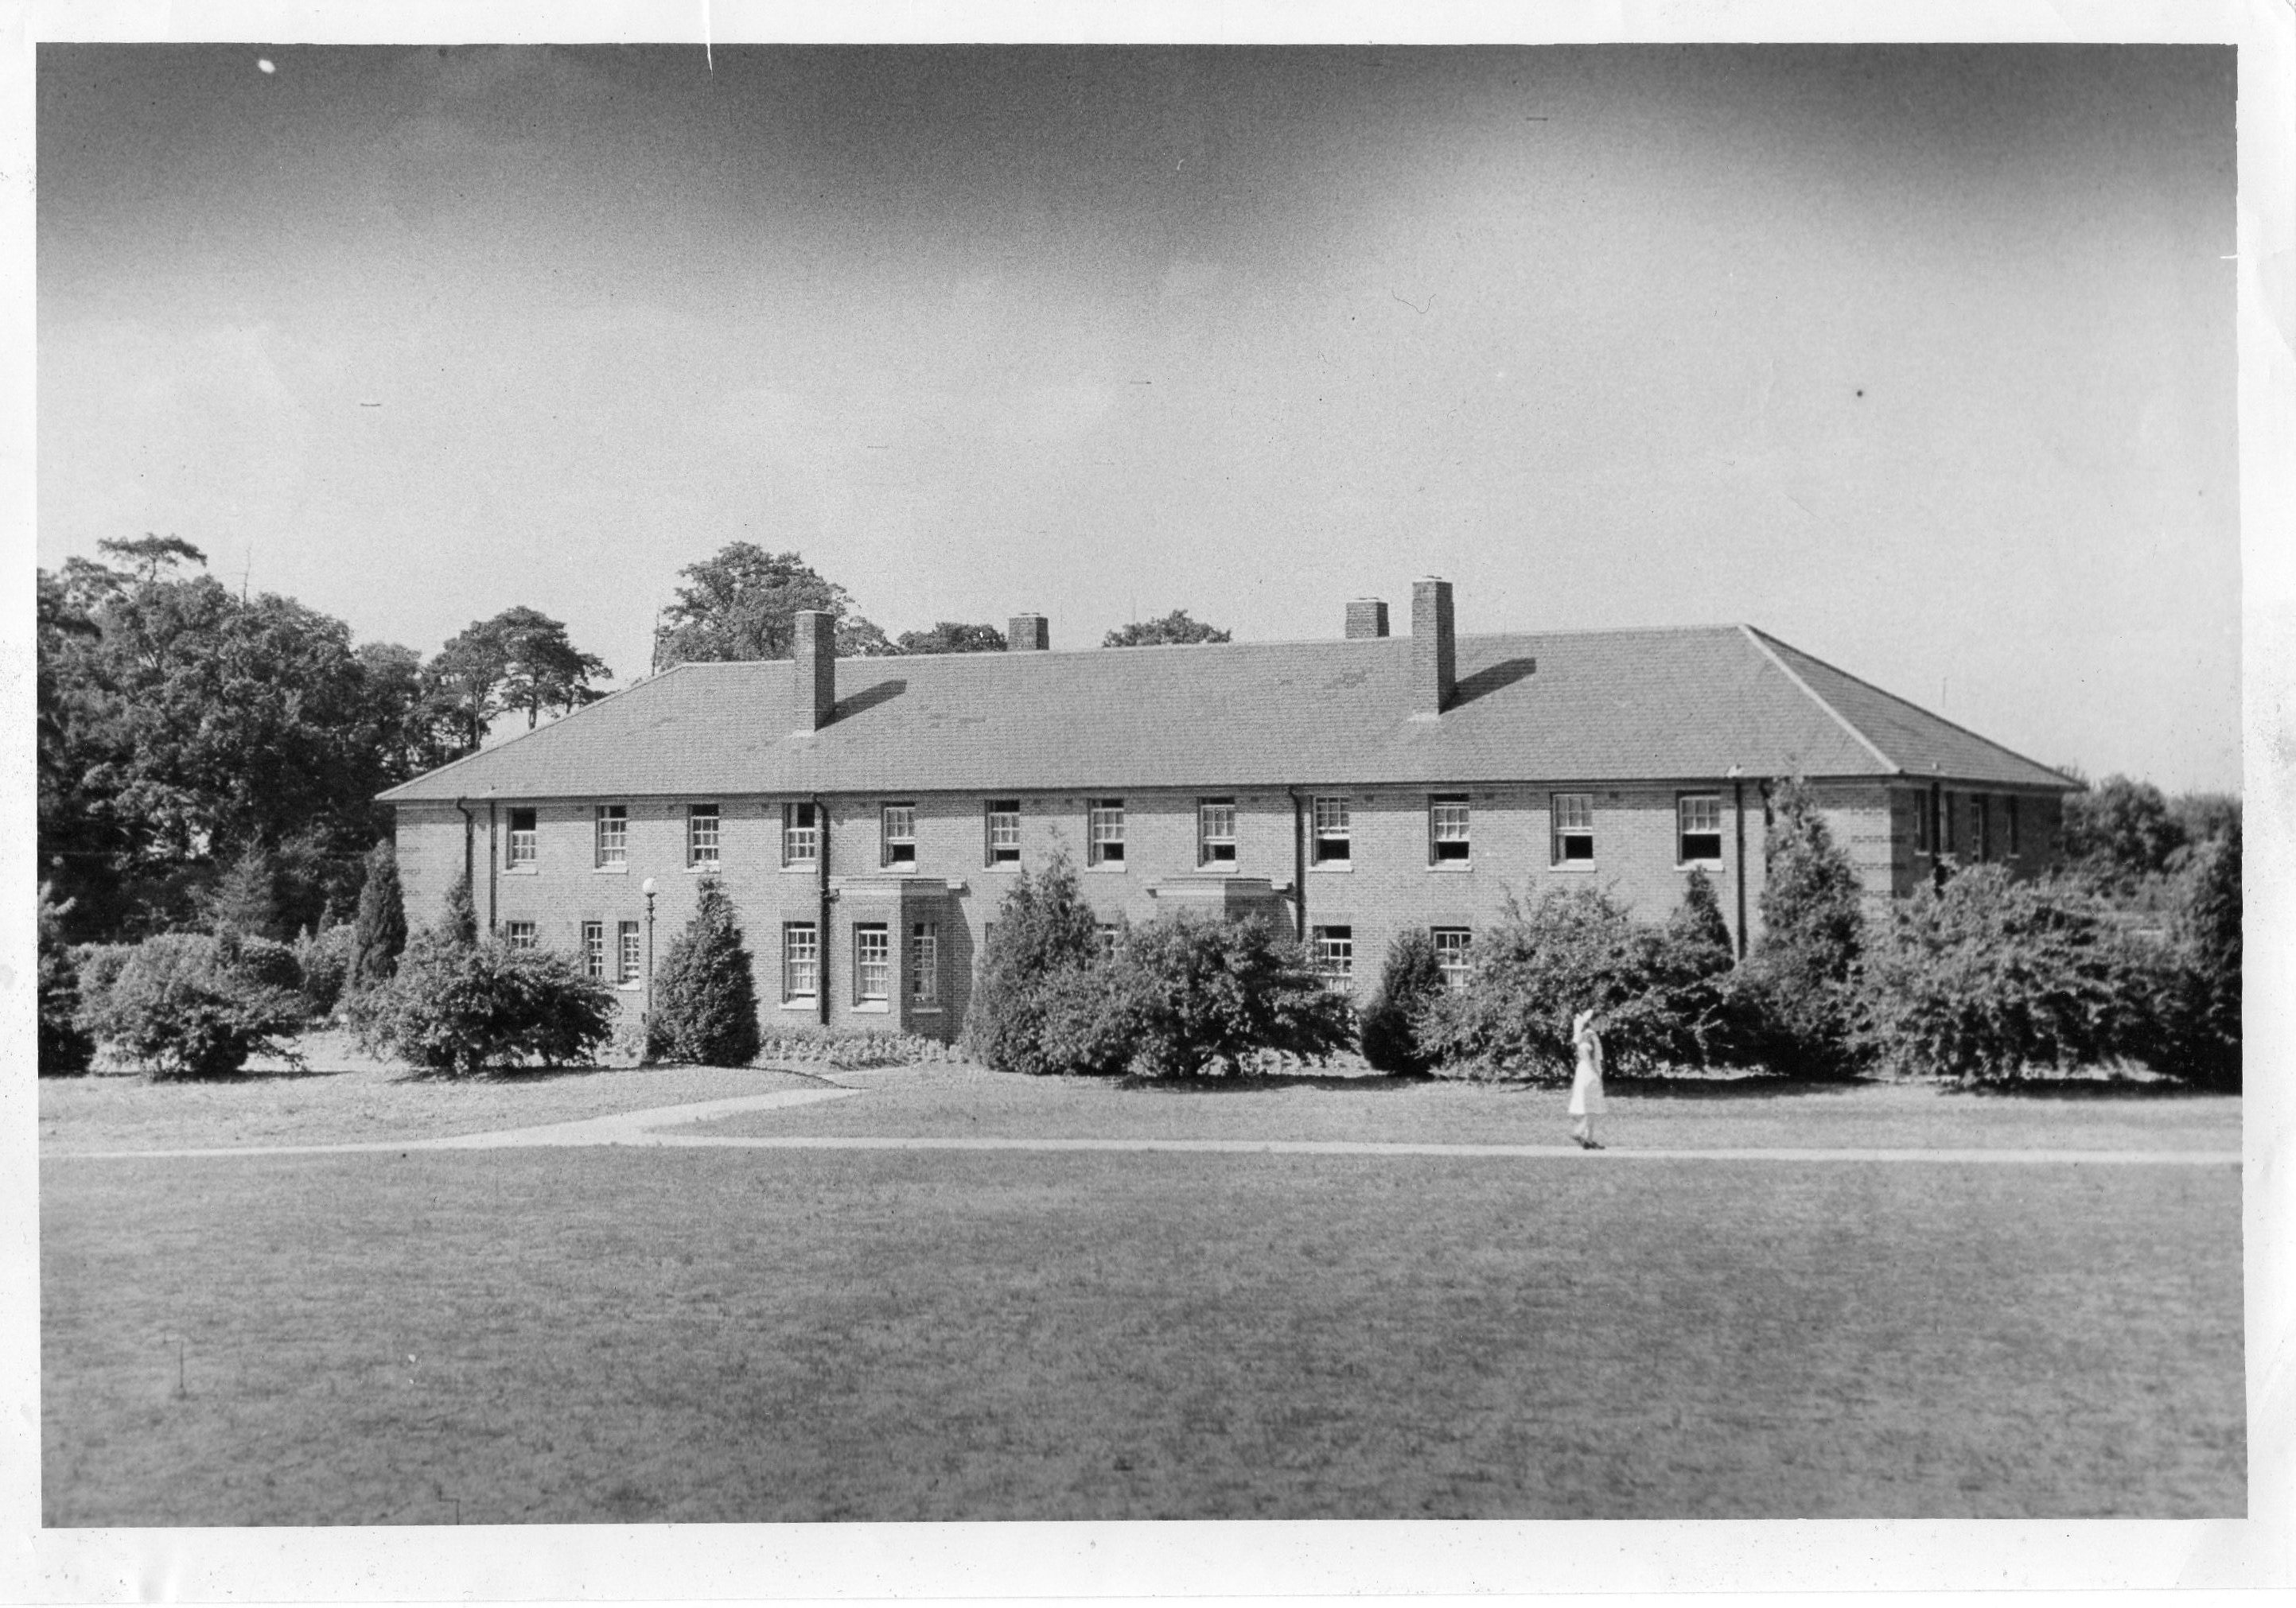
Photograph of Cell Barnes Hospital Circa 1950 - TBC
Joint Conference: APP
HPFT
University of Hertfordshire


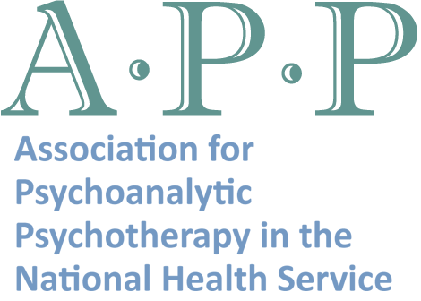
OUTLINE OF THE DAY

9.00-9.30 Registration and Coffee

9.30 - 9.45 Welcome and Introduction
Chair: Tom Cahill, Chief executive HPFT

9.45 - 10.30 No Going Back
Professor Jan Warmsley, Open University

10.30 - 11.00 “I like it where I live. Well most of the time. “
David O Driscoll, HPFT in conversation with Service User Carole Lee CBE

11.00 - 11.30 Break

11.30 – 12.15 Response from former BMA President, Home Sweet Home
Professor The Baroness Sheila Hollins

12.15 - 13.00 Workshops

- Introduction to psychodynamic model
  - David O’Driscoll

- Experiences of Learning Psychotherapy
    - Dr Georgina Parkes, Dr Rehana Akther, Dr Adeel Khan & Dr Sonika Bhasin, & Dr Toby O’Hanlon

- Using Books Beyond Words in Therapy
- Professor The Baroness Sheila Hollins & Dr Sophie Shardlow

13.00 - 14.00 Lunch

14.00 – 14.45 A Therapeutic Community in a High secure environment
Dr John Taylor, Rampton High Secure Hospital

14.45 – 15.00 Break

15.00 - 15.45 Adaptations to traditional psychoanalytical techniques
- Professor Nigel Beail

15.45 – 16.15 Summary, discussion and feedback - Dr Georgina Parkes

16.15 - End
Please note that the programme is subject to change

No Going Back:
Psychodynamic perspectives on community living

“The new beautiful community homes provide an even more disconcerting backdrop for communications of despair.”
Valerie Sinason

Today there is a developing interest in the use of psychodynamic psychotherapy with people with learning disabilities and the recognition that an understanding of some of its key concepts will bring greater understanding of a person’s behaviour. This conference has been organised jointly between Hertfordshire Partnership NHS Foundation Trust and the Association for Psychoanalytic Psychotherapy in the National Health Service (APP) with the support of the University of Hertfordshire. Research has shown that for the majority of service users the change from long term institutional care to community care has been positive. But, it would be wrong to say that this has not been without its challenges and problems. In this conference we want to think about some of these challenges and problems in particularly the service user internal experience of community life and the staff relationship. The main perspective of the day will be psychodynamic, but we will be hearing about other points of view including from a service user.

Organisers
Dr Georgina Parkes
Consultant Psychiatrist Learning Disability and Joint Medical Lead HPFT
Chair of Institute of Psychotherapy and Disability.
Learning Disability section and co opted council member of APP

Mr David O’Driscoll
Honorary Visiting Research Fellow University of Herts,
UKCP registered psychotherapist
Loss and Bereavement Service SLDS HPFT.
Learning Disability section and co opted council member of APP.

Booking Form

Full name: …………………………………………………..

Organisation: ………………………………………………..

Address: ………………………………………………………. Telephone: …………….

…………………………………………………………………….

Email Address: ……………………………………………..

 | YES | FEE
APP Member | □ | £85
HPFT staff | □ | £85
Other |  | £95

Limited number of free places for people with learning disabilities and carers

Sign up on the day for workshops

Special Dietary requirements: ……………………………………………………………………

Please print/detach form and send with cheque (payable to HPFT) to:-

Carolyn Johnson
Medical Secretary to Dr G. Parkes
Specialist Learning Disability Services
Yew Tree Lodge
2a Baldock Street
Ware SG12 9DZ
Email: carolyn.johnson@hpft.nhs.uk

