WHAT DOES CHEMOTHERAPY DO?

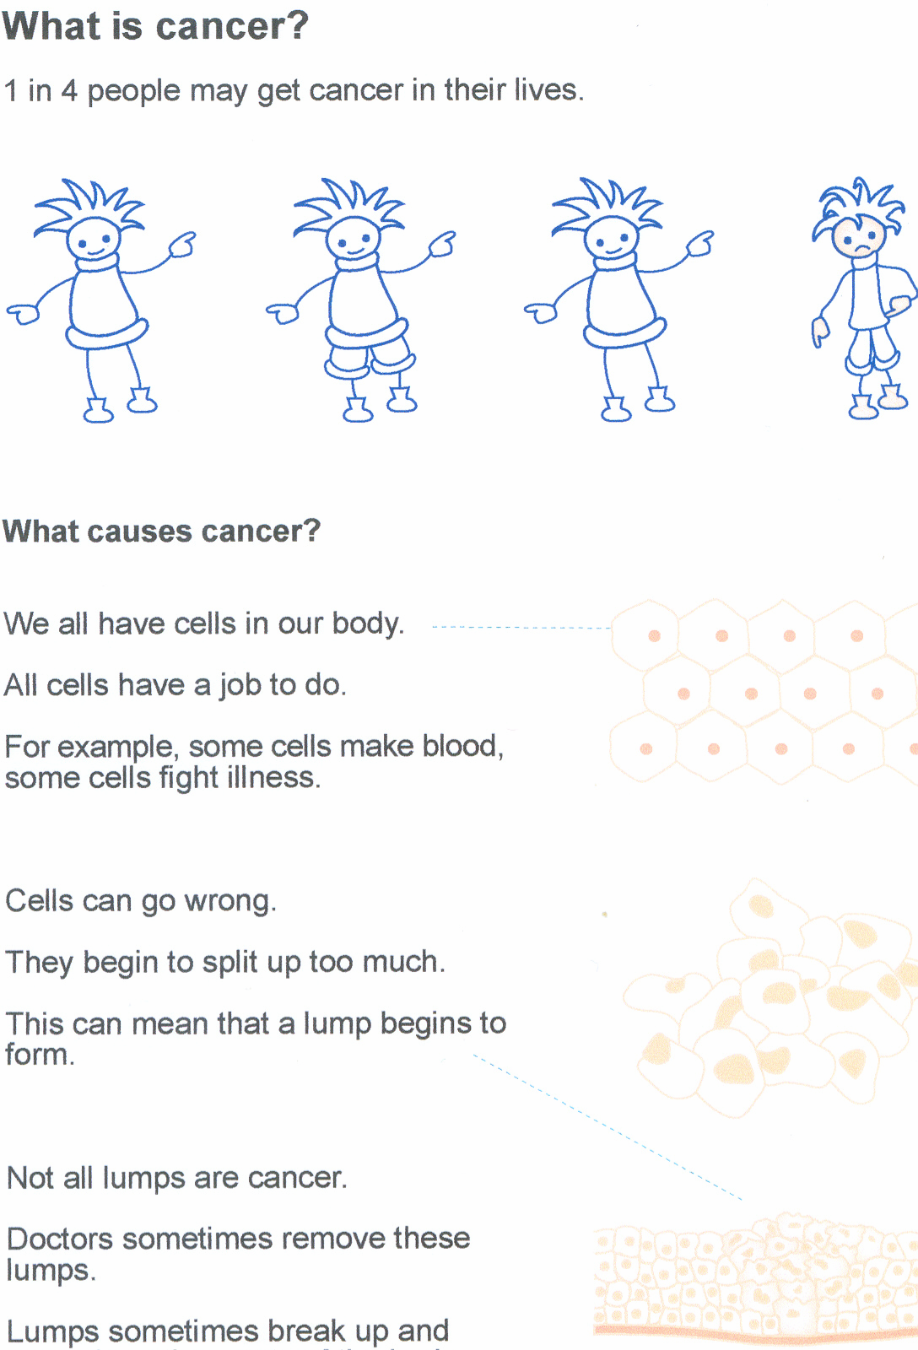

Having Chemotherapy will kill off any cancer cells that are left

WHERE YOU WILL HAVE YOUR TREATMENT

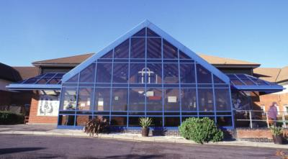

You will be going to the William Harvey Hospital to have your Chemotherapy treatment.
Staff will stay with you.
You will go home the same day.

WHERE YOU WILL HAVE YOUR TREATMENT

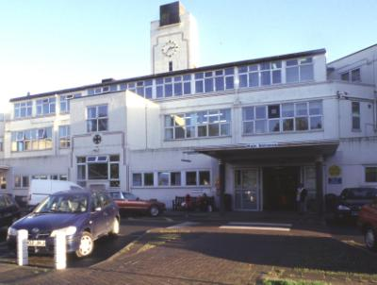

You will be going to the Kent and Canterbury Hospital to have your Chemotherapy treatment.
Staff will stay with you.
You will go home the same day.

HOW OFTEN YOU WILL HAVE YOUR TREATMENT
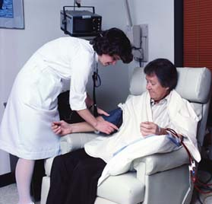

You will have 1 treatment at a time.
It will be given to you in the morning.
You will wait for 3 weeks between each treatment.
You will have 6 treatments in full.

THE PROCEDURE
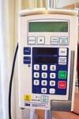
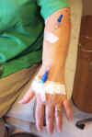
You will have a special needle put in your hand or it may be your arm.
A machine will slowly inject your medicine into your arm through the needle.


It will take 3 or 4 hours to
give but you will be sat in a
very comfortable chair and Staff will stay with you all time.

SIDE EFFECTS

After your treatment you may feel

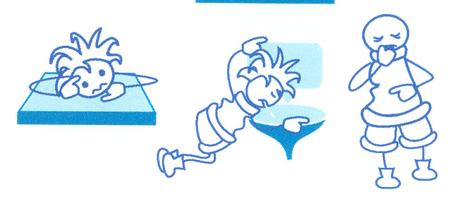
- Tired
- Sick
- Upset

You may have
- Diarrhoea

- Vomiting

- A sore mouth or mouth ulcers
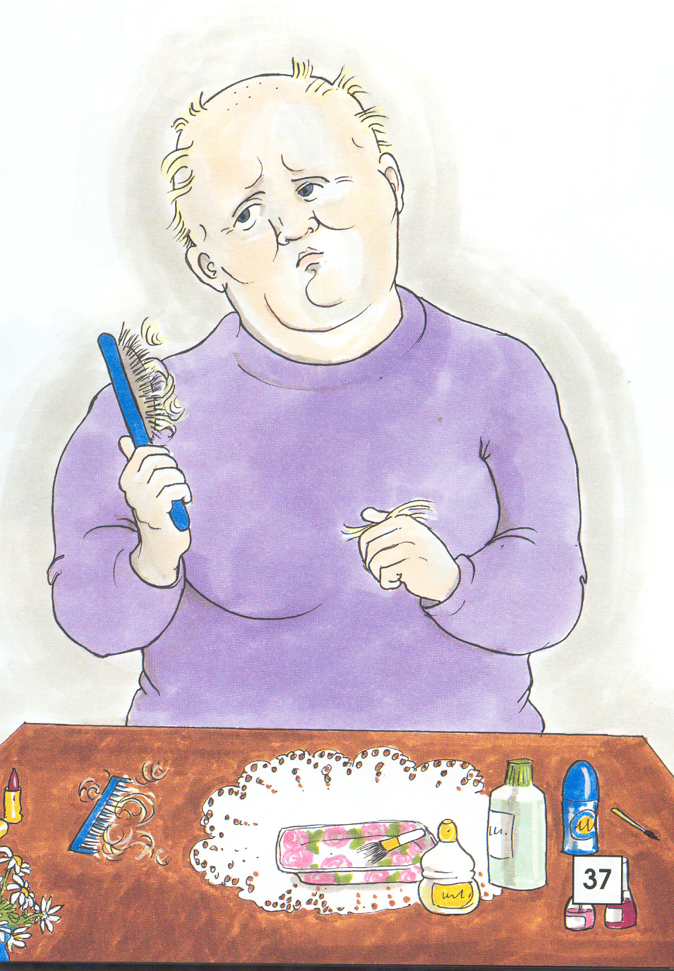
- You may lose some or all of your hair

PEOPLE TO SUPPORT YOU

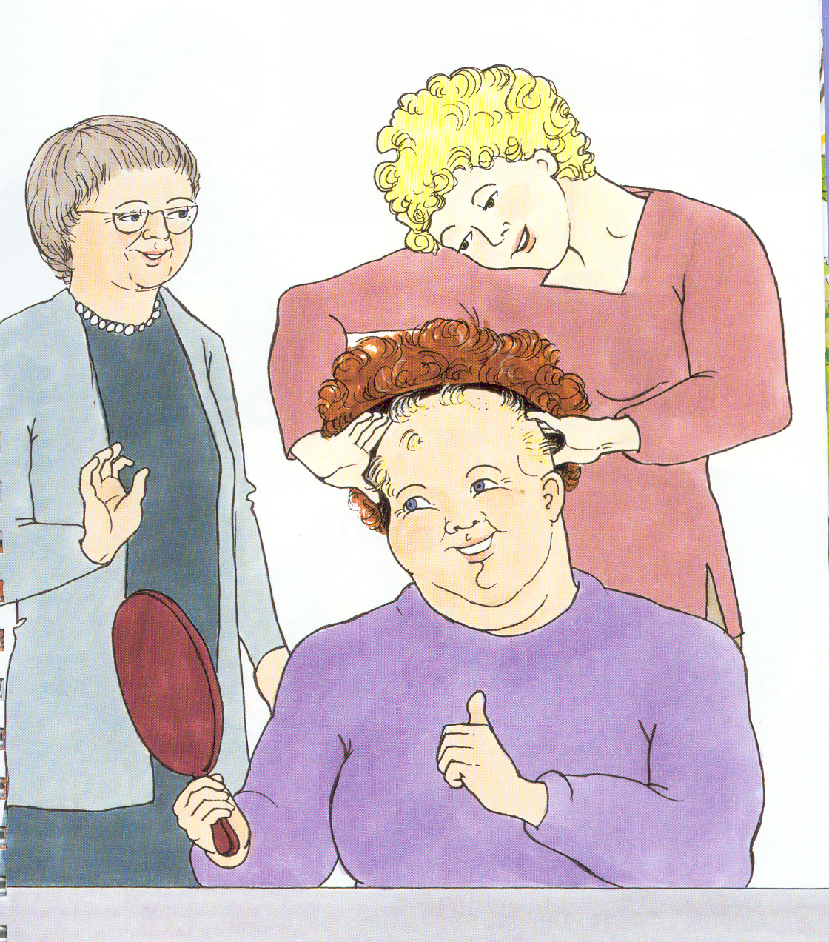

If you are feeling poorly you can talk to staff. They will help you and support you to feel better about yourself.

