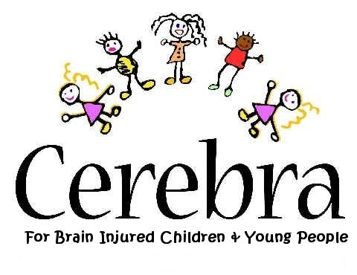Enrolment Form

Please send completed enrolment form + fee
(cheque payable to CEREBRA prior to event)

to Gaynor Ellis, CEREBRA Research Dept.,
FREEPOST SWC 3360,
Carmarthen SA31 1ZY
or email to gaynore@cerebra.org.uk

Telephone: 01267 244226

Cheque (£100 per person) payable to: CEREBRA

Number of delegates: x £100

Total payable:

Free Places

CONFERENCE

“Complementary and Alternative Medicine for Children with Neurological Deficits”

Thursday, 2nd October 2008 at

The Grand Hotel, Sea Front, TORQUAY, TQ2 6NT

Name(s):

Address:

Tel.

Email contact:
What is your professional interest in this conference?

CEREBRA looks forward to meeting you.

