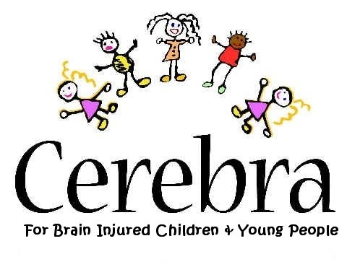

PUBLIC LECTURE ON BEHAVIOUR MANAGEMENT
“MINIMISING EXPLOSIONS – helping parents/professionals reduce conflict in everyday situations”

THE DEPOT ROOM, GRAND THEATRE,

SINGLETON STREET, SWANSEA, SA1 3QJ
Thursday 6th December, 2007, from 7 – 8:30 pm

FREE ADMISSION
Cerebra – a charity for children and young people with brain-related, neurological conditions – is looking to bring together professionals, parents and members of the public who have an interest in behavioural issues, not only to enable them to improve their knowledge, but also, to offer them the opportunity to make contacts and to network in an ideal environment.
This will be an informative evening from an experienced professional in the field of behaviour management, in relation to neurological conditions.

SPEAKER
Mr Nigel Mason, Primary Mental Health Worker, Swansea C.A.M.H.S
Swansea Child and Family Clinic

The evening will conclude with a question and answer session
Tea/Coffee and light refreshments will be served.

PLEASE REGISTER YOUR INTEREST (for catering and security purposes) BY CONTACTING:
Gaynor Ellis, 01267 244226, email; gaynore@cerebra.org.uk

