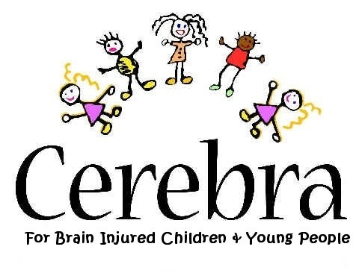

PUBLIC LECTURE
‘A.D.H.D. - What is it - and what can we usefully do?’

THE DEPOT ROOM, GRAND THEATRE,

SINGLETON STREET, SWANSEA, SA1 3QJ
Tuesday 27th November 2007, from 7 – 8:30 pm

FREE ADMISSION
Cerebra – a charity for children and young people with brain-related, neurological conditions – is looking to bring together professionals, parents and members of the public who have an interest in A.D.H.D., not only to enable them to improve their knowledge, but also, to offer them the opportunity to make contacts and to network in an ideal environment.
This will be an informative evening from two knowledgeable professionals in the field of A.D.H.D.

SPEAKERS
Dr Neil Rutterford, Chartered Psychologist and Head of Centre for Counselling and Psychology, Swansea Institute of Higher Education.
and
Dr Anne West, Child and Adolescent Psychiatrist, Pembrokeshire and Derwen NHS trust

The evening will conclude with a question and answer session
Tea/Coffee and light refreshments will be served.

PLEASE REGISTER YOUR INTEREST (for catering and security purposes) BY CONTACTING:
Gaynor Ellis, 01267 244226, email; gaynore@cerebra.org.uk

