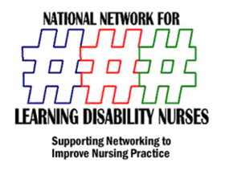
ANNUAL Continuing Practice Development Day
& NNLDN AGM
University of Hertfordshire July 2nd 2012

Programme
9.00 Welcome from Chair of NNLDN
9.20 Welcome from University of Hertfordshire Centre for Learning Disability Research (Professor Bob Gates)
9.35 NNLDN Fiona Law Student Award 2012 Helen Laverty University of Nottingham (nominations & presentation)
9.55 2011 Finalists Anthony Green/Sean leadington/Tracey March Learning Disability Nurse.com project
10.15 Modernising Learning Disability Nursing UK Report –Hazel Powell Scottish Nursing Office
10.45 Break & exhibitions
11.15 Outcome measures for Learning disability Nursing – Dr Ben Thomas Department of Health
11.30 Outcome measures workshop (group sessions)
12.30 Feedback from Group Sessions
12.45 Lunch & exhibitions
1.45 The Launch of the Positive Choices Preceptorship Charter Helen Laverty University of Nottingham.
2.00 Mencap Health Projects & Six Lives & counting – Bev Dawkins MBE
2.30 Lessons from Winterbourne Implications for LD nursing – Debra Moore Director of Nursing Castlebeck
3.00 break & Exhibitions
3.30 NNLDN AGM & Election of Board for 2012/2013
3.45 Announcement of next years CPD date & AGM

