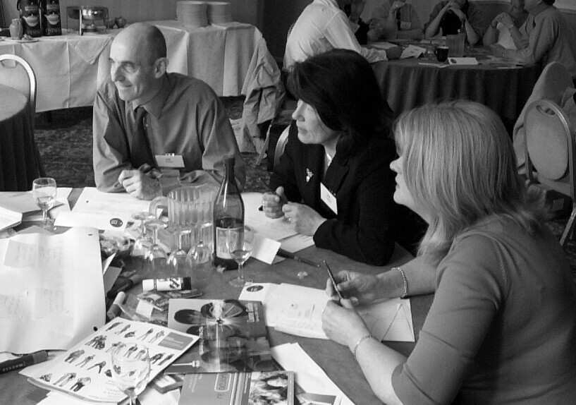
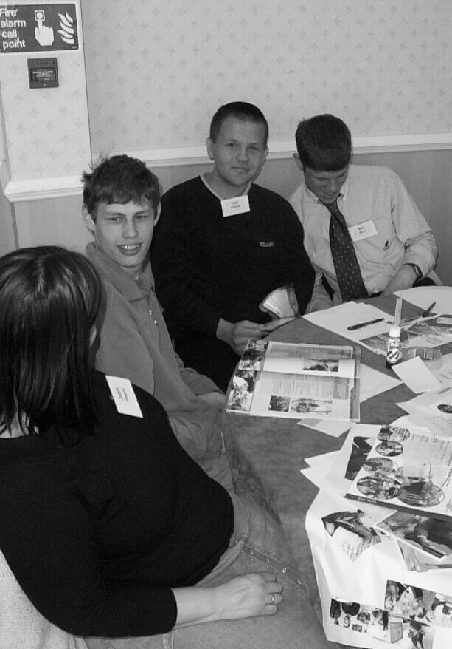

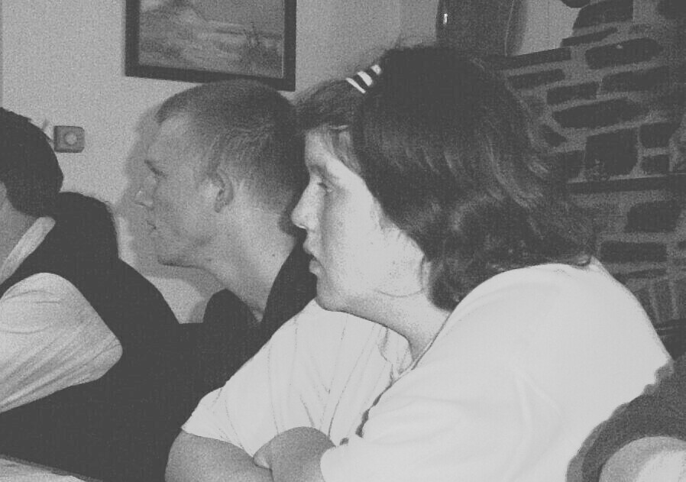

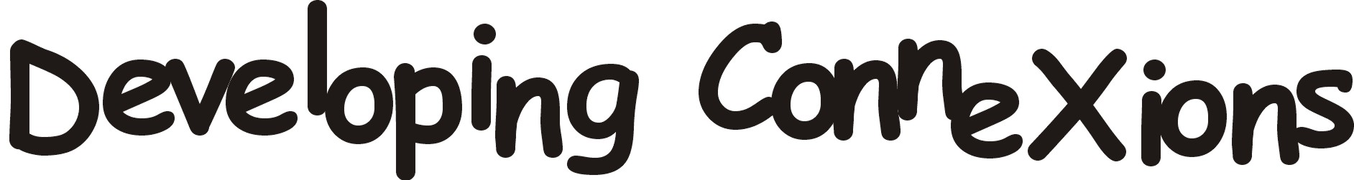

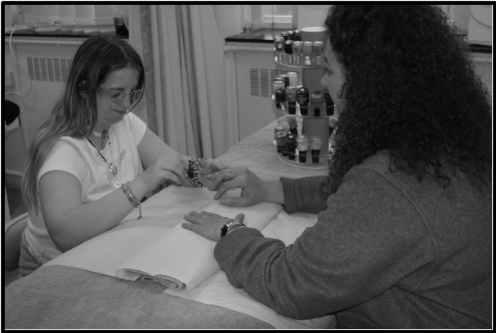
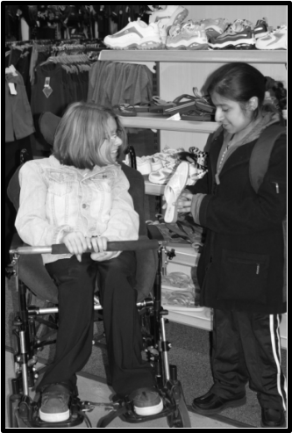

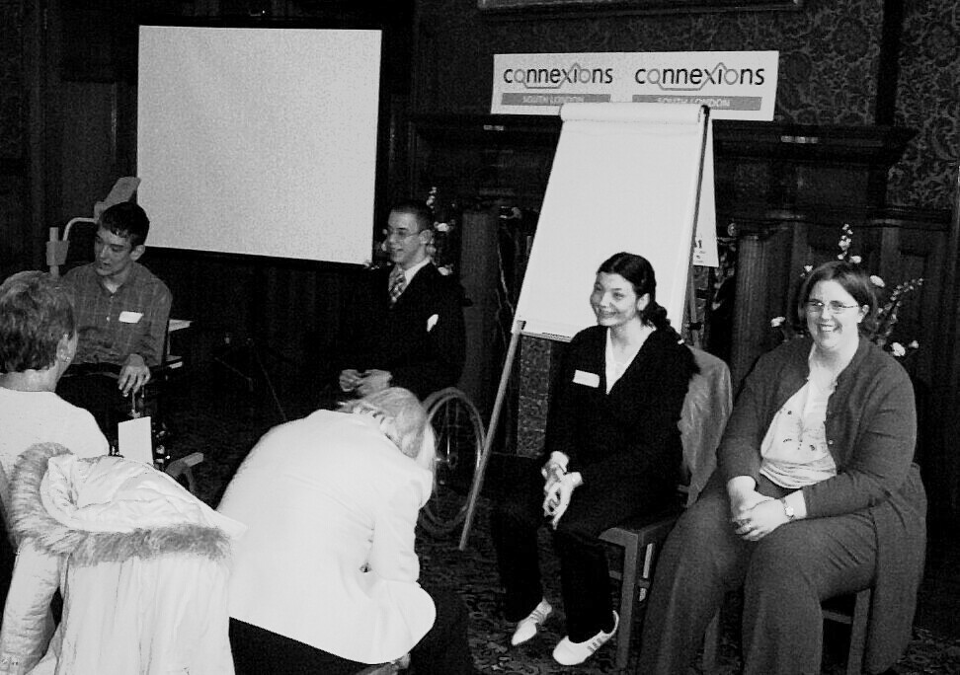

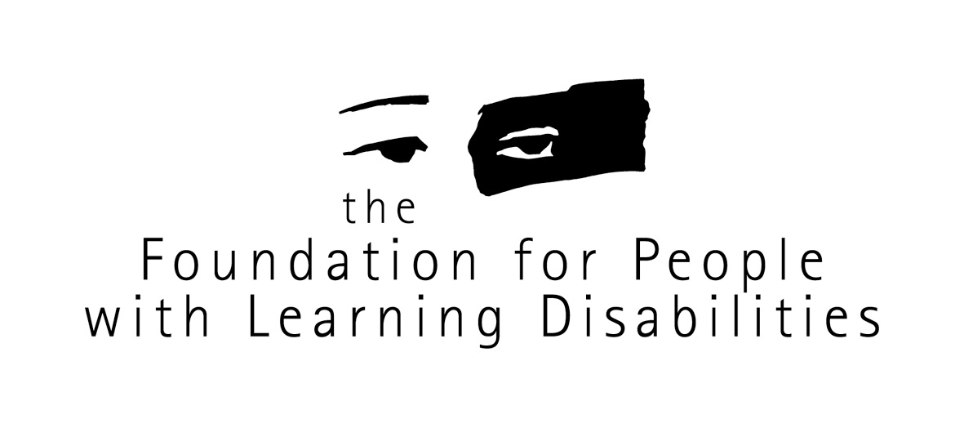
Funded by
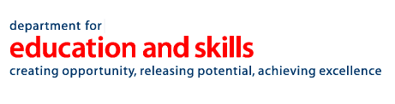

Young people with disabilities, mental health needs or autistic spectrum disorders

Nic Rowland-Crosby
Alison Giraud-Saunders
Paul Swift

July 2004

A two and a half year project evaluating the support offered by the new Connexions Service to young people with learning difficulties, young people with physical impairments, young deaf people, those with visual impairments, young people experiencing mental health problems or those with autistic spectrum disorders.

For further information about this project, newsletters, web based materials and past interim reports please contact fpld@fpld.org.uk or telephone 020 7802 0300.
For further information about the work of the Foundation for People with Learning Disabilities, please visit our website
www.learningdisabilities.org.uk
email: fpld@fpld.org.uk
or telephone 020 7802 0300

Contents
Page

Glossary 5

Acknowledgements 6

Each Chapter starts with an easier to read summary of the key points

Chapter 1 - The Project
- Easier to Read Summary 7
- The Final Report 9
- What is the Connexions Service? 10
- Description of the Project 14
- Making the Project Work 16
- Recruiting Young People 17
- Involving and Consulting with Young People 22
- Consulting with Connexions Services, Personal Advisers and Partner Agencies 24

Chapter 2 - The Evidence
- Easier to Read Summary 1
- Young People, Parents and Carers 3
- The Connexions Service and Personal Advisers 29
- What Partners Said About the New Connexions

Service and the Work of Personal Advisers 49
- The Evidence: Conclusion 53

Chapter 3 - The Learning
- Easier to Read Summary 1
- The Delivery of a Differentiated Service 3
- The Role of the Personal Adviser 7
- Involving Young People 11
- Information 17
- Working with Partners 24
- The Learning: Conclusion 40

Chapter 4 - The Future
- Easier to Read Summary 1
- Independence 4
- The Role of the Personal Adviser 6
- Involving Young Disabled People and Their Families/Carers 8
- The Future: Conclusion 9

References 1

Appendices
- Appendix 1: Models of Delivery 3
- Appendix 2: Responsibilities for Pupils with Statements
of Special Educational Needs 4
- Appendix 3: A Tiered Approach to Service Delivery and
the Role of the Personal Adviser 5
- Appendix 4: The Connexions Service National Unit 8
- Appendix 5: Assessment, Planning, Information and

Review Framework 9

Glossary

APIR Assessment, planning, information and review framework
ASD Autistic spectrum disorder
CAMHS Child and adolescent mental health services
CSNU * Connexions Service National Unit
DDA Disability Discrimination Act
DfEE Department for Education and Employment
DfES Department for Education and Skills
DH Department of Health
DRC Disability Rights Commission
DWP Department of Work and Pensions
LA Local authority
LDD Learning difficulties and/or disabilities
LEA Local education authority
LSA Learning support assistant
LSC Learning and Skills Council
NEET Not engaged in education or training
NVQ National Vocational Qualifications
PA Personal Adviser
PCP Person centred planning
RNIB Royal National Institute for the Blind
RNID Royal National Institute for Deaf People
SEN Special Educational Needs
SENCO Special Educational Needs Co-ordinator
SSAFA Soldiers, Sailors, Airmen and Families Association

* Throughout the report ‘Connexions Service National Unit’ (CSNU) has been used when referring to the central government body responsible for supporting local Connexions Partnerships. Recently the unit merged with other departments within the Department for Education and Skills. The new unit responsible for supporting Connexions Partnerships is called the ‘Supporting Children and Young People Group’ (SCYPG).

Acknowledgements:

Most importantly of all, thank you to all the young people who participated in this project. There are too many of you to mention. Your input has been fantastic.

To all the hardworking Connexions people who have supported the project, organised meetings, sent out agendas, and identified people to take part, especially: Claire Bradley, Julia Copping, Debbie Farthing, Elizabeth Filmer, Deborah Huggons, Sue Hughes, Gary Longden, Joanne Parker, Martin Patrick, Amanda Payne, Jane Riley, Rosemary Robbins, Jackie Sanders, Lee Tether and Elaine Thomas.

Thank you to the Department for Education and Skills, the Connexions Service National Unit and the national Learning and Skills Council for funding this project. Thank you to all the people who attended or participated in the national Steering Group and the local Steering Groups.

A special thanks to Pat Donlan for his support in the early stages and a valuable critical eye throughout the project.

With special memories of Jenny, a committed and person centred Personal Adviser who listened to young disabled people and made them feel very important.

Symbols, pictures and photographs have been used throughout this report. All permissions for use of photographs were given by those appearing in them. Acknowledgements to CHANGE Picture Bank, People First Picture Bank, Somerset Total Communication and WIDGIT Symbols.
Chapter 1 - The Project

Easier to Read Summary
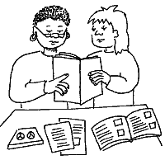

An evaluation of the Connexions Service and the support that it offers to young disabled people

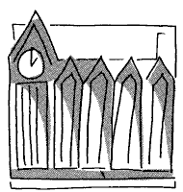

The Department for Education and Skills funded this project, with extra money coming from Connexions Service National Unit and the national Learning and Skills Council.

The project started in February 2002 and ended in July 2004.
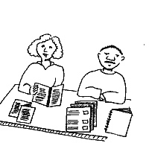
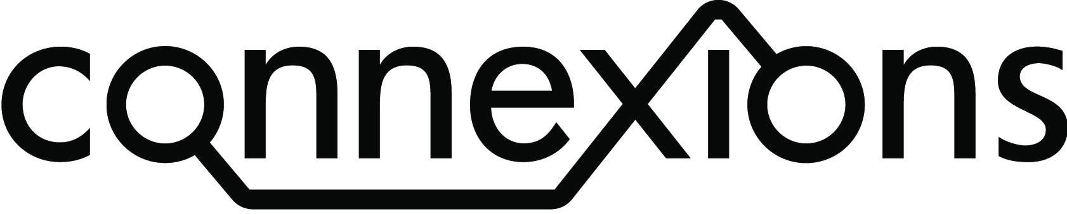

The project set out to find out about the new Connexions Service and the support they offered to young disabled people.


Nottingham
South London
Black Country
Cornwall and Devon
Humberside

The project covered five Connexions Services across the country. Each area had a group of people who listened to what the project found out.

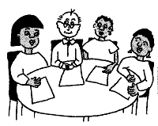
There was a national steering group with people from the Department for Education and Skills, the Valuing People Support Team, the Connexions Service National Unit, the Learning and Skills Council and people from different voluntary organisations.

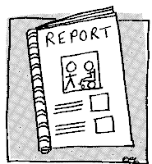

The project produced three early reports. The final report is available to download from the internet and has lots of information about supporting young disabled people to take part in consultation and in the development of children’s services in the future.

The Final Report

This report has a number of key tasks:

- To provide Connexions Services with an easy-to-use evidence base.
- To enable Connexions Services to use this information as their service undergoes further development in integrated service delivery.
- To provide partner agencies and professionals with an understanding of the key learning from this project and how a multi-agency approach (as highlighted in the Green Paper and the Children Bill) should be supporting young people.
- To provide evidence and practice guidance on involving a wide and diverse group of young people in ongoing service development and one-to-one.
This report and the accompanying web-based resources develop this evidence base and will help to enable ‘every young person to get the best start in their life’.

The report presents the learning and findings of two and a half years’ work. It has been split into four sections to ease navigation. Each section begins with an easier to read explanation of the contents of the chapter and highlights the key learning.

- The Project – An explanation of Connexions, how the project was set up and how young people were identified to take part.
- The Evidence – A detailed account of all the evidence that was gathered through the work of the project from many sources and individual learning points that accompany each piece of evidence.
- The Learning – Exploring all the evidence and learning from the previous chapter to identify clear learning points that need to be shared with all participants.
- The Future – Applying the learning to a discussion about future directions in children’s services and the role of independent advice and guidance within those developments.

What is the Connexions Service?

Summary

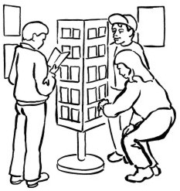
Connexions offers information, advice, guidance and opportunities to think about what you want to do in the future and in your spare time.

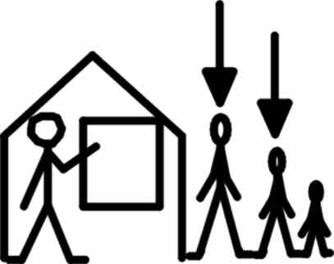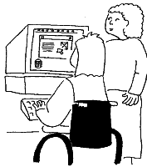
You can talk about school, going to college, getting a job, getting involved in voluntary activities and what support you need to help you do this.

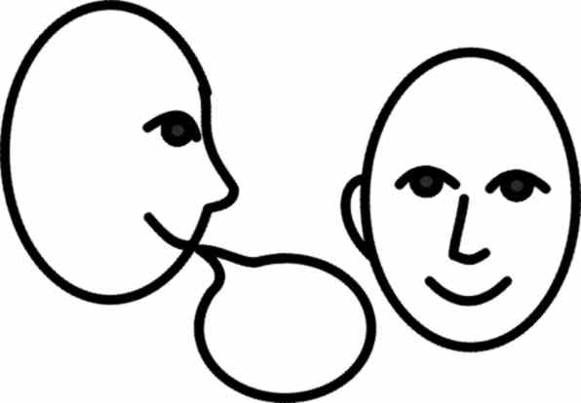

Any young person between the ages of 13 and 19 can talk to someone at Connexions. Sometimes Connexions Personal Advisers can support young people up to the age of 25.
The support is offered by Personal Advisers. Personal Advisers work in schools, youth clubs and other places where young people meet.



You can also talk to Connexions Direct by phone, text messaging, webchat and e-mail. Connexions Direct is open all year round between 8am and 2am. The service is confidential and easy to use. It offers advice on lots of things like learning, careers, housing, money, health and relationships.

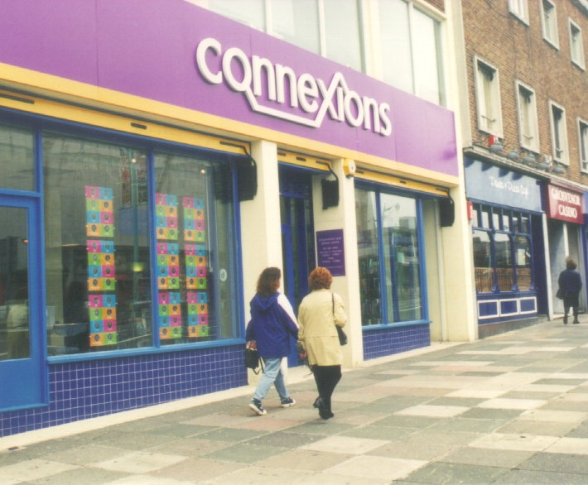
Connexions have offices – mostly near the centre of town - which are open to all young people.

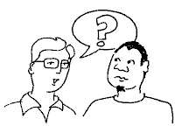
You can find out about your local Connexions by asking a teacher at school, your tutor at college or a social worker or nurse or logging onto www.connexions-direct.com

(Extract from Connexions Direct and SSAFA leaflet designed by the Foundation for People with Learning Disabilities. SSAFA, 2004)

Evident from both the reference section in this report and by visiting the national Connexions website (www.connexions.gov.uk), there is an immense amount of information about the service, methods of delivery and examples of practice. There is a detailed explanation of the Connexions Service in Appendices 1-5. In addition to the extract above from an information leaflet, here is a brief introduction to the Connexions Service.

Central to the Connexions Service is the Personal Adviser (PA). The Personal Adviser is charged with delivering advice and guidance to young people at a school, college or other setting. Their work and the work of the service is enshrined in these eight principles:

- Raising aspirations – setting high expectations of every individual;
- Meeting individual need – and overcoming barriers to learning;
- Taking account of the views of young people – individually and collectively, as the new service develops and as it is operated locally;
- Inclusion – keeping young people in mainstream education and training and preventing them from moving to the margins of their community;
- Partnership – agencies collaborating to achieve more for young people, parents and communities than agencies working in isolation;
- Community involvement and neighbourhood renewal – through involvement of community mentors and through personal advisers brokering access to local welfare, health, arts, sport and guidance networks;
- Extending opportunity and equality of opportunity – raising participation and achievement levels for all young people, influencing the availability, suitability and quality of provision and awareness of opportunities;
- Evidence based practice – ensuring that new interventions are based on rigorous research and evaluation of ‘what works’. (Department for Education and Employment, 2000).

The work of the Personal Adviser is further underpinned with six key values as outlined in the Code of Practice for Personal Advisers published by the Connexions Service National Unit (CSNU) in October 2003:

- Personal Advisers must work in the best interests of young people, placing the young people’s needs, welfare and interests before their own beliefs and values.
- Personal Advisers must work to establish and maintain the trust of young people, providing an appropriate and agreed level of confidentiality in all their dealings with young people.
- Personal Advisers must promote the rights of young people when working with other voluntary, statutory and community organisations, advocating on young people’s behalf and ensuring there is a coherent approach to support for young people.
- Personal Advisers must, wherever possible, engage parents, carers and families in supporting young people, upholding their trust in the service.
- Personal Advisers must uphold the integrity of the profession at all times.
- Personal Advisers must be responsible for reflecting on their own professional practice and for taking steps to maintain, improve and update their own knowledge and skills so they are able to continually deliver a quality service. (Department for Education and Skills, 2003).
In the first years of delivery Connexions Personal Advisers were identified as holding one of three roles. This distinction is particularly important with reference to learning identified later in this report. The three roles were:

- Universal or generic Personal Adviser
- Targeted or personal support Personal Adviser
- Special educational needs Personal Adviser.
When supporting a young person with special educational needs, the Personal Adviser has a certain number of tasks that must be completed (see Appendix 2). These include:
- Attending the school Year 9 transition review and ‘co-ordinating and overseeing the delivery of the transition plan’.
- Completing a Section 140 assessment of any student identified as having learning difficulties and or disabilities in the last year of their compulsory schooling or when they leave sixth form provision.
The past two years have seen a concerted national drive towards a ‘fully differentiated service’, i.e. a service able to offer a differentiated response to an individual young person. Alongside this has been a rapid and often seismic period of development for the whole service.

Description of the Project

This was a two and a half year project funded primarily through a Section 64 grant from the Department for Education and Skills (formerly the Children and Young People’s Unit at the Department of Health). Extra funding was given by the Learning and Skills Council and the Connexions Service National Unit to support specific work with young people with autistic spectrum disorders.

The project proposal set out three key aims for the project:
- To evaluate the impact of the Connexions Service and the access of young people with disabilities to education, training and employment choices;
- To monitor the Connexions partnerships’ compliance with key objectives of Connexions;
- To provide real comparisons of young disabled people along with non-disabled peers with regard to accessibility of key services.
A project co-ordinator was appointed in February 2002. The project was carried out by staff from the Institute for Applied Health and Social Policy, King’s College, London, who relocated to the Foundation for People with Learning Disabilities at the Mental Health Foundation in November 2003.

A national steering group, whose remit was both to steer the project in line with the three aims and to learn from and share the findings as they emerged, oversaw the work of the project. Members included representatives from: the Department of Health, the Valuing People Support Team, the national Child and Adolescent Mental Health Services Development Team, the Department for Education and Skills, JobCentre Plus, the Learning and Skills Council, Connexions Service National Unit and representatives from voluntary organisations (including the Council for Disabled Children, the National Autistic Society, the Royal National Institute for the Blind, the Royal National Institute for Deaf People and Young Minds. Three interim reports were presented.

The project set out to identify four project sites through contacting Connexions Services that had been part of the initial 12 to go ‘live’ in 2001. A fifth site was added after the start of the project; there the work focused on young people with autistic spectrum disorders. The services were confirmed as:

- Black Country Connexions
- Cornwall and Devon Connexions
- Humberside Connexions
- Nottinghamshire Connexions
- South London Connexions.

The project followed an ‘action research’ methodology with the emphasis being on sharing learning through the project. This enabled the local areas and national representatives to take learning from a very early point and start using it as part of the new service’s development.

Example:
During interviews with Connexions Personal Advisers in the summer of 2003 it was clear that there was little or no knowledge in local Connexions Services about adult protection as outlined in ‘No Secrets’ (Department of Health, 2001). This was shared with the Connexions Service National Unit and the project team assisted in writing an insert in the Code of Practice for Personal Advisers (CSNU/Department for Education and Skills, 2003).

Three interim reports were written and shared with both the national steering group and the local steering groups. The local groups asked for individual local reports and where this was appropriate they were provided.

The reports were also shared across an informal network of other Connexions Services and linked professionals; the learning was widely shared from early in the project with a large number of people.

The final product of the project focuses both on the evaluation and on ways of involving young disabled people both in the work of the project and in the development of local Connexions Services.

Example:
The project supported eight young disabled people in becoming involved in the work of the local Youth Boards or Connexions Young People’s consultation forums.

Making the Project Work

Looking at the three aims for the project as quoted earlier, the project team set out to investigate and explore them in the following ways.
Aim 1: Evaluate the impact of the Connexions Service and the access of young people with disabilities to education, training and employment choices:
- Through following groups of young people over a two year period where all of these young people were going through one or more transitions in learning environment or training provision.
- Meetings were held at the end of academic year 2001 - 2002, in the winter and spring terms of 2002-2003, at the end of the academic year 2002 - 2003 and in the autumn term 2003.
Aim 2: Monitor the Connexions partnerships’ compliance with key objectives of Connexions:
- Through consultation and questionnaires sent to the five participating Connexions Services and through interviews with Personal Advisers and Team Managers.
- Through organising and hosting two learning events for participating Connexions Services and their partner agencies – December 2002 and March 2004.
Aim 3: Provide real comparisons of young disabled people along with non-disabled peers with regard to accessibility of key services:

- Through interviews with young people who use the Connexions Service and through interviews with Personal Advisers and Team Managers in local Services.

Finally each participating area identified a specific geographic area within which they wanted the project to focus. This resulted in two services focusing on rural areas and three on urban areas that included diverse populations and areas of high and low income.



Recruiting Young People

The project set out initially to identify groups of 10 young people in each area, representing each of the four following groups:

- Young people with learning disabilities or difficulties:
These young people are likely to demonstrate mild, moderate or severe intellectual impairments and consequent learning difficulties, and they are likely to have had special educational services designed to help them achieve aspects of the national curriculum.
- Young people with physical disabilities:
These young people are likely to have physical disabilities that moderately or severely limit their ability to participate fully in educational or employment activities without special care programmes or equipment.
- Young people with sensory impairments:
These young people are likely to experience diminished or no vision or hearing in a way that limits their ability to participate fully in educational or employment activities without special care programmes or equipment.
- Young people with mental health problems:
These young people are likely to have experienced psychological disorders that leads to behaviour toward themselves or others that curtails their ability to participate fully in educational and employment activities without special care programmes, medication or equipment.

Soon after the start a new group was added: those with autistic spectrum disorders, as it was felt by all concerned that their needs were identifiably distinct from the other groups. This work attracted the extra funding already mentioned and the addition of one new fieldwork area.

5. Young people with autistic spectrum disorder:
These young people will have a clinical diagnosis that places them within the autistic spectrum, for instance Asperger’s syndrome, autism, semantic pragmatic disorder. They are likely to have had or need specialist support services designed to help them achieve aspects of the national curriculum, further education or work and related training.

Definitions
Different agencies use different definitions to identify these client groups.

The Connexions Services and the Learning and Skills Council define a person with ‘learning difficulties and/or disabilities’ (LDD) as:

Someone who ‘has a greater difficulty in learning than the majority of persons of his/her age, or
He/she has a disability that either prevents or hinders him from making use of facilities of a kind generally provided by institutions providing post-16 education or training’
(Learning and Skills Council, 2002)

In some cases the phrase ‘special educational needs’ (SEN) is used. This phrase does not only include those with statements, but also those young people who require ‘extra’ or ‘specialist’ support that enables them to participate in learning and education.

Language
The language used in this report follows the Disability Discrimination Act language and reflects the preferred language of the ‘disability movement’. Hence the word ‘disabled’ precedes the word ‘person’ or ‘people’ as this reflects the fact that the person is disabled by society. When describing different young people, the word ‘impairment’ is used to describe a medically diagnosed condition or illness. This is the case for both young people with physical and/or sensory impairments. The exception to this is the use of the word ‘deaf’, which the ‘deaf’ community prefers to ‘sensory impairment’. The project has tried from the outset to use the preferred language of the ‘disability movement’ as opposed to government definitions.

This is reflected in the use of the phrase ‘learning difficulties’, the preferred words of the self-advocacy movement, as opposed to ‘learning disabilities’, even though this may include a much larger group of young people.

In order to enable the project team to focus on outcomes for the young people and the work of the local service, decisions were taken about which age groups should be included and how this could be done.

These decisions were made based upon both the project team’s knowledge of the work of Connexions and the long standing problems with the transition process identified by ‘Bridging the Gap’ (Heslop et al., 2002) and other pieces of research including ‘Hurtling into the Void’ (Morris, 2000).

There are two key transitions within the age span covered by Connexions: from 16 into post-16 learning and at the age of 18-19 covering the move into both the adult world of work and support from adult social care. Bearing in mind Connexions’ responsibilities for promoting learning and work, young people chosen as the focus for the project were those experiencing:

- The move from Year 11 into further education or sixth form
- The move onwards at 19.

This was done by asking each area to identify, through negotiation with other areas, which age range they wished to work with:

- either those aged 15 to 17 (school years 10 - 12)
- or those aged 17 – 20.

The project team could then follow cohorts of young people, meeting with them four times over the period of their move from either Year 10 to Year 12 or the move from their second year post-16 onwards.

A smaller group of young people with autistic spectrum disorders (ASD) were recruited and less emphasis was put on their age, although it was hoped to follow them through one move during the two years.

The nature of autism, in particular the difficulties experienced by people with autistic spectrum disorders around social interaction, mean that many find it difficult to accept new people in to their lives. New people, change and interaction are skills which many people with ASD find difficult. Respecting this, and by restricting the size of the group, the project hoped to release time to build relationships with individual young people through increased interaction.

This approach enabled a much more diverse group of young people to participate in the project.

Once it had been decided which area was working with whom, the five local Connexions Services set out to identify young people to take part. They did this through involving the specialist SEN/LDD Personal Advisers who had a reasonably up to date knowledge of who to invite to take part. The project developed various versions of an introductory explanation, in some cases using symbols or photos dependent upon which group of young people it was for. The local service would then send this out to young people, or the Personal Adviser would take it along to a school group and ask if any of that group would like to be involved.

Each young person participating was paid a £10 gift voucher as a ‘thank you’ for his or her time and expertise. The young people were also assured that their names would not appear in any reports, either local or national. Photographs were only used after permission had been given. Every young person was asked to share the information about the project with their parents, who were provided with a consent form (again some of these forms were adapted to include symbols and/or photos).

There were particular difficulties in some areas around identifying young people with mental health problems who would be interested in taking part and a number of additional ways of contacting and inviting this group to participate were tried. This included the project team contacting local CAMHS teams directly. It also proved quite difficult to identify young deaf people or those with visual impairments to take part in two of the areas. The reasons for this formed some valuable early learning for the project around the storage of information, how it was shared within local Connexions Services and the relative invisibility of certain groups of young people.

- Management information systems should identify young people on their database with specific information about their impairment or difficulty.
- Not identifying them means that they are less visible to the service as a whole (so their needs may not be met) and work undertaken by a Personal Adviser may duplicate work undertaken by another.
- Links between Connexions Services and the local CAMHS were poor or non-existent at this early stage of Connexions Services (this finding related to the first/second year of service delivery).

In total 125 young people have taken part in the project; some stayed with the project all the way through from start to finish, whilst others took part in one or two consultation meetings or completed questionnaires covering the topics discussed at consultation meetings. The target for the project had been approximately 170. The main reasons for the shortfall were low take-up generally in some areas, and particularly amongst young people with mental health problems and those with sensory impairments. In order for the project to consult with at least some people within the Connexions age range who had experienced mental health problems, two meetings were held with two groups at an educational facility that was part of a mental health residential unit for young people. There were also a number of older people (20 – 28) who took part in one area; they provided invaluable guidance and feedback on how Connexions could work and what sort of support they felt would have helped earlier in their lives.

Table 1: Numbers of young people taking part in the project

 | Learning difficulties | Physical impairment | Sensory impairment | Mental health problems | Autistic spectrum disorders
First round | 50 | 20 | 2 | 6  (22+ years ) | 5
Second round | 53 | 26 | 14 | 8 (20+)  13* | 6
Third round | 52 | 24 | 16 | 8 (20+) | 5
Fourth round | 36 | 17 | 14*  2 | 4 (20+)  10 | 3

* Questionnaires

A number of parents were interviewed, mainly in one rural area where some meetings were held at home. One parent support group was also interviewed. The parents added a useful perspective and provided key issues that are included within this report.

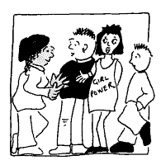
Involving and Consulting with Young People

The Department for Education and Skills (DfES) as main funders of the project were clear that they wanted a key outcome of the report to be examples of different ways of involving young people both on an individual level and in the development of local services.

Most participating Connexions Services have Youth Boards and often had representatives of the Youth Board on their management committees. When the project started there were few disabled young people taking part in the Youth Boards and other consultation methods used by the services. The work of the project forms the basis for the learning highlighted later in the project and informs good practice on involving young people locally in service development.

In order to have some level of consistency across the whole group of young people taking part, the questions used to develop discussion and interaction had to be easily accessible and understandable to include both those who were very skilled at communicating and those who found communication, especially with new people, extremely difficult. The project followed a ‘total communication’ approach using relevant tools such as symbol cards, photographs, drawing and sign language where appropriate for the individual or group. How people chose to communicate was established either through consultation with the group or by talking to professionals and family members who knew the young person best.

For some young people, especially those with autistic spectrum disorders, there were additional considerations to be taken in to account. For many young people with ASD, meeting and spending time with new people is very stressful and difficult. In order to respect this, the project worker spent time with those participating in the project during activities at their school; this included going swimming, doing some cooking, sharing lessons and sharing lunch. This proved both an exceptionally good way of including a wider group in the consultation and also valuable learning for the project in terms of skills required by Personal Advisers if they are to support each and every young person in an appropriate way.

The questions were designed to capture information enabling the project team to look at the outcomes for the young people by the end of the project; these would include the ‘distance traveled’ and the changing perception of adult life and the future. Questions were also asked about Connexions, including about the young person’s knowledge of their local Connexions Service, what support had been offered and how Connexions had helped, if at all. There were questions about good and bad support and how young people felt Connexions could offer a better service. The answers provided by the young people were heavily influenced by the newness of the Connexions Service and how widely awareness and knowledge about it had been spread locally.

Key topics for interviews were:

- What do you want to do when you grow up / leave school?
- What do you know about Connexions and Personal Advisers?
- What makes good support and bad support?
- How could Connexions do a better job for young people?

For some young people these questions were much too complex; where this was the case, the emphasis was on making it relevant to the young person. So for some the questions focused on their favourite lessons at school or the best things they were doing at college. In another example, rather than investigating how much people knew about Connexions, some young people were asked to name their Personal Adviser and explain what they did or if they had met them.

The emphasis was very much on including the most diverse group possible in the project and modeling good practice in consultation. Thus people were met on their terms as opposed to having to fit in to certain ability groups who could then take part in a prescribed process. This may run counter to established methods of evaluation or research, but the input from young people proved useful, appropriate and enlightening.

Consulting with Connexions Services, Personal Advisers and Partner Agencies

Connexions Services are between one and three years old. At the time of the beginning of this project, and in particular when the consultation with Connexions Services and their partner agencies took place, the ‘newness’ of the service was reflected in both the responses to questionnaires and the overall understanding of what Connexions do.

Each of the five Connexions Services were given a questionnaire which covered areas of work, their responsibilities, key principles and partnership working. All the services completed and returned their questionnaires.

A similar questionnaire was sent to representatives of partner agencies as identified by local Connexions Services. These included CAMHS teams, learning disability services, children’s social services, health professionals, local Learning and Skills Councils, JobCentre Plus and community and voluntary groups.

The development of the role of the Personal Adviser was one of the highest profile developments and, as so many were new to the role, the consultation exercise with these local Personal Advisers was not carried out until the second year of the project. The interviews with Connexions Service workers followed a set questionnaire that included space for discussion. Interviews were completed with a number of different Connexions Service workers, including Team Managers, Personal Advisers and specialist advisers.

SSAFA – Soldiers, Sailors, Airmen and Families Association

