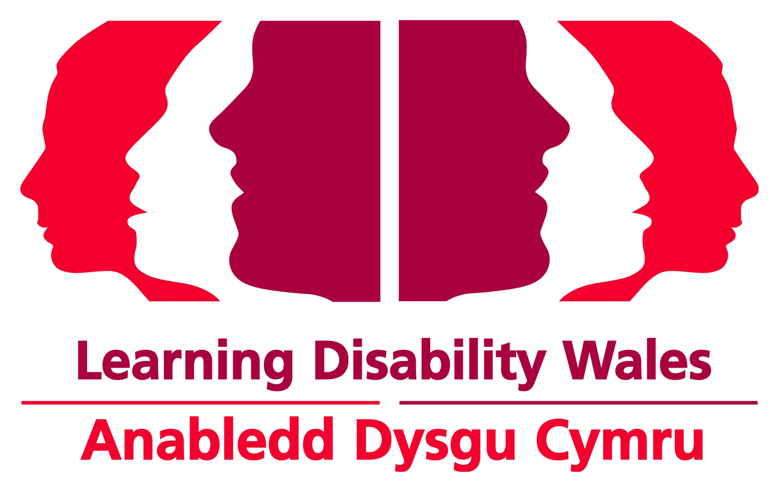 |  |  | Booking Form  Please use a separate form for each delegate and course.
 | Course Details
 | Name of course
 | Date of course
 | Delegate Details
 | Name
 | Job Title
 | Organisation Name
 | Address
 | Town
 | Postcode
 | Phone number
 | Email
 | Any dietary / special
 | requirements
 | Booking type | Member Person with learning disability  Non Member Parent / Unpaid Carer  Paid carer to someone else attending
 | In which language will you be contributing to the event? |  |  | Welsh English
 | Will you require translation equipment to understand any contribution made in Welsh? |  |  | Yes No
 | Which language would you prefer your delegate pack in? |  |  | Welsh English
 | Payment Details
 | Course Fee | £ (Please add VAT at current rate)
 | Please enclose a cheque made payable to Learning Disability Wales. Alternatively we can invoice you; a £5 administration charge will apply for each invoice.
 | Invoice Address
 | (If different to above)
Please return this booking form to:
Learning Disability Wales, 41 Lambourne Crescent, Cardiff Business Park, Llanishen, Cardiff. CF14 5GG
Tel: 029 20681160 | Fax: 02920752149 | Email: training@learningdisabilitywales.org.uk

Photography: Photographs may be taken during the training and used in future publications and publicity. Please make the trainer aware if you do not agreed to be photographed.

Cancellation Policy: Cancellations must be made at least 10 working days before the start of the training. Failure to do so will result in the full training fee being charged.

Your details: Learning Disability Wales would like to keep your details on record for future events and training. If you do not wish to receive any further information from us please tick the box

Ffurflen Archebu

Defnyddiwch ffurflen ar wahân ar gyfer pob cyfranogwr a chwrs.
 | Manylion Cwrs
 | Enw’r cwrs
 | Dyddiad y cwrs
 | Manylion cyfranogwr
 | Enw
 | Teitl Swydd
 | Enw’r Corff
 | Cyfeiriad
 | Tref
 | Côd Post
 | Rhif Ffôn
 | E-bost
 | Unrhyw ofynion dietegol/arbennig
 | Math yr Archeb | Aelodau Pobl ag anableddau dysgu  Heb fod yn aelodau Rhiant / Gofalwr Di-dâl  Gofalwr taledig rhywun arall a fydd yn bresennol
 | Ym mha iaith y byddwch yn cyfrannu at y digwyddiad? |  |  |  | Cymraeg  Saesneg
 | A fyddwch angen offer cyfieithu i ddeall unrhyw gyfraniad yn Gymraeg? |  |  |  | Byddaf  Na fyddaf
 | Ym mha iaith yr hoffech dderbyn eich pecyn cynadleddwyr? |  |  |  | Cymraeg  Saesneg
 | Manylion Talu
 | Ffi’r Cwrs |  |  | £ (Ychwanegwch TAW ar y gyfradd gyfredol)
 | Amgaewch siec yn daladwy i Anableddau Dysgu Cymru. Neu gallwn eich anfonebu ar ôl y digwyddiad; bydd tâl o £5 am bob anfoneb.
 | Cyfeiriad anfoneb
 | (os yn wahanol i’r uchod)
Dychwelwch y ffurflen archebu hon at:
Anabledd Dysgu Cymru, 41 Lambourne Crescent, Parc Busnes Caerdydd, Llanisien, Caerdydd CF14 5GG
Ffôn: 029 20681160 | Ffacs 02920752149 | E-bost: training@learningdisabilitywales.org.uk

Ffotograffi: Gellir tynnu lluniau yn ystod yr hyfforddiant a’u defnyddio mewn cyhoeddiadau a chyhoeddusrwydd yn y dyfodol. Os nad ydych eisiau cael tynnu eich llun dywedwch hynny wrth yr hyfforddwr/wraig.

Polisi Canslo: Rhaid canslo 10 diwrnod gwaith o leiaf cyn cychwyn yr hyfforddiant. Bydd methu â gwneud hynny yn golygu eich bod yn talu’r ffi hyfforddiant llawn.
Eich manylion: Hoffai Anabledd Dysgu Cymru gadw eich manylion ar gofnod ar gyfer digwyddiadau a hyfforddiant yn y dyfodol. Os nad ydych eisiau derbyn unrhyw wybodaeth bellach oddi wrthym ticiwch y blwch

