We are an independent consultancy organisation providing accredited training and support around the issue of Protection of Body Shape for people with movement difficulties, such as children with cerebral palsy.

Our work has been developing for the past 15 years and we are very proud of the results achieved by families, self advocates and professionals working in partnership.

Combining professional experience with personal commitment, we are recognised as one of the most innovative teams; contributing to leading developments in government policy for people with learning disabilities and other groups within the NHS.

Our training courses are accredited through the National Open College Network, and we are audited every 6 months for quality assurance. We are very proud to be associated with the largest education provider for adults in the UK.

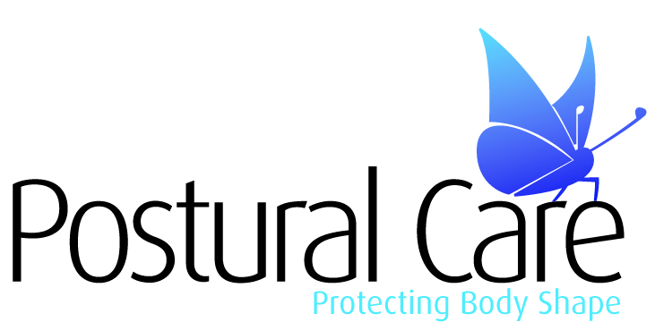

Proud to Work in Partnership

People who find it hard to move are at risk of developing changes in their body shape. These changes can make life much more difficult for the person and for those caring for them, they are also preventable.

Our teams train people to protect body shape using therapeutic positioning, particularly at night. This form of therapy is very gentle and based on common sense principles.

Night positioning involves using the long hours spent in bed, usually about a third of the year, to gently position the person to prevent stresses on joints or even to restore existing problems with body shape.  The earlier you start to protect body shape the better – but it’s never too late.

Our courses provide you with practical skills that you can adapt and develop to suit your needs. If you would like to talk this through with one of our team please don’t hesitate to [get in touch.](http://www.posturalcareskills.com/contact.php)

All of our courses have been developed with a view to improving the health and lifestyle of individuals affected by movement difficulties.  
  
As noted in the ‘Healthcare for All’ publication by Sir Jonathan Michael, “many families receive no support or advice about how to manage the sleeping position of their child...later wheelchair use and/or back surgery could have been avoided.”

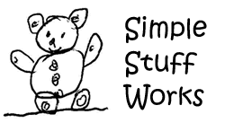

Providing families and the healthcare industry with inexpensive therapeutic positioning equipment

[www.simplestuffworks.co.uk](http://www.simplestuffworks.co.uk)

By delivering courses and training, the Postural Care Skills Programme empowers families, individuals and professionals to make a difference to the lives of those affected by movement difficulties.

[www.posturalcareskills.com](http://www.posturalcareskills.com)

t: 44 (0)1827 304 938

email: [info@posturalcareskills.com](mailto:info@posturalcareskills.com)