Dear





PLAN





The Care Quality Commission (CQC) is organising a Learning Disabilities all day event on Monday 22 June at Aston Villa Football club in Birmingham.

I am writing to invite the partnership board to nominate a person with learning disabilities to attend this event who is interested in supporting us to write a five year plan for learning disabilities.

I have also included in this email two documents in easy read that should give people a good idea about what we are , what we can do and the powers that we have. I hope you find them useful.

For each person attending, we will pay £7.50 per hour for
attendance plus reasonable expenses. Please note that
this payment does not include travel time to and from the venue.

Daphne Antoine
Care Quality Commission
13th Floor, Finsbury Tower
103-105 Bunhill Row
London EC1Y 8TG
Telephone: 0207 448 9341
Email: daphne.antoine@cqc.org.uk












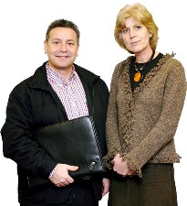

If you fill in this form with people’s details and let
Daphne Antoine have this as soon as you can.

Name

Address

Access issues

Hearing loop

Sign language

Interpreter

This needs to go in a form







Yours sincerely
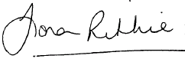
Fiona Ritchie
Adult Senior Policy Lead

Name

Address
Telephone
Email

Supporter’s details
Name
Address
Telephone
Email

Cost of support

Any special dietary requirements please let us know (vegetarian catered for)

Places will be on a first come first serve basis

Thank you for helping us once again

