
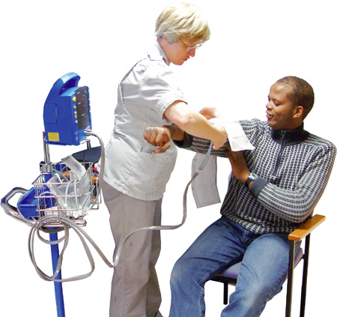



Before I see the Nurse…
Checking my health needs
for my Health Action Plan

(This is Confidential)

This health check tool has been adapted from that used by Westminster PCT.
Getting a Health Action Plan

Fill out this form and keep it safe. You might need to ask someone to help you fill out this form.
You only have to fill in boxes with this purple colour

Take this form with you when you go and see your doctor or your nurse for your annual health check.
Staff at the GP surgery will fill in boxes this green colour
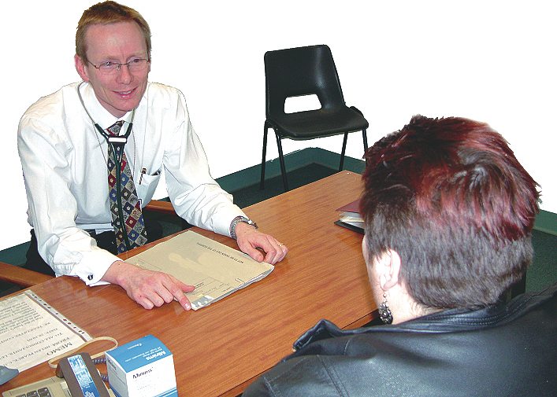

You also need this form when you complete your health action plan.
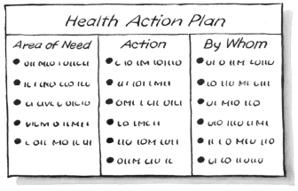


The nurse or doctor might tell other people about you so that they can help you to stay healthy. They will tell you about this first so that you can decide what you want to do.

Preparation for a Health Action Plan
Please fill in boxes with this purple colour


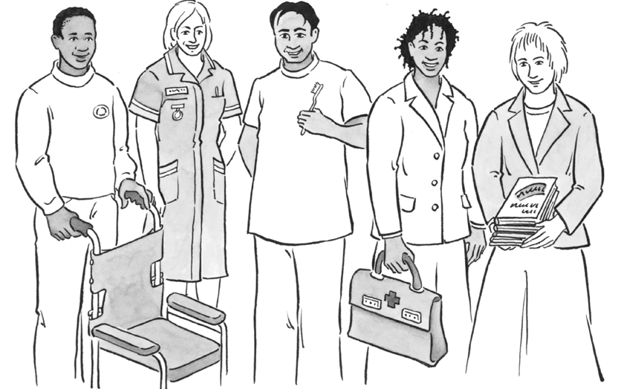
My Name is:
Do you have support from the Mental Health team?


My Care Manager is:
Other important people:


My Carer is:
Other important people:

My Health Facilitator is:
Other important people:

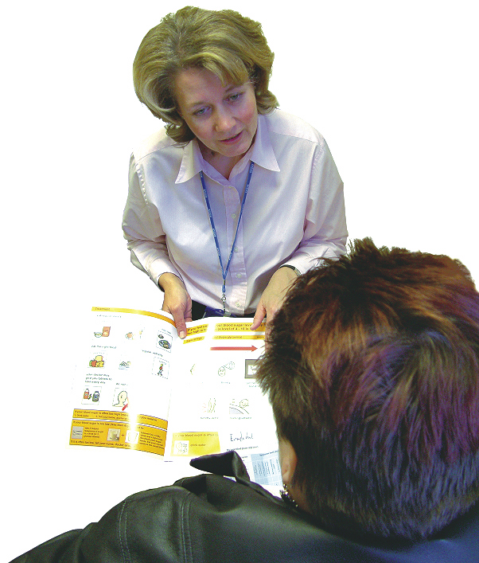
Please fill out these boxes.
Please ask the GP practice to fill out these green boxes for your Health Action Plan when you go for your check. up.

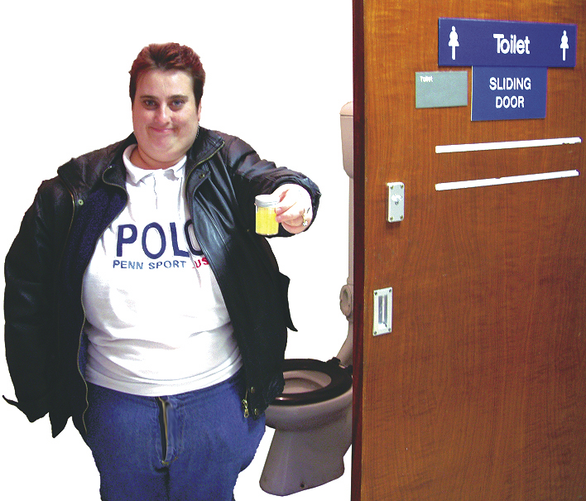
Remember to bring a urine sample.
For office use only. Please circle:
Urine glucose test negative
Urine glucose test trace
Urine glucose test +
Urine glucose test++
Urine glucose test +++
Urine glucose test ====
Glycosuria


How much alcohol do you drink?

Advice:

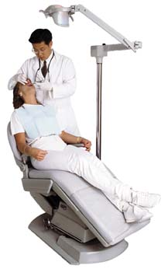
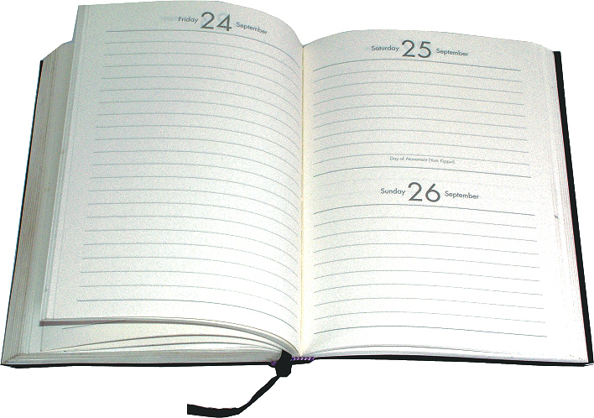
Are you registered with a dentist? If yes, who is it?

When was the last time you went for a dental check up?

Date:

Any dental issues you want to tell us about:

Advice:


What did you eat yesterday?
Breakfast:

Lunch

Dinner:

Snacks:


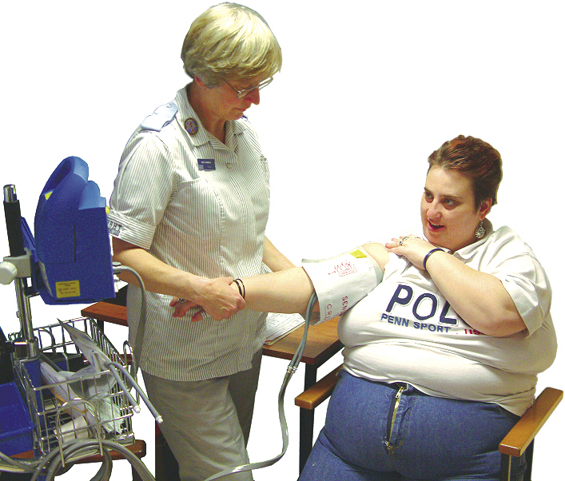
Diet:
Do you often choke on your food?

Yes No

Diet:
Do you follow a special diet?

Dietician:
Have you seen a dietician?

Yes No

Who is your dietician?

Advice:

The practice will now take some important measurements:

Weight:
Height:
BMI:
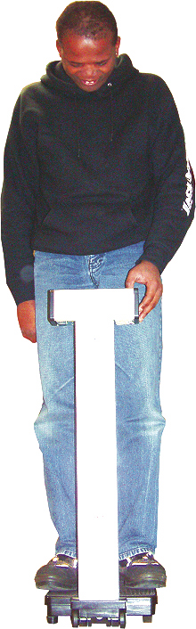

Blood Pressure:
Pulse:
Have you ever smoked?

Yes No

How many do you smoke?

Advice:


Did you ever live in a hospital?

Yes No

Do you know your Hepatitis A status?

Yes No

Do you know your Hepatitis B status?

Yes No

If, yes do you know your Tuberculosis status?

Yes No

The nurse might check your blood

The nurse will check if you had a flu jab.

The nurse will check if you need a pneumococcal jab.


THIS PAGE IS FOR WOMEN ONLY
The nurse will ask you questions about your body and what you know about sex. This is to make sure that you are offered the right check ups to help you stay healthy.

Have you ever had a smear test?

Yes No

Do you know about smear tests?

Yes No

Advice:
Do you know how to check your breasts?

Yes No

Have you ever had a breast screen?

Yes No



If you had a breast screen, when was it?


THIS SECTION IS FOR MEN ONLY
The nurse will ask you questions about your body and what you know about sex. This is to make sure that you are offered the right check ups to help you stay healthy.

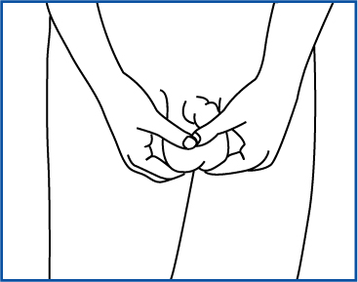
Do you know how to check your testicles?

Yes No

Advice:

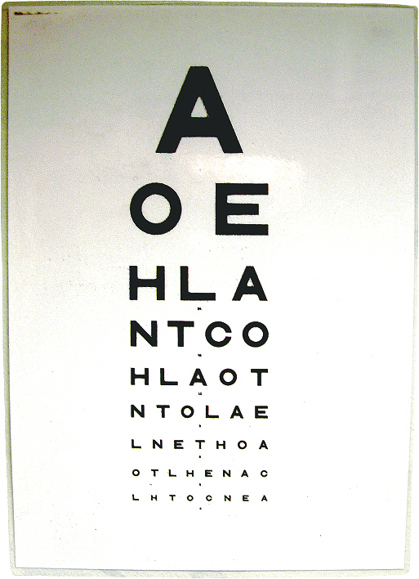
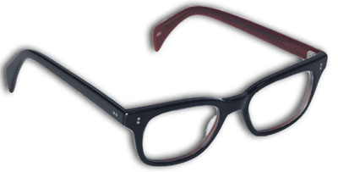

Do you wear glasses?

Yes No

Have you had an eyes test?

Yes No

When and by whom?

Do you eyes hurt?

Yes No

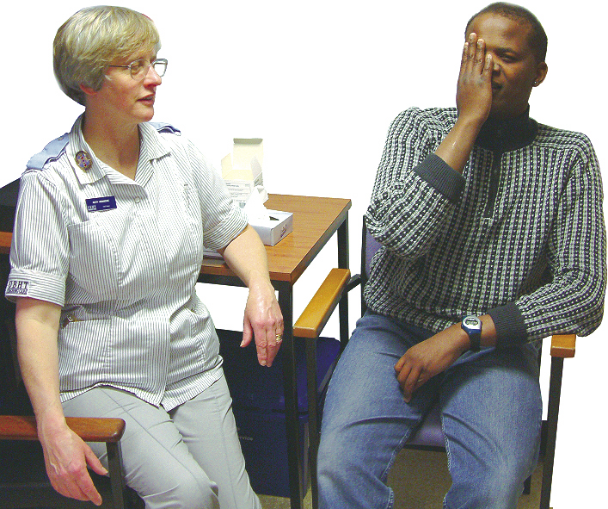

Tell us if there have there been changes to your eyes that you are concerned about?

Advice:

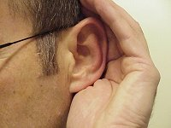
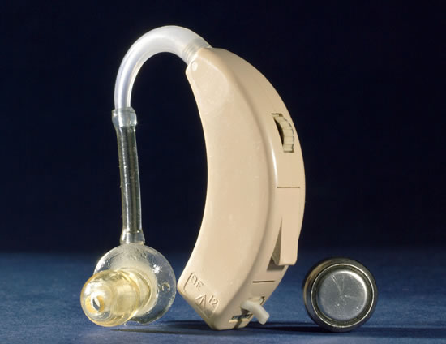
Have you had a hearing test?

Yes No

When and by whom?

Have you got a hearing aid?

Yes No

Has anyone commented that you might have a hearing problem?

Yes No

Is there anything that you want to tell us about your ears?

Advice:
The nurse will look into your ears.

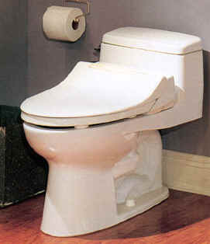
Do you have difficulties urinating?

Yes No

Do you find it difficult going to the toilet on time?

Yes No

Do you use any equipment?

Yes No What do you use?

Advice:
Is there anything else you want to tell us?

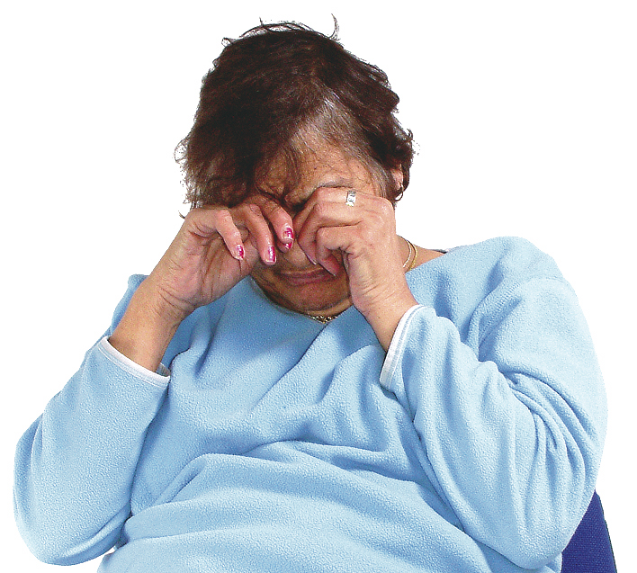
How are you feeling?

Do you get upset easily?

Yes No

Are you worried about anything?

Yes No

Are you on a CPA?

Yes No

Are worries stopping you doing the things you want to do?

Yes No

Do you sometimes feel like hurting yourself or others?

Yes No

If you are on a CPA, who is your Care coordinator?

Advice:

Have you ever seen a psychiatrist?

Yes No

Anything else you want to tell us?


Are you physically active?

Yes No

Do you have difficulties walking?

Yes No

Do you have difficulties moving your arms?

Yes No

Do your feet itch or hurt?

Yes No

Are you seeing someone for your feet?

Yes No

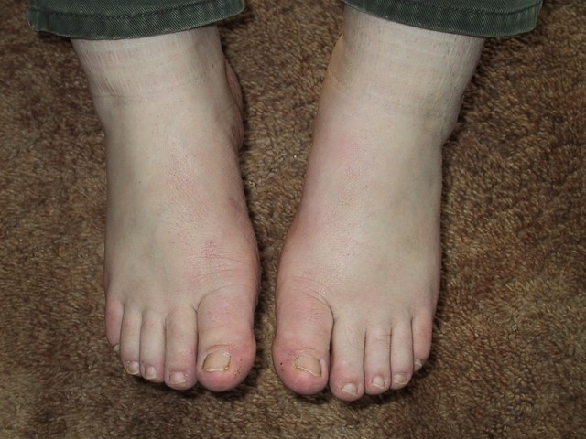

Who are they?

Yes No

Can you cut your own toenails?

Yes No

Advice:

Anything else you want to tell us?


Do you have Epilepsy?

Yes No

How many seizures do you have a month?

Do you know what your seizures are called?

Who is your epilepsy doctor?

When did you last check that your medication is working?

Advice:
Anything else you want to tell us?


Do you have any illnesses or conditions that stop you doing the things you like to do? Please tell us:

Advice:

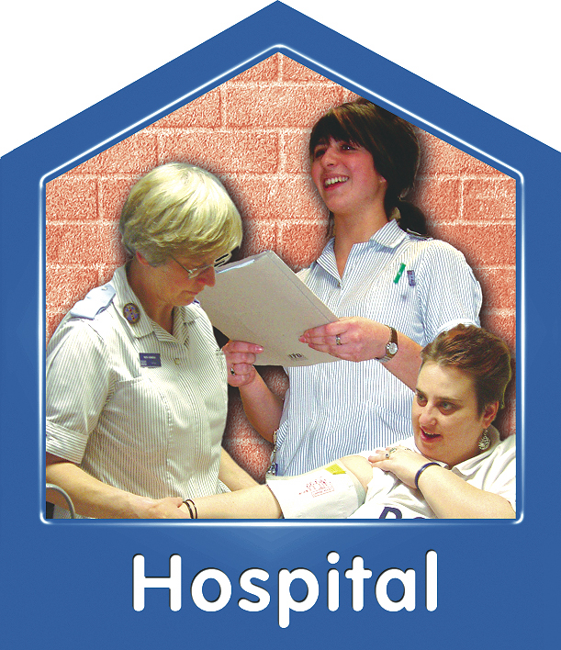
Have you ever had to stay in hospital overnight? Please tell us:


Advice:
Please list all your medication and bring these along:

Have you got a health action plan, please bring it along:

Yes No

Do you want a health action plan?

Yes No

How would you describe yourself? (Ethnicity)

Date and Signature:

