Learning Disability
Open Meeting
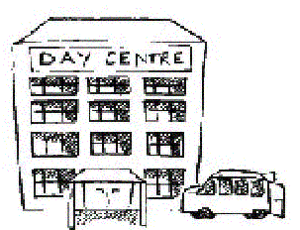Past, present & future: Learning Disability Nursing
Bob Gates
FREE
EVERYONE IS WELCOME
Date: FRIDAY 6th February ROOM 6030
Time: 2.00 - 4.00 PM
Place: Sir Frank Lampl Building, Kingston Hill KT2 7LB
If you would like to attend or find out more please contact:
JIM BLAIR
Email: jblair@hscs.sgul.ac.uk
Tel: 020 8725 2155 (Deb Bunyan)
A useful website to visit is: www.mencap.org.uk/gettingitright

Supported by:

Learning Disability Forum

