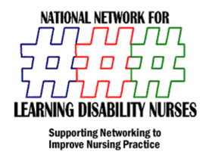

**NNLDN Third Sector Learning Disability Nurses Network**

Next Meeting

Wednesday 14th December

The Vineyard Nottingham

10 -3pm

**Programme**

Maintaining CPD

Clinical Supervision in the Third sector

Supporting Service Users with Visual Impairment

Cost £20.00 Including Lunch

To book Email

Mark Gray

[mark@markgrayassociates.co.uk](mailto:mark@markgrayassociates.co.uk)



*Opening Doors to New Ideas*

Mark Gray Associates LTD

5 Kirkland Drive

Chilwell

Nottingham

NG9 6LX

Tel 01159732540

**Mob 07970 369827**

Email [mark@markgrayassociates.co.uk](mailto:mark@markgrayassociates.co.uk)

Web [www.markgrayassociates.com](http://www.markgrayassociates.com)