
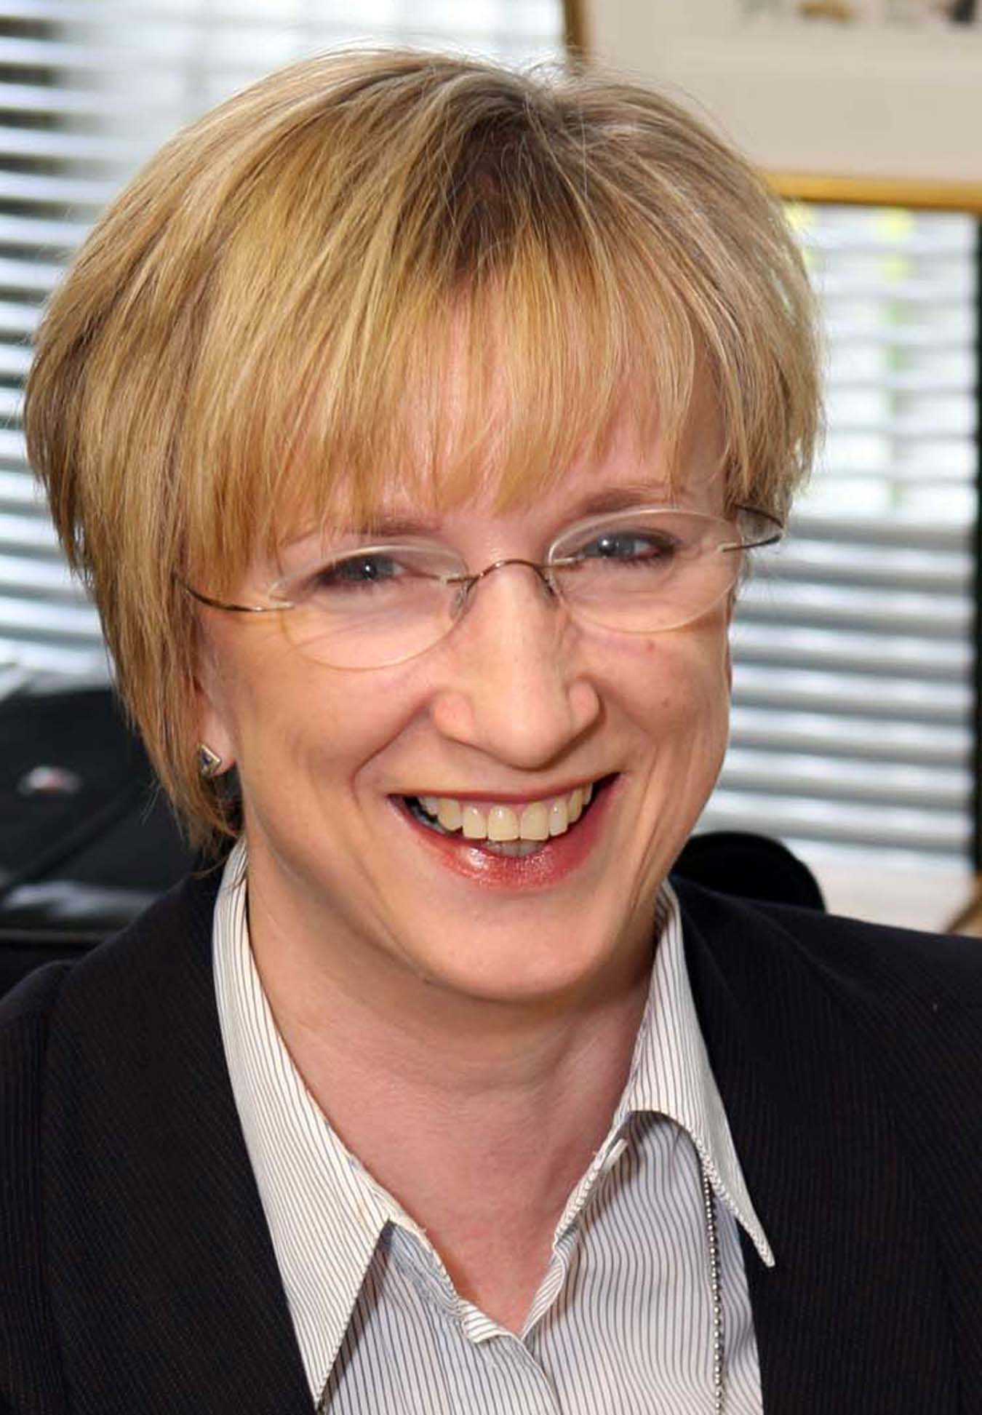
Chief Executive
Fiona Edwards
18 Mole Business Park
Leatherhead
Surrey
KT22 7AD
 01883 383838

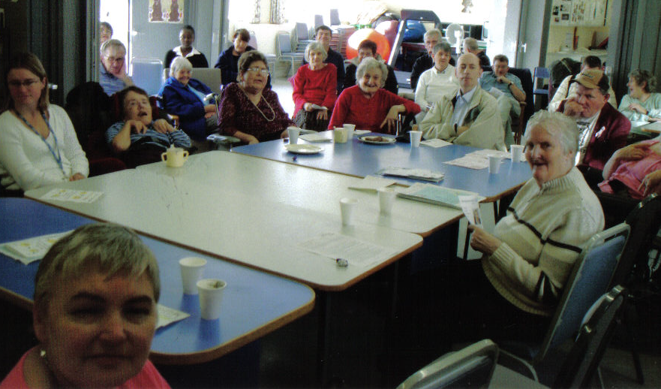
Designed with help from
3rd✓Third
Friday
supported self advocacy group

How to complain




If you are unhappy about something, we want you to tell us



Hampshire County Council
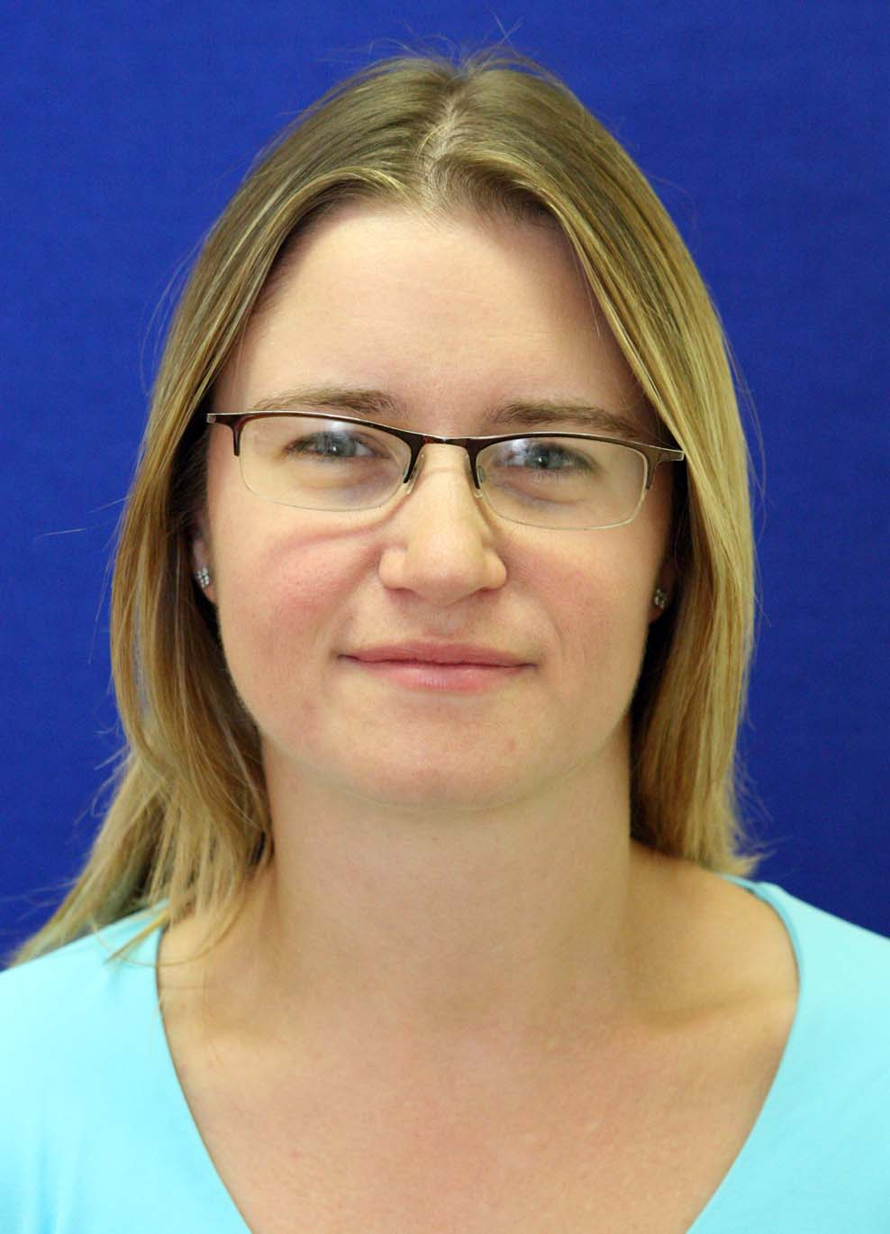
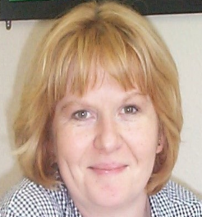
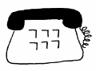

Making a complaint means speaking up about something you do not like or are not happy with.
Complaints Manager
Susan Sharpe
01883
388321
If you are still not happy,
PALS staff will talk to the Trust’s Complaints Manager

We will not treat you badly because you speak up or make a complaint.

Tell someone you trust about what is wrong or is making you unhappy - ask if they will help you.
The Complaints Manager will tell the Trust Chief Executive why you are unhappy.


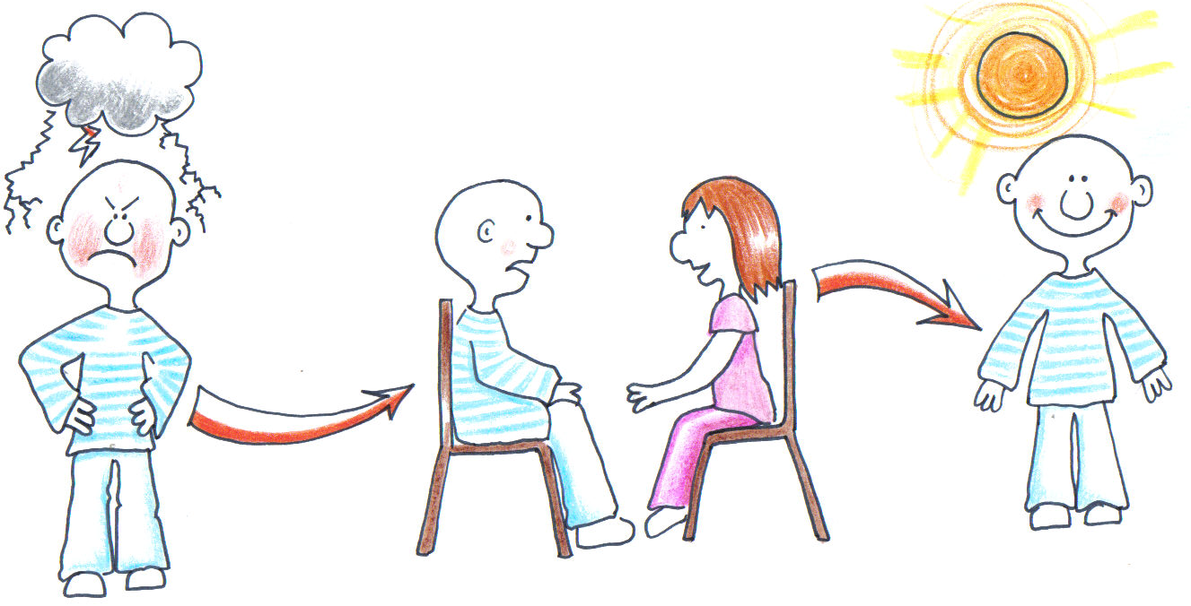
If they cannot help to make things better, then you can talk to Jo or Nikki at PALS (Patient Advice and Liaison Service)
PALS Manager
Nikki Green
01483
443628
PALS Manager
Joanne Chapman

The PALS staff will try to sort out the problem and tell you what will be done to put things right.
The letter will tell you what can be done to sort out what is wrong.
The Complaints Manager will make sure you understand what the letter says
?✓
The Chief Executive will write a letter to you within 5
weeks time.
01372
204191

