
My Medication

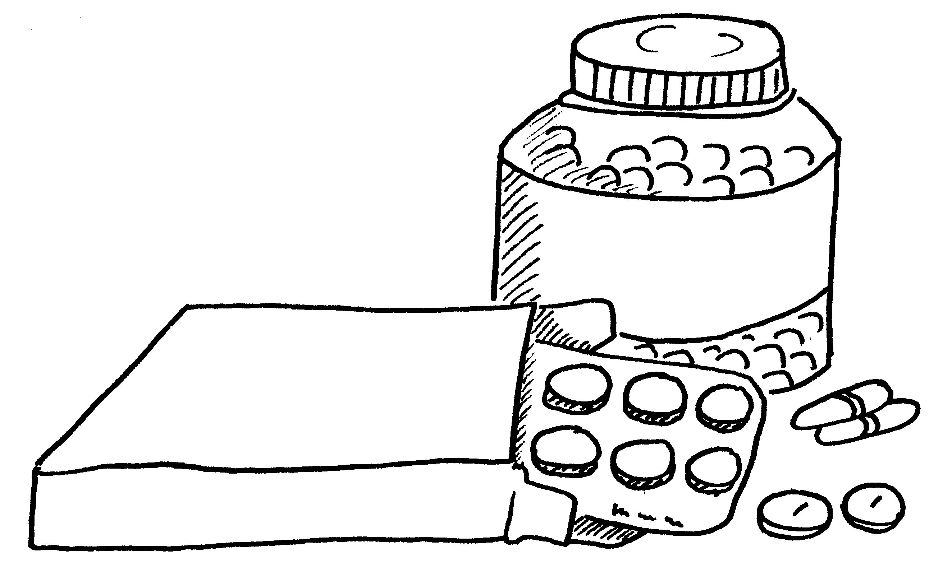

Aricept Dose 5mg 1 tablet in the morning

You need to take Aricept because you have been feeling muddled in your head.
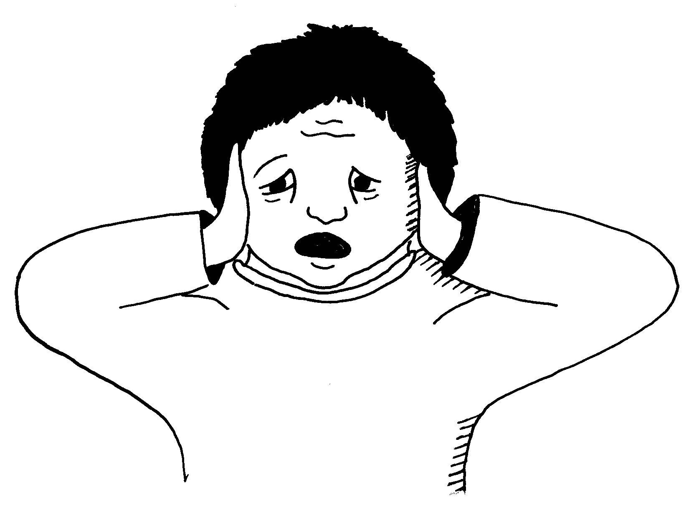
The tablets you take help you to think more clearly and less
muddled.

You will need to take your tablets regularly even when you feel well as you will become muddled again.
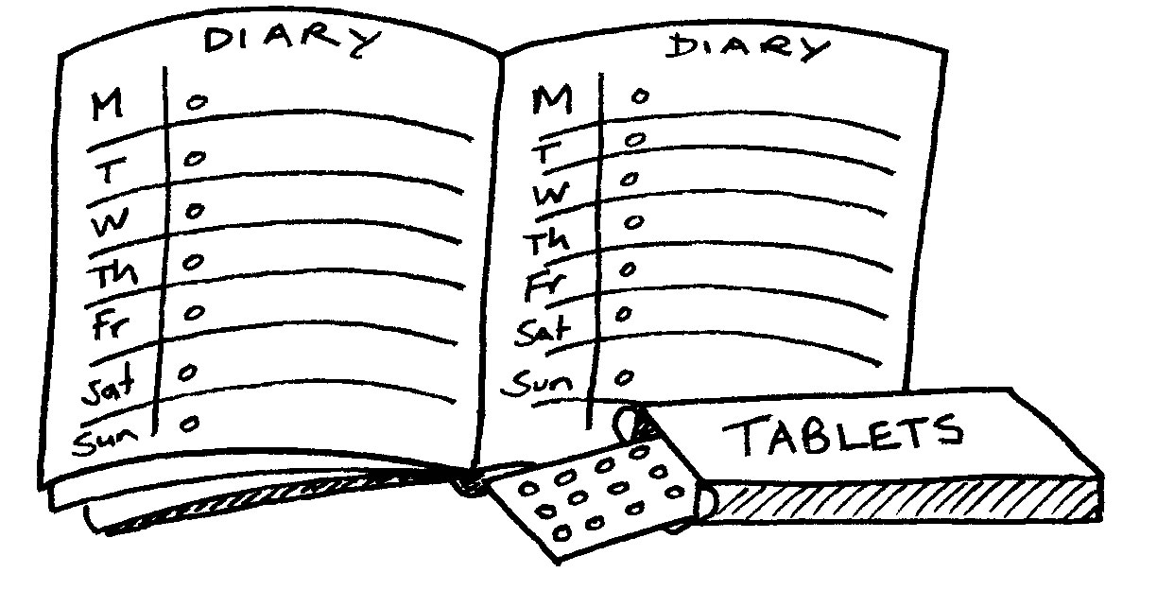

Missed Doses
If you miss a dose take it as soon as you remember if it is the same day. If it is the next day don’t take two tablets just carry on with your usual dose.

Common Side Effects

You may experience

Diarrhoea ,Feeling sick, Being sick

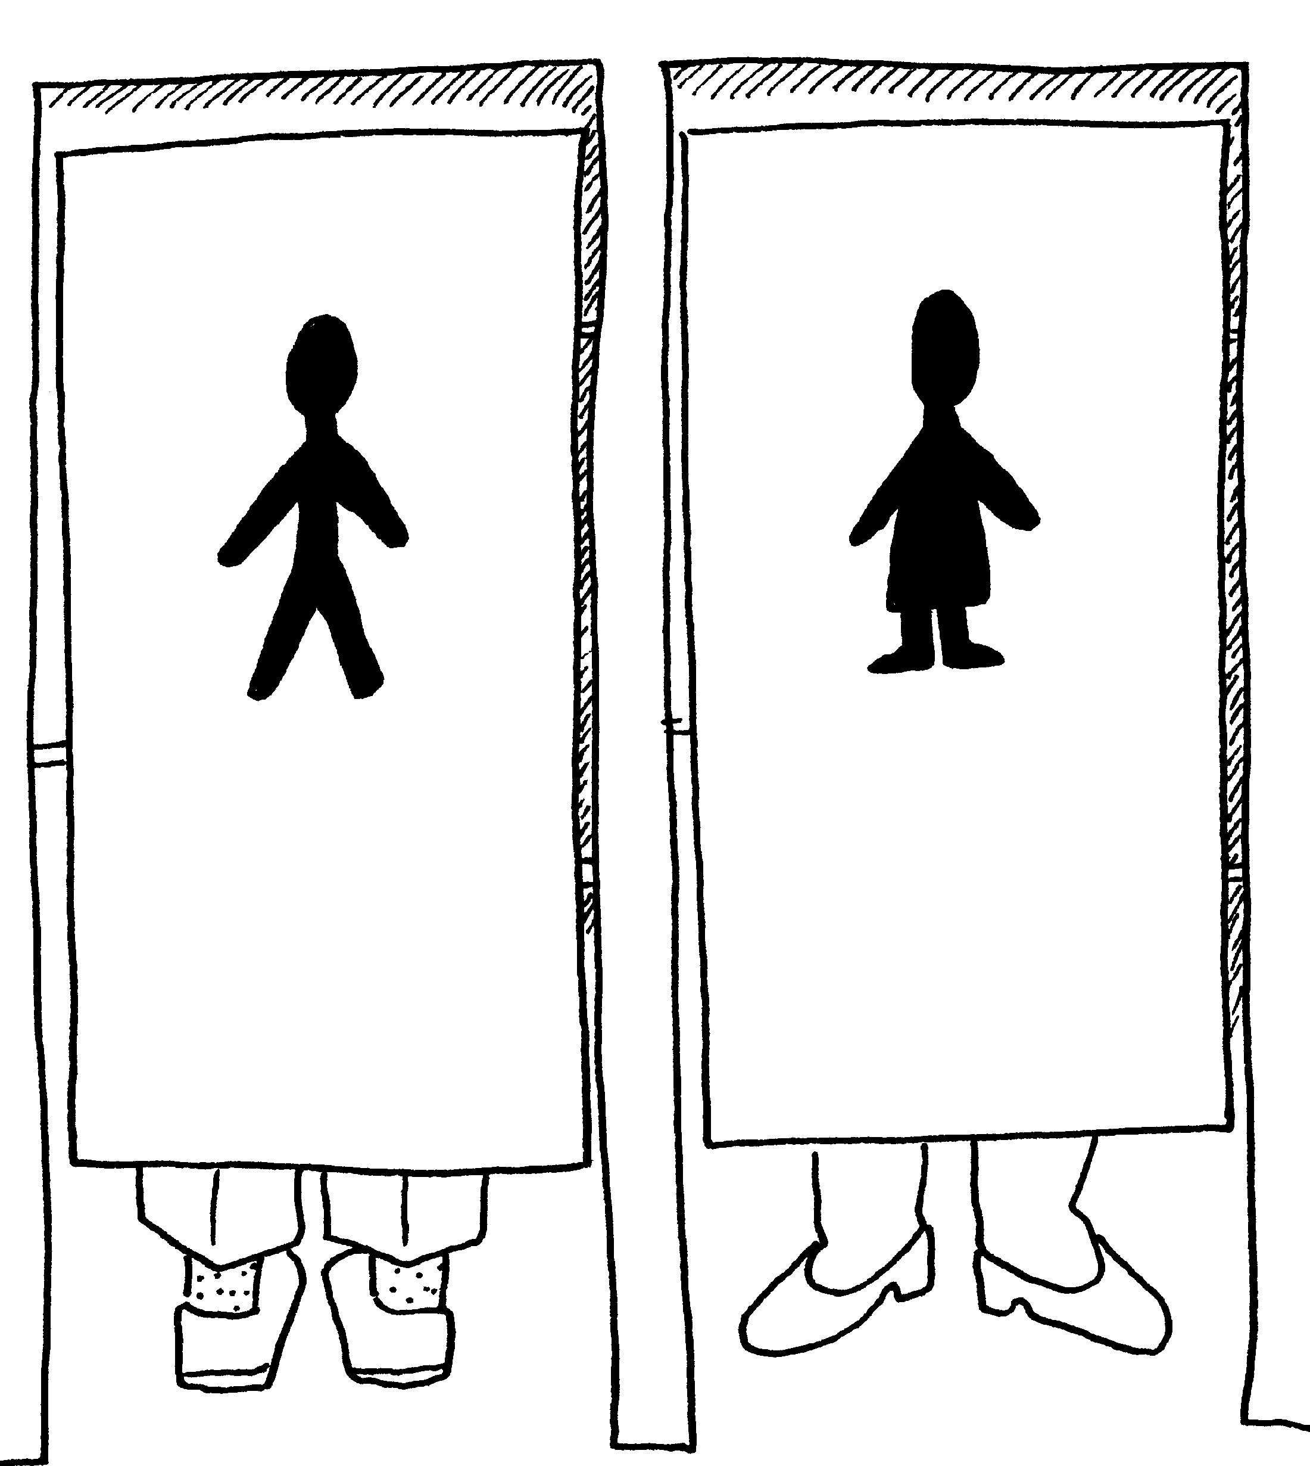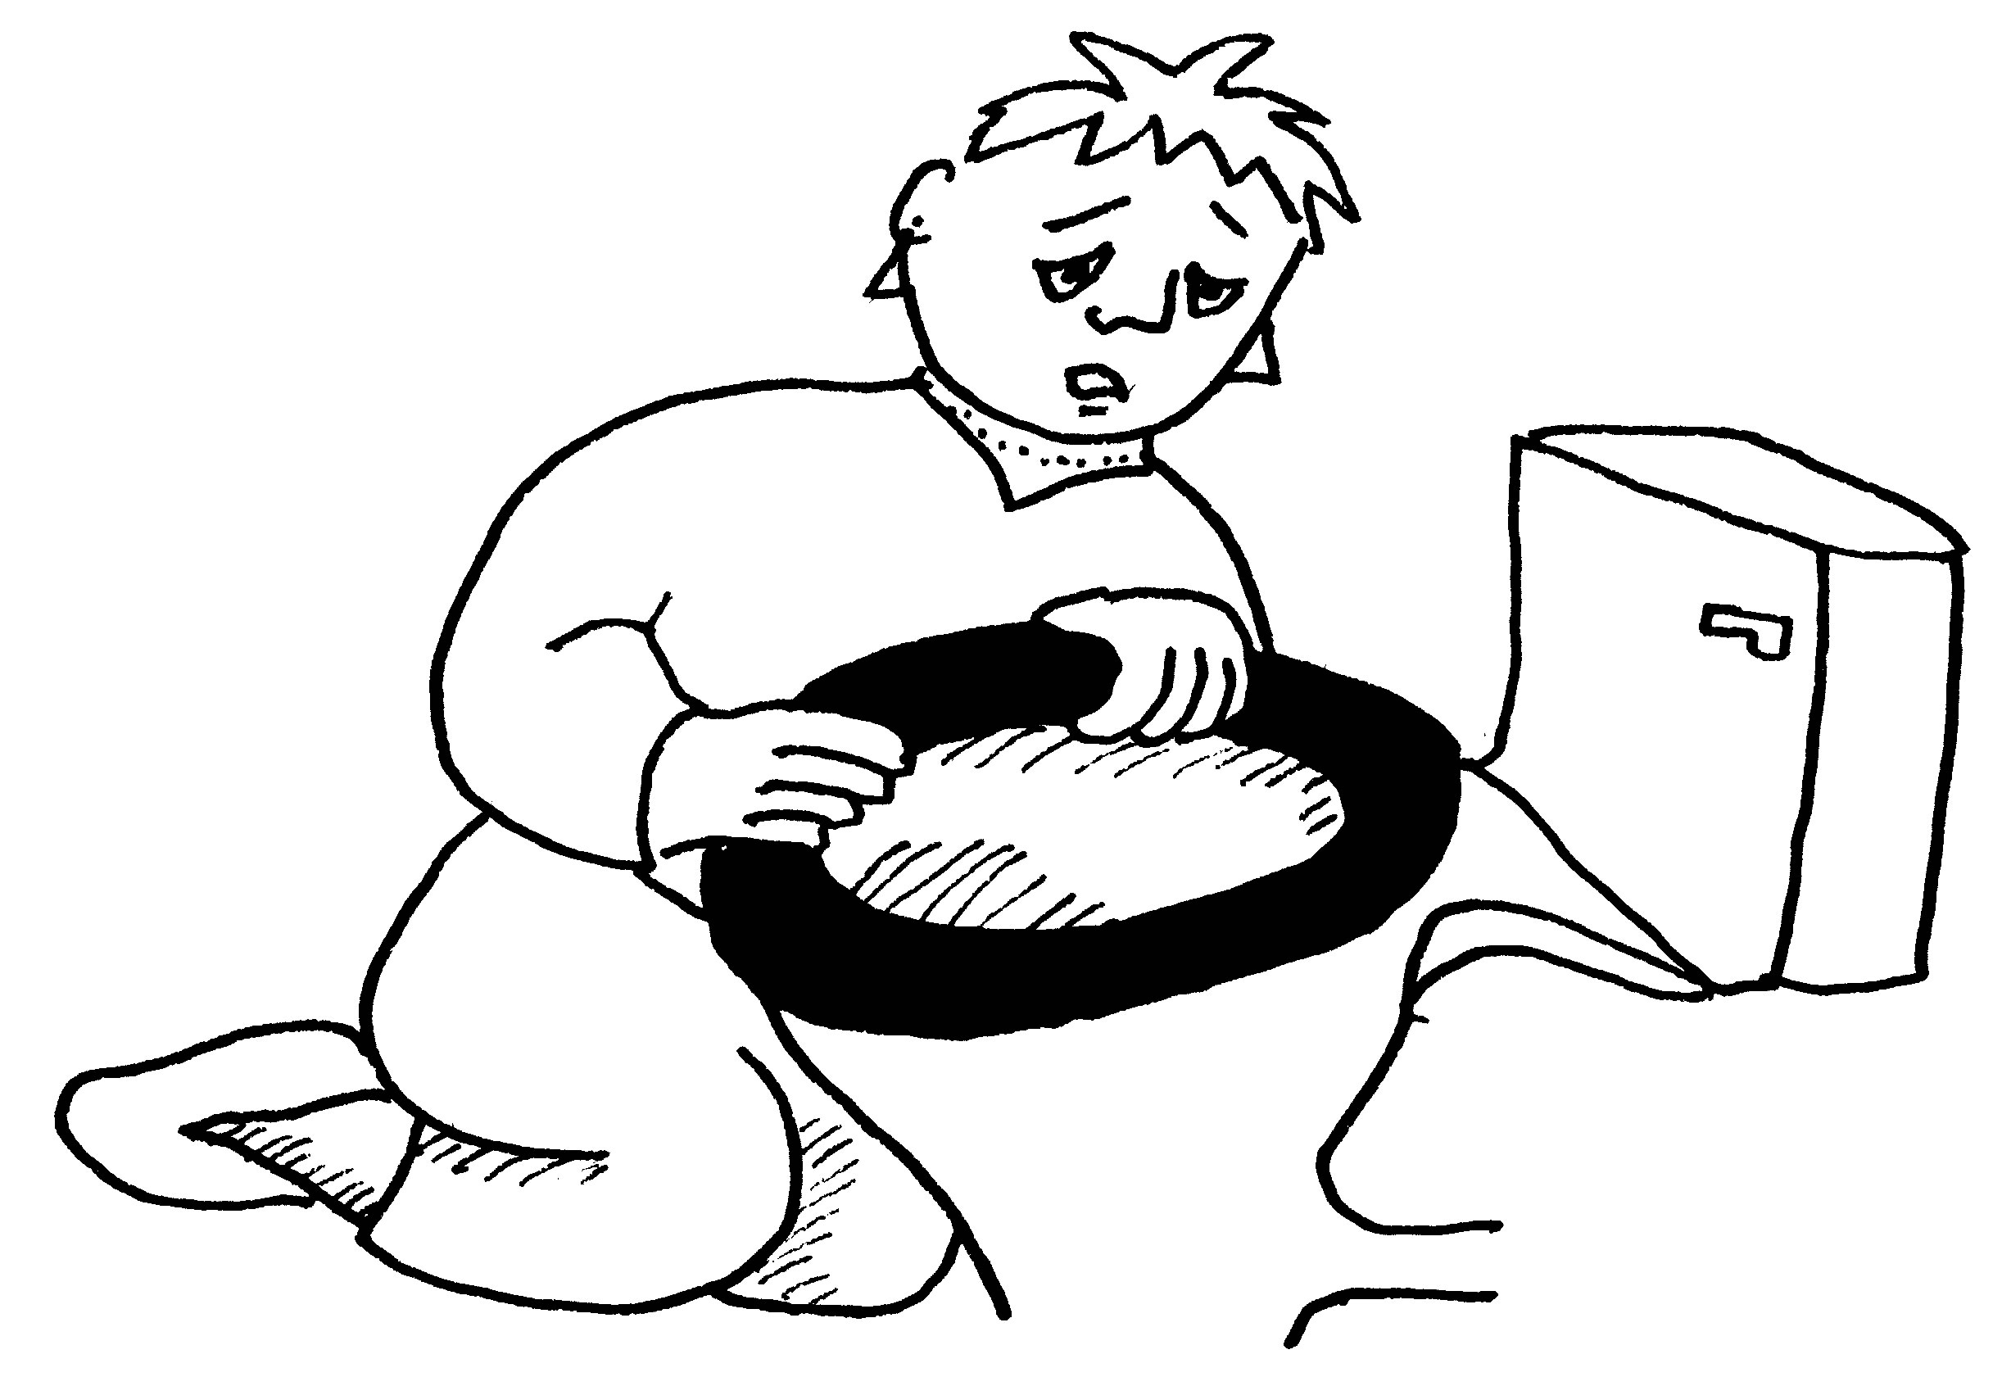

Pains in your muscles, Feeling tired, Unable to sleep
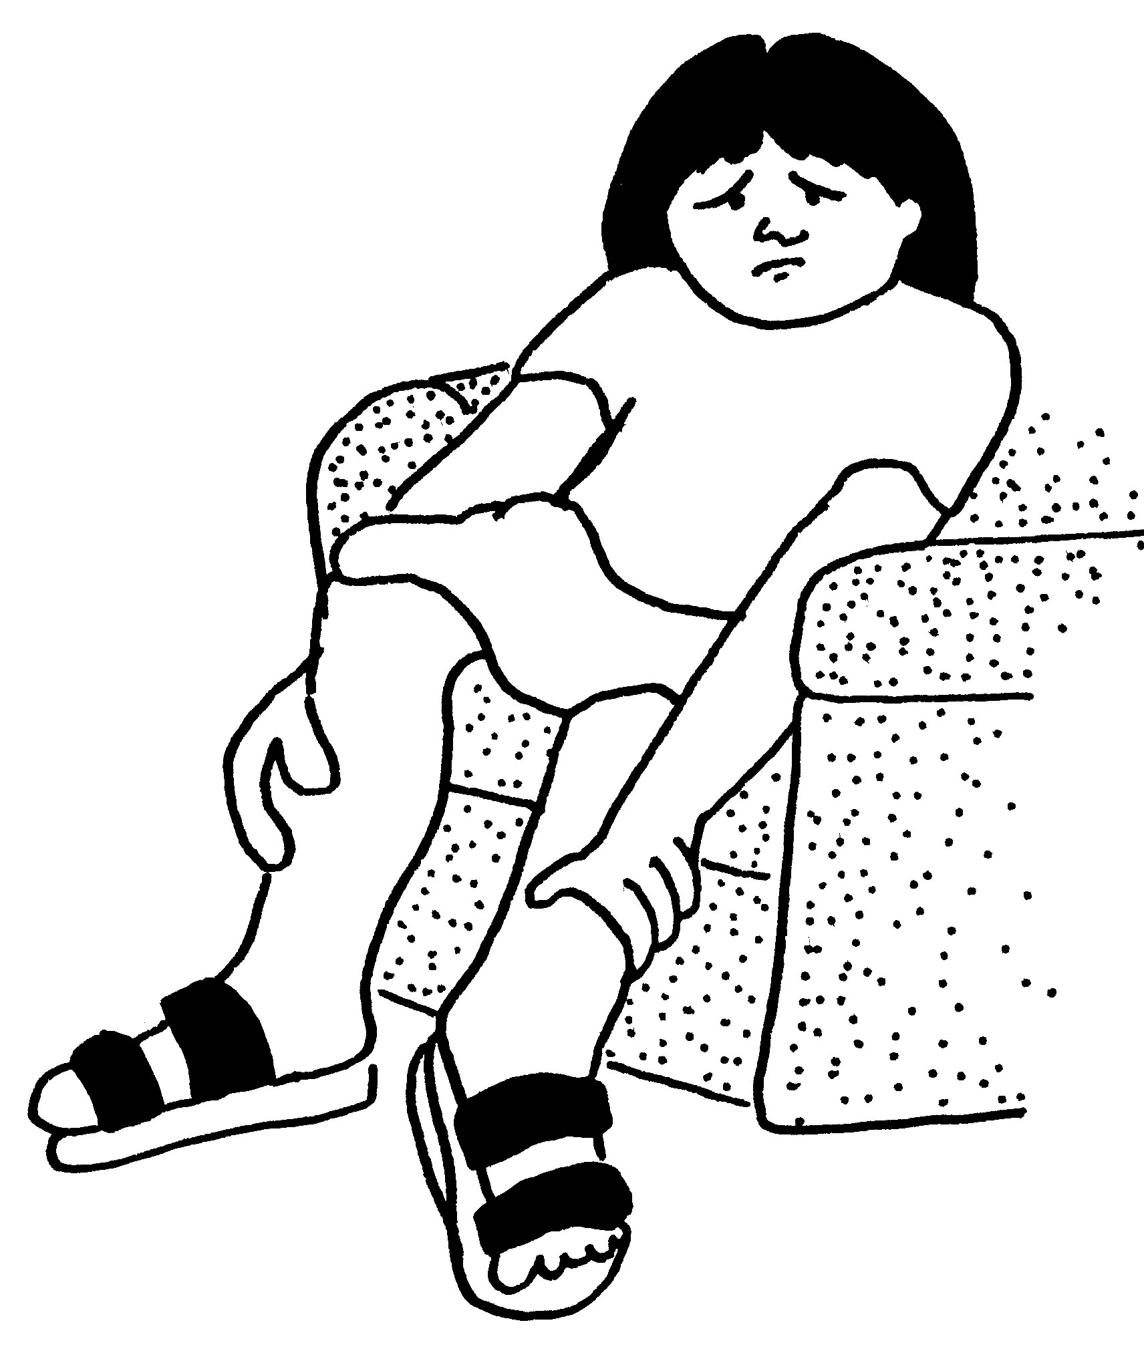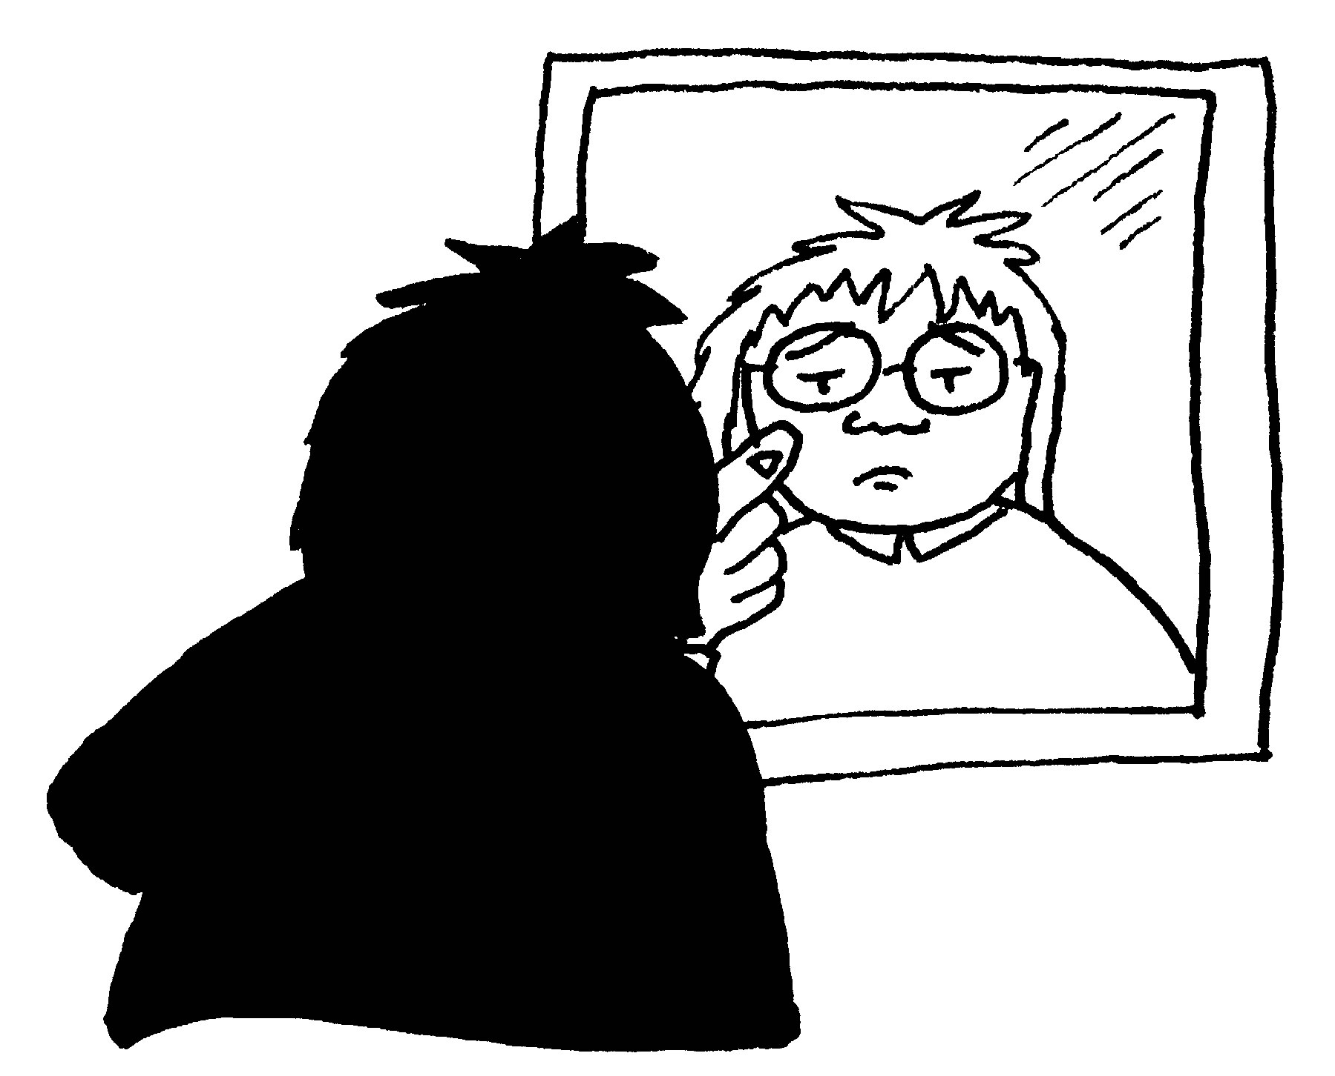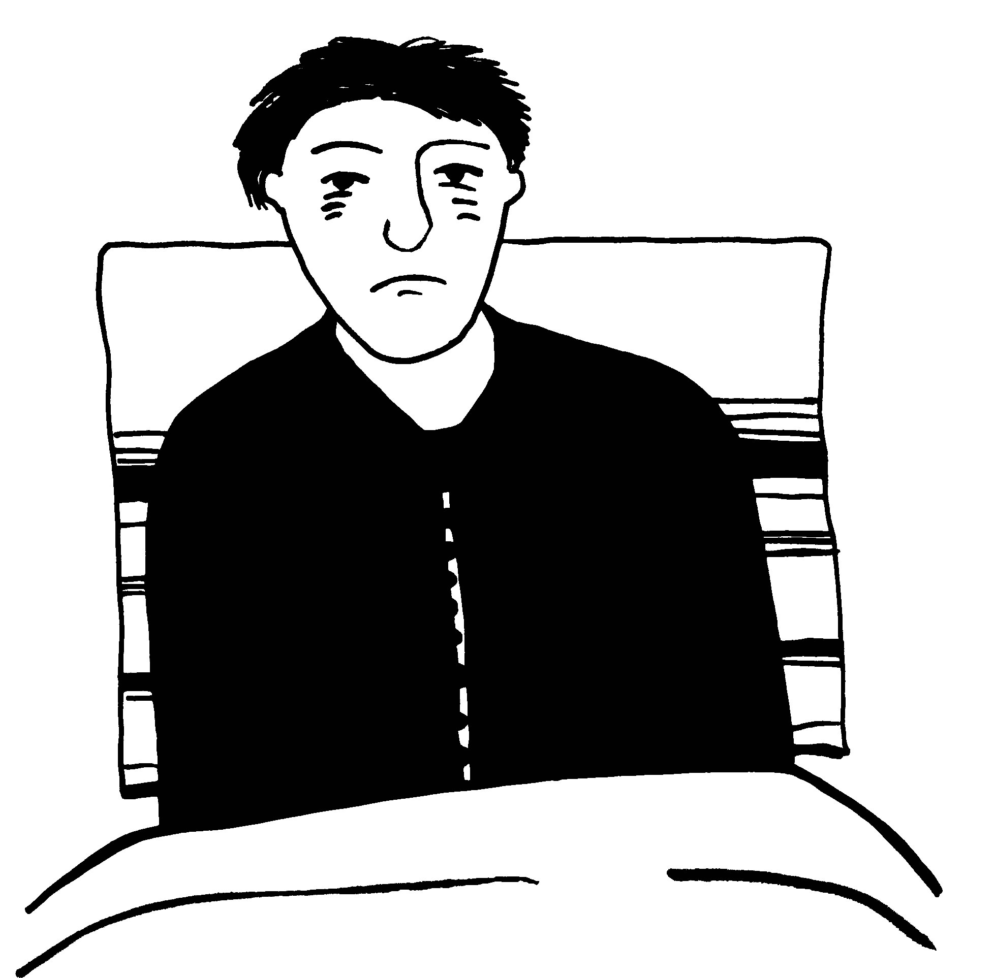

Not wanting to eat

These side effects may go away after a while.
If they carry on or if you are worried talk to your doctor or nurse.


