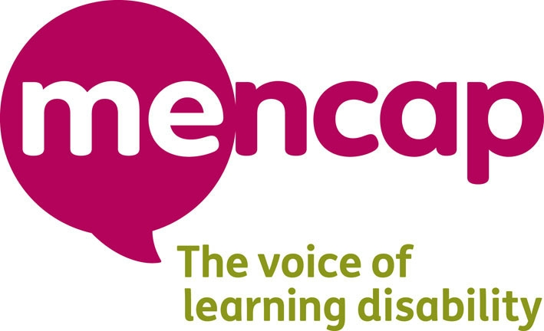
Person specification

The job Learning Disability Consultant for the Inspire Me project

This information tells you what knowledge, skills and experience you need to do this job.

This information is called a person specification.

Please read it carefully. It will help you decide if you can apply for the job.
You may like to ask someone to go through this information with you.

You will see the letters E and D next to the information about this job.

E means you must have the skill, knowledge or experience.

D means it would be good if you had the skill, knowledge or experience but you do not have to.

It is fine if you need support to do any of the things in this person specification.

Needing support will not stop you being able to apply for the job.

This information was written in May 2011

Your knowledge
What you need to know about to do this job

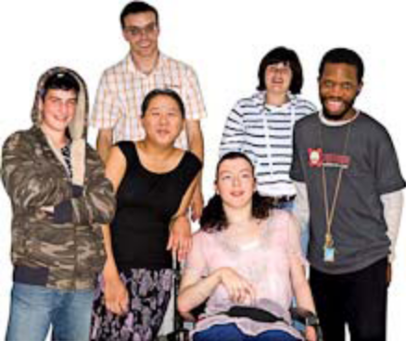 | You must have a learning disability | E
 | Know about some of the issues that young people with a learning disability face | D

Your skills
What you need to be able to do

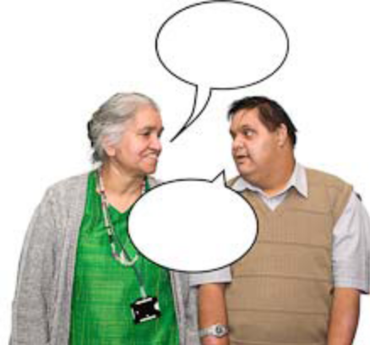 | Be able to communicate with people in a friendly and open way.  Be able to communicate with people from Mencap and other groups. | E
 | Be able to speak up for people with a learning disability.  Be able to work well with lots of different people. | E
 | Be able to  - listen to what other people think,  - answer questions and,  - say what you think | E
 | Be able to use a computer for things like sending emails and finding out information. | D
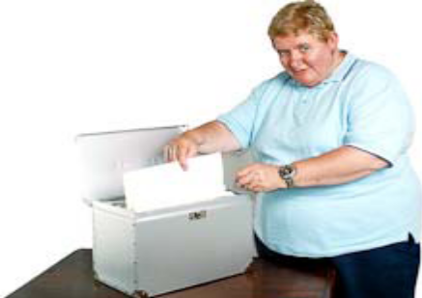 | Be organised and be able to keep information up to date | D
 | Be able to talk to people in person and over the telephone | E
 | Be able to work as part of a team as well as working on your own | E
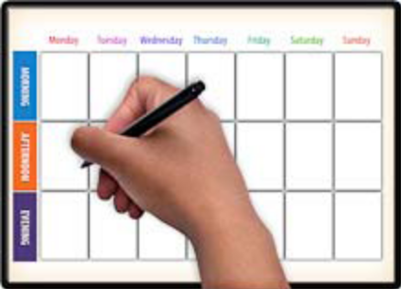 | Be able to make plans about your work and follow them | E
 | Be able to do research  This means find out information about topics to do with learning disability and young people | D
 | Be able to talk to groups of young people and other groups about the project  Be able to deliver training to groups of young people with a learning disability aged 16-25 | E

Your experience

 | You must have delivered training to groups of people | D
 | You must have experience of going to conferences and other big meetings and talking in front of people | D

What other things you will need to do for this job

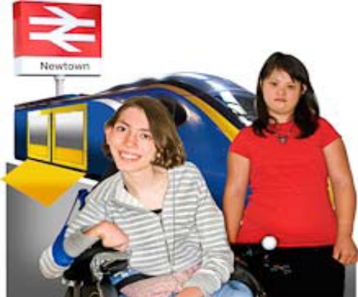 | Be able to travel around the country with support if you need it  Be able to travel around your region independently | E
 | Be able to be flexible about the hours and days you work.  For example, you might have to work some evenings if you are going to visit a youth club as part of your job | E

