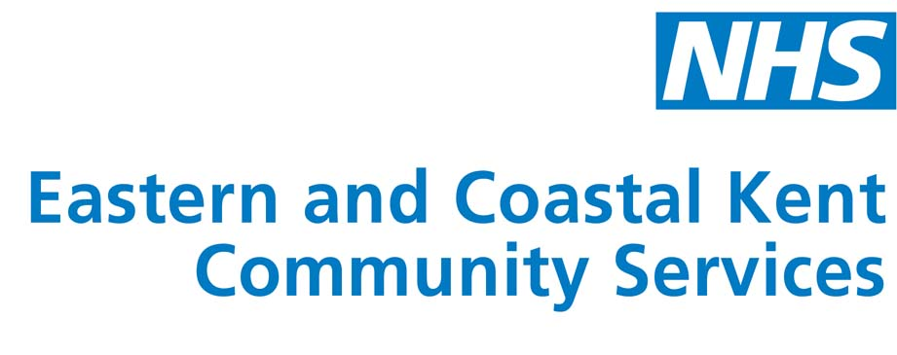

SEEKING ALL LEARNING DISABILITY NURSES
(*) ()

EXCITING OPPORTUNITIES!!

- SPECIALIST SERVICES TEAM MANAGER (BAND 7)
- SPECIALIST SERVICES DEPUTY TEAM MANAGER (BAND 6)
- TEAM LEADERS (BAND 5)

We are currently looking to recruit motivated nurses interested in working in a new and unique environment in the Sandwich area of East Kent.

This will be highly specialist service in a purpose built environment designed to separately support two gentlemen with learning disabilities and highly complex support needs, including physically challenging behaviours.

We are looking for nurses who either already have, or would like to develop skills in both behavioural and cognitive therapeutic approaches. The service will be part of an action research project.

- The specialist Team Manager post will require someone who can evidence staff development and performance management skills as well as appropriate clinical background.

- The Deputy Team manager post will require someone looking to develop these management skills along with the clinical experience.

- The Team Leader posts will be responsible for shaping the clinical practice within the teams.

For an informal chat call: Pene Stevens on 01303 717000

A comprehensive corporate induction programme is provided at the commencement of employment.

Please note if you are successful obtaining an interview you will be notified via your NHS Jobs Account.

TO APPLY GO TO: www.jobs.nhs.uk

Closing Date 2nd July 2009

(*) Employment in this post is subject to a satisfactory Enhanced Disclosure from the Criminal Records Bureau | () Car owner/driver essential, subject to the provisions of the Disability Discrimination Act (1995)

For other job opportunities visit our website www.easternandcoastalkent.nhs.uk

