

Learning Disability Peer Reviewer

people who use learning disability services and family carers


What your job is about

What your job is called
Learning Disability Audit Team Member


Who you have to answer to
Senior Manager, Associate Management

Your day to day Manager is


A Senior or Assessment Manager

- What you will be paid
£5.50 an hour
Expenses

- What you have to do

Go to 1 day of training.
Be able to take part in at least 3 audits.
You will need to spend about 12 hours on each audit.
This 12 hours includes the time you need to prepare, the
time you spend on a visit and any other meetings or
planning to do with each audit.

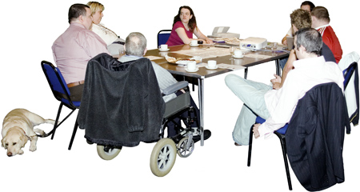
More about your job
- To work well as an equal member of a peer review team.
- To give advice on parts of the national audit for different learning disability services.
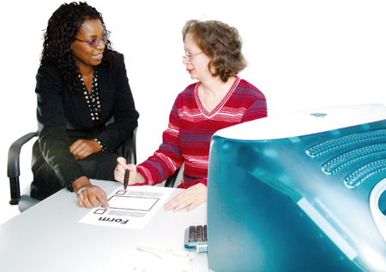
You will be helped and managed to do this work by a Senior/Assessment Manager. This person is a member of the Healthcare Commission’s staff.

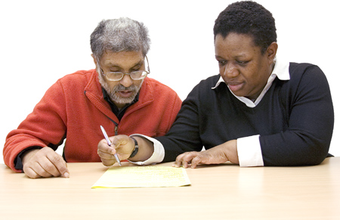
What you need to do – your responsibilities

- Go to any training sessions to do with the audit

- look at information from different places and people
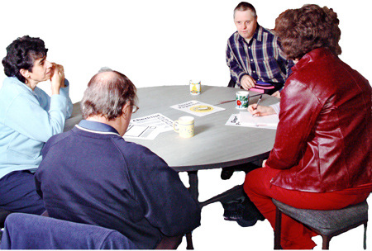
- take part in review team meetings, talk about and say what you think about different learning disability services

- talk to staff and people with learning disabilities about the care and support they give, or get

- look at care in different parts of the country for people with learning disabilities

- work with other peer review team members to look at the evidence you gather to do with the main things the audit is concerned with

- say what you think about the draft written report

The skills and experience you need
- to be able to work as a member of a team and to work with other people to get things done
- to be good at listening and be able communicate with others
- to be able to get work done by deadlines (a date when something has to be done by)
- to be able to follow instructions and stick to tasks
- ability to work on your own at times (with your supporter)
- to be willing to go to training to do with your work
- know about learning disability services
- know how to communicate with people with a learning disability
- if you are a person with a learning disability
- experience of using any learning disability services
- if you are a family carer
- experience of visiting services for people with a learning disability

Mencap and Photosymbols helped to make this easy read.

