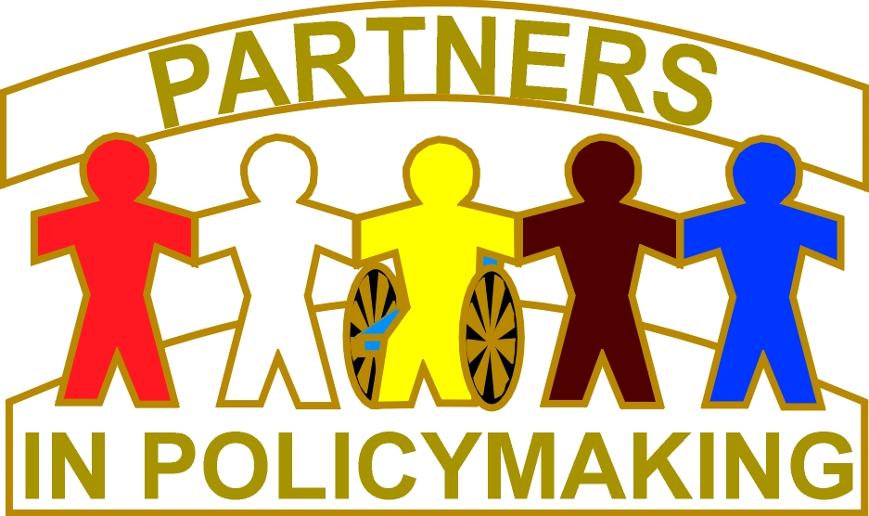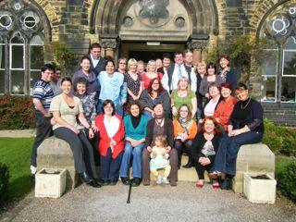

Sharing Knowledge
Lincolnshire
A Ten day leadership development Course held two days a month over five months.
This is a new local Course run by Lynne Elwell which will identify, train, and sustain a local network of champions for Lincolnshire. The Course is designed for disabled people, family carers and people who support them through work in social care, health services, education and leisure. This will include people representative of all major ethnic, cultural and religious groups in Lincolnshire. ‘Sharing Knowledge’ is about building new alliances, which will become powerful and make real differences to the future of disabled people and their families. The Course will build on work already done in Lincolnshire and will contribute to more effective partnership working. Its design is based on existing leadership development courses which have a successful track record, such as Partners in Policymaking™, and Kindred Spirits.

Sharing Knowledge will be a tailor-made course for Lincolnshire. It will incorporate all the key elements of the above leadership development courses. It will provide information and build participants’ skills so that they gain the knowledge and confidence they need to campaign and advocate for a better future for disabled people and their families. A strong values base of inclusion and equality underpins the programme. Participants will be listening, learning, planning and creating together.

To find out more please join us at one of two sessions being held on 17th May:
Session 1: Lincoln City Football Ground, Sincil Bank, Lincoln, LN5 8LD Please click on Link
12.30 – 2.30

Session 2: LDCP, Croft Street, Lincoln, LN2 5AX
Time: 5-7pm

 rsvp 01522 553994
Katie.hibbard@lincolnshire.gov.uk

