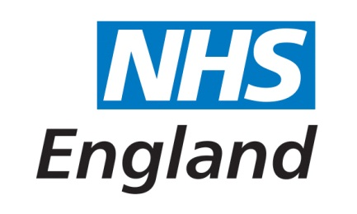
Interim Expenses Policy for Patients and Carers
NHS England will reimburse all reasonable expenses that are necessary for patients and
carers to attend NHS England events. This policy is based on the Interim Expenses Policy for NHS England, which is currently being developed.

Receipts are required for all expenses, except for travel and accommodation booked on your
behalf by the NHS England Patient and Public Voice Team. Receipts can be scanned and
emailed with your claim form if you have the facilities to do this.

If any of the limitations given below (including the initial financial outlay) pose specific
barriers to your involvement, please contact england.nhs.participation@nhs.net or phone 0113 8251338 and we will try to find a solution.

- Travel and accommodation

- Rail travel must be standard class, and, where possible, on fixed tickets. If
required, train tickets can be booked through the NHS England Patient and Public
Voice Team using the Advance Booking Form. (see below) and return to england.nhs.participation@nhs.net

- You may use your own vehicle when necessary (however, it would be preferable to
use public transport where possible to minimise costs); use of taxis should be kept to
a minimum.

- Please provide proof of engine size with your first claim and subsequently if details
change, e.g. insurance, a log book or MOT certificate.

- Mileage rates
Engine capacity up to 1000cc and up to 3,500 miles per year 37.4 pence
Engine capacity up to 1000cc and over 3,500 miles per year 17.8 pence
Engine capacity 1001cc to 1500cc and up to 3,500 miles per year 47.3 pence
Engine capacity 1500cc and up to 3,500 miles per year 58.3 pence
Engine capacity 1500cc and over 3,500 miles per year 22.6 pence

- Overnight accommodation we appreciate that in some circumstances this may be necessary, and if this is the case will need to be agreed and booked by the NHS England Patient and Public Voice Team. Please email england.nhs.participation@nhs.net or phone 0113 8251338 if required.

Limits are £150 per night within London wherever possible.

- Subsistence / Meals are not always needed, since lunch and refreshments may be provided as part of the meeting. However, where these are required, receipts must be retained for the claim. NHS England staff and patient and public voice representatives are subject to the same rates and allowances. These are currently:

One meal rate | Up to  £5 | If you are away for up to 5 hours
Two meal rate | Up to  £15 | If you are away for up to 10 hours
Whole day rate, including evening meal | Up to £20 | If you are away overnight

These values include the cost of food and drinks, but in line with NHS policy the purchase of any alcoholic drinks will not be reimbursed.

2. Other expenses

- We will reimburse pre-agreed child and carer costs from registered workers with formal/valid receipts; please agree these with us first by emailing us at england.nhs.participation@nhs.net

3. Claims from patient groups

- If your organisation is funded by the NHS, we would not expect you to claim expenses via this process. If you work or volunteer for a patient group that is not funded by the NHS for public and patient involvement and other related activities, we will reimburse your costs via this process.

4. Filling in the expenses form

- In order to make an expense claim, please request an expenses claim form from the following email address: england.nhs.participation@nhs.net All completed forms should be accompanied by copies of all related receipts, with your name and a date on each receipt, and sent within four weeks of the expense being incurred. If claiming for mileage please include proof of engine size.

