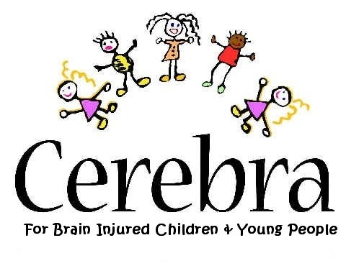

CONFERENCE

“Legal/police issues affecting children/young people with neurological conditions”

Tuesday 20th May 2008 at

Pen Green Centre (Research, Development & Training Base & Leadership Centre),
Rockingham Road, Corby, Northants. NN17 1AG.
(Tel. 01536 443435).

What is it about? The conference will focus on the issues surrounding legal and police involvement with children/young people with neurological conditions, the problems encountered by families and how these can be addressed by professionals, in order to improve practice

Cost? The cost of attending the day is £100 for professionals, with a limited number of free places for students.

Professionals attending the conference can claim up to 5 CPD points in accordance with current R.C.P.C.H. guidelines

Who’s it for? People with a professional interest in legal and police issues affecting brain-injured children and young people and their families, for example:

the legal profession, police officers/trainers psychologists/psychiatrists, prison officers, probation officers, voluntary and support workers, agency/group workers, social services employees, (SEN) teachers, research assistants and students.

Organisers? CEREBRA – for children/young people with neurological conditions.

Interested? Please send completed enrolment form + fee (cheque payable prior to event) to:

Gaynor Ellis, CEREBRA Research Dept.,

FREEPOST SWC 3360, Carmarthen SA31 1ZY or email to gaynore@cerebra.org.uk tel: 01267 244226

