



Changing Places campaign flushmob
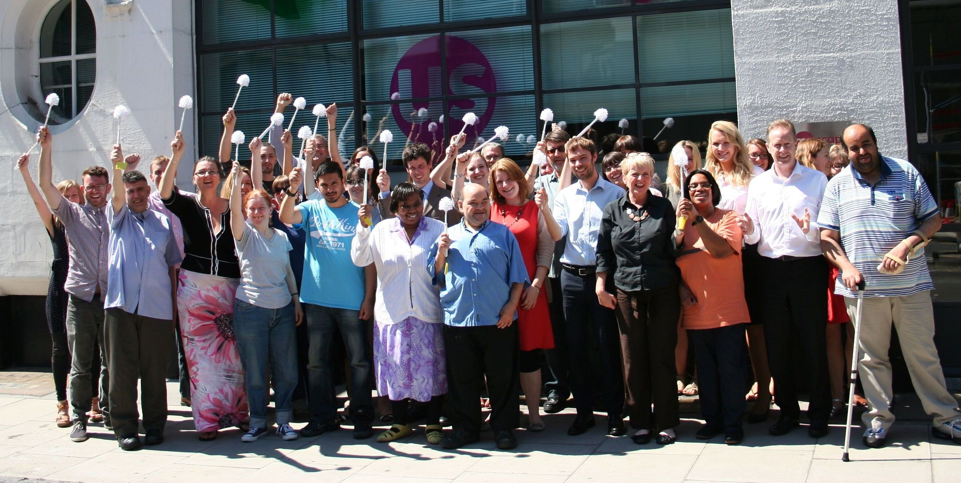
2.30pm Thursday 11th October
Trafalgar Square, London
Flashmob for more Changing Places accessible loos in London

No one should have to be cared for whilst lying on a filthy, cramped toilet floor. Join us to fight for the rights of everyone to go out and enjoy our community safely and with dignity.

Please meet in front of national gallery. Bring a new loo brush and freeze when you hear the alarm. Do not be late or you will miss it! Photographs and video will be taken.

To come please contact Mark Grainger
Telephone 077 8972 0406
Email mark.grainger@mencap.org.uk

