
Learning Disability
Open Meeting

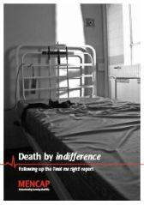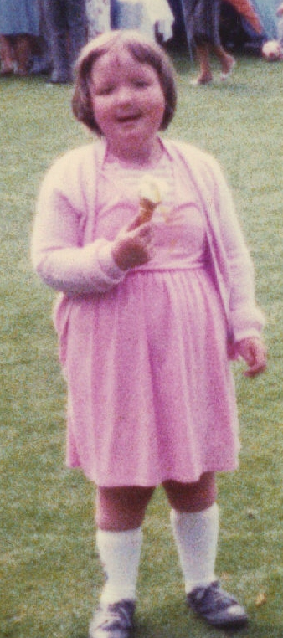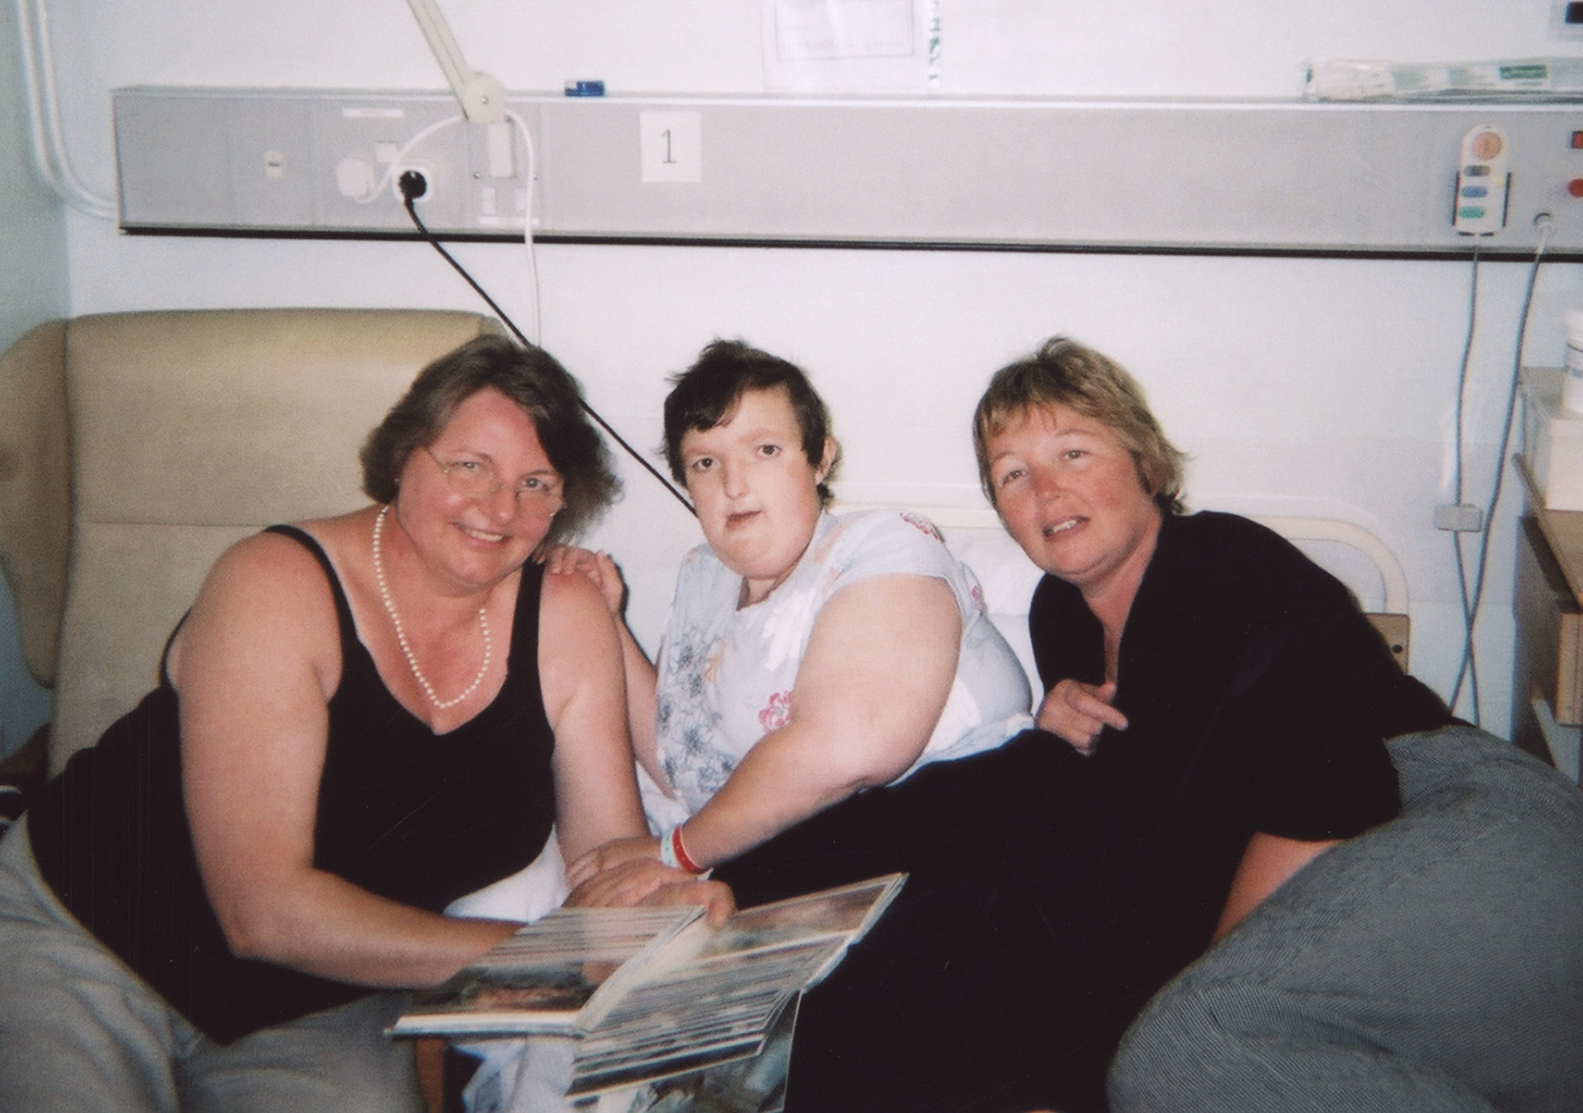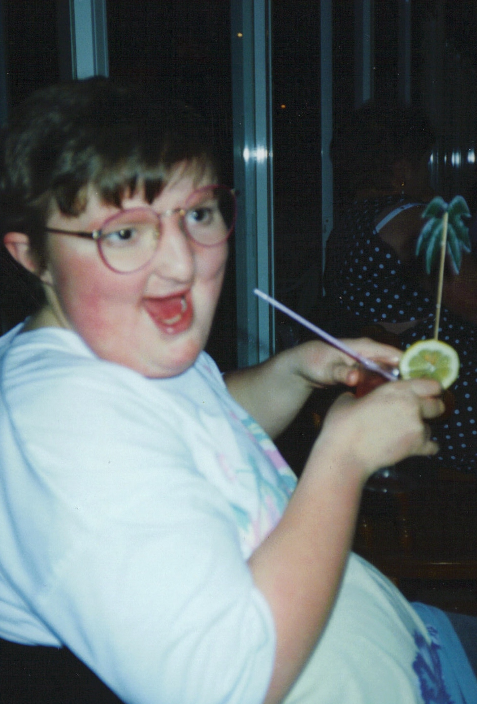

Death by Indifference
Emma
&
Her family’s experience
Jane Kemp

FREE

EVERYONE IS WELCOME
Date: FRIDAY 8th February ROOM 6032
Time: 2.00 - 4.00 PM
Place: Sir Frank Lampl Building, Kingston Hill KT2 7LB
If you would like to attend or find out more please contact:
JIM BLAIR
Email: jblair@hscs.sgul.ac.uk
Tel: 020 8725 2155 (Deb Bunyan)
Supported by:

 Learning Disability Forum

