UK Disabled People’s Council

Disability Hate Crime: How to Get Involved Guide



Supported By



27 Old Gloucester Street, London, WC1N 3AX
Charity Number: 1068743 Company Number: 3455202
www.ukdpc.net info@ukdpc.net
Contents

Disability Hate Crime: How You Can Get Involved and Make a Difference |  | 2
What is Disability Hate Crime? |  | 3
How can you make a difference and get involved? |  | 4
 | Report It! | 4
 | Online Reporting | 4-5
 | Your Local Police Force | 6
 | Independent Advisory Groups | 6-7
 | Safer Neighbourhood Panels | 7
 | Become a Third Party Reporting Site | 7-8
Funding |  | 8-9
What is your local disabled people’s organisation doing? |  | 9-13
Equality and Human Rights Commission (EHRC) Inquiry |  | 14-15
Other Useful Organisations |  | 15-17
Our Contact Details |  | 18

Disability Hate Crime: How You Can Get Involved and Make a Difference

All people in the UK have the inherent right to equality, freedom, dignity and justice and individuals are given protection against violations of those rights under United Nations Human Rights instruments and the Human Rights Act. Hate Crime is another important route within the justice system for redressing wrongs.


It has taken decades of work to get disability hate crime recognised, believed and responded to. This recognition is only due to disabled people themselves sharing their experiences, asking questions and refusing to take ‘no’ for an answer. This, and the ratification of the Convention on the Rights of People with Disabilities has now made the government and justice services begin addressing this issue.

In the meantime, we still need more disabled people involved at local levels to truly ensure our voice is heard and that what we experience as a result of disability hate crime is dealt with.

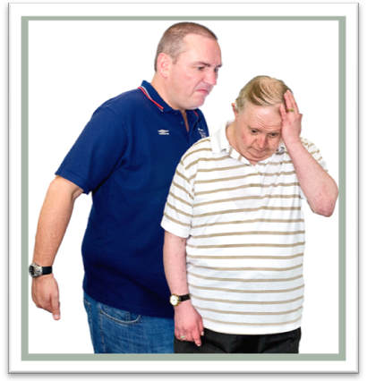
Individually, and as a disabled people’s organisation (DPO), you can make a huge difference locally and nationally by raising the issue of disability hate crime.

When the people who are most affected by this issue rise up and say ‘Enough is Enough!’ then we can become the centre of huge social change where society can respond through the police, justice services and government.

What is Disability Hate Crime?

Racist and homophobic hate crime has been recognised for some time now, though not always dealt with appropriately. Police and government have produced policies on hate crime, following the report into the death of Stephen Lawrence in 1993. But disability hate crime has only recently been recognised by the police. It is also not a term that we as disabled people are used to or perhaps often understand. Often we don’t recognise what happens to us as hate crime. We have been isolated and segregated for so long that we do not recognise our own humanity or the right to protection of that humanity and dignity.

As disabled people, we can experience hate crime in many forms.
- verbal abuse or insults - offensive leaflets and posters, abusive gestures, dumping of rubbish outside homes or through letterboxes, and bullying at school or in the workplace
- physical attacks – such as physical assault, damage to property, offensive graffiti, neighbour disputes and arson
- threat of attack – including offensive letters, abusive or obscene telephone calls, groups hanging around to intimidate and unfounded, malicious complaints.




How can you make a difference and get involved?

Report It!

Firstly, if you have or ever experience an incident which is related to your impairment that you view as harassment, bullying, targeted violence, attacks, thefts, or anything else due to you being a disabled person then report it to the police as disability hate crime.

The more people who do this the more records there will be of what we experience and then more and better plans will be made to deal with it. If you get a poor response to your report then complain. Do not accept a poor service from the police who are in place to serve its community. At the moment very few disabled people report such incidents, making disability hate crime an invisible crime.

Online Reporting

It is possible to report disability hate crime online. You must ensure that you state you are a victim of disability hate crime. You will not get an immediate response but should be contacted by the police within two days. Some police forces have their own on-line reporting sites, for example:


In London, you can report it at https://online.met.police.uk/

This is an independent project that produces materials about hate crime. They will soon include disability hate crime on their website; this will give information on how you can report a hate crime, with forms in accessible formats.

Stop Hate Helpline: 0800 138 1625, or go to: www.stophateuk.org

This 24 hour helpline is run by the charity Stop Hate UK for immediate advice and support. Anyone who is either a victim or a witness of a hate crime will be able to report the incident directly to the Helpline. The aim is to encourage the public to report incidents where they have been called names, physically hurt, or had their property damaged because of another person’s prejudice towards their race, faith, age, sexuality, gender or disability. This organisation has just received funding to make their service more accessible for disabled people.

Victim Support: 0845 303 0900, or go to: www.victimsupport.org.uk
Victim Support Scotland: 0845 603 9213, or go to: www.victimsupportsco.org.uk

The Victim Support Helpline is for anyone affected by crime regardless of whether a crime has been reported. They can direct you to local services and guide you on how to report an incident. They also give information on local victim support groups.

Your Local Police Force

You can telephone the police in your area and report a hate crime or you can ask them to visit you to make the report. You can also contact your local police and ask what they are doing about disability hate crime, ask to meet with a senior officer to discuss this.
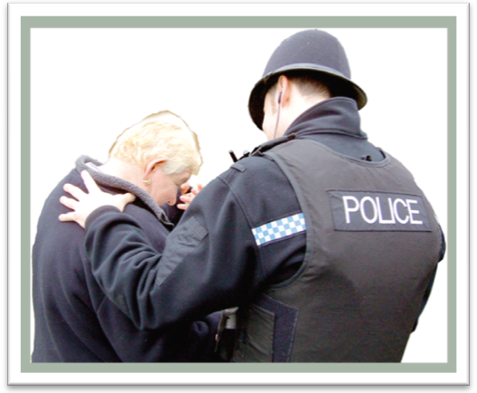

You can make contact with the local police in other ways, including through the local safer neighbourhood teams, community safety team or by going in person to your local police station.

Report it and you make a difference not just for you but all disabled people. We think more disabled people would report such crimes if they could do so through their local disabled people’s organisation.

Send your local police force a copy of our ‘Getting Away with Murder, disabled people’s experience of hate crime in the UK.’


http://www.ukdpc.net/library/Getting%20Away%20With%20Murder%20-%20Hate%20Crime%20Report.pdf

Independent Advisory Groups

You and your local disabled people’s organisation can get involved advising the police. You can do this by finding out if your local police have an Independent Advisory Group.

This is a group of people from the community who give advice on local issues to the police. Ask them if they have disabled people on the group who have knowledge about disability hate crime, if not ask if you could come along or be an Independent Advisor.
Safer Neighbourhood Panels

Also find out if there is a Safer Neighbourhood Panel in your area. These are groups of local people who talk with the local police about local policing issues. Ask if you can become a member, they will have a process for this.


Get involved with the police as an advisor or community representative and you can influence what they do about DHC.


Become a Third Party Reporting Site

You can take reports of disability hate crime from disabled people who will be far more likely to report incidents if they know they will be doing so with people who understand and believe them.

As a disabled people’s organisation you can agree with your local police to become a ‘Third Party’ reporting site. This means your organisation will take reports of disability hate crime from its users and members, so disabled people can come to you, as an organisation they trust.

A form is made available by the police for this. You can get them to change the format so it is accessible. The form, once completed, is passed back to the police. Your local police force will also provide a training session about the form and the process of becoming a Third Party reporting site.

The main issue to consider when thinking about this is which staff members will take reports, as it does take staff time. Also some people may be distressed and want to talk about what has happened to them.

The disabled person does not have to give any details they do not wish to and they do not have to have the crime investigated if they would rather not. This is important as it means that even though no investigation takes place the crime is recorded. It allows the police to identify areas where hate crime is taking place.

Reporting hate crime also means the police and government become more aware of what we experience, and this can influence legislation.


Funding

It is possible for disabled people to seek funding to set up a Hate Crime and Domestic Violence Advocacy project to support Third Party reporting.

The new Disability Equality Duty codes of practice, a part of the Disability Discrimination Act 2005, means that public bodies like local authorities or councils have a duty to ‘promote disability equality, and to eliminate harassment against disabled people’.

You could use this to approach your local council to fund such a project. Sometimes housing departments have funded disability hate crime work, as they have a duty to ensure that their tenants have the service to support them when experiencing such crimes.
The Equalities and Human Rights Commission has also launched a 10 million pound grants programme and wishes to positively encourage our organisations to apply for funding from them around hate crime and human rights issues.

Visit a disabled people’s organisation that has such a service up and running, so you can learn how they did it. Some of these examples include; Greenwich Association of Disabled People, People First and local Centres for Independent Living.


Contact the UK Disabled People’s Council to find out if there is a disabled people’s organisation or centre for independent living in your area.

What is your local disabled people’s organisation doing?

Find out if your local disabled people’s organisation is doing anything on disability hate crime, if not why not, ask the question. You can join the group or organisation and then you can influence what work it does.

You can also get involved voluntarily or offer any expertise or skills you have that could help the organisation address disability hate crime.


Join your local disabled people’s organisation.

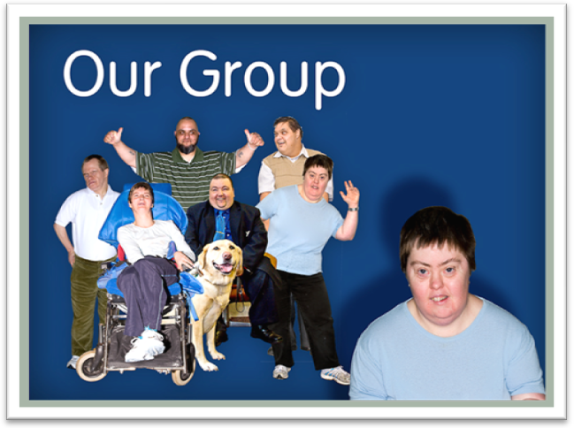

Disability Hate Crime Email Network

Join the Disability Hate Crime Email Network. This is an email network of disabled people, disabled people’s organisations, justice services and others who want to share experiences about disability hate crime, events, reports, issues and incidences.

By being on this group you will keep informed of what is happening and any events you could attend and also share your views. To become a member, contact Stephen Brookes on:


01253 594114
stbmbe1@btinternet.com

The Network also has a Facebook site. This is an active forum for disabled people, DPOs and other organisations to capture articles about targeted crimes and hate incidents against disabled people. You can find members discussing issues and what they think should be done about disability hate crime and harassment. The link to the site is:


http://www.facebook.com/group.php?gid=304401563986

You can also attend consultations or any other events in your area about hate crime or crimes against disabled people. By attending you learn more about the issues and can also add your knowledge and experience to the debates.


Often accessibility expenses and needs will be met, just ask.

Hate Crime Panels

Find out if your local authority has a Hate Crime Panel, any disabled people’s organisation in your area should be represented on this panel.
So if you are a DPO ask to be a member, if they have no disability representatives ask why not as this is not acceptable.
The Home Office states all such panels should involve disabled peoples organisations.

Contact your local authority about Hate Crime panels.

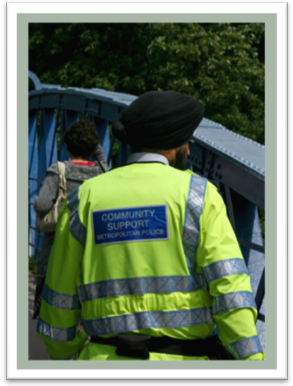

Multi Agency Crime Reduction Panels
These are in each area around the UK, and disabled people’s organisations should be on these groups. If you are a disabled people’s organisation and not on this group, inform them you that you would like to become a member.

Local Authority Disability Equality Scheme

Every local authority and public service has an Equality Scheme, have a look at the one about your area and see what plans they have in place to: ‘Eliminate harassment against disabled people’.
If they do not have an Equality Scheme then contact them, ask why not and what are they going to do about this legal duty under the Disability Discrimination Act. You can ask the same of your local police, health authority, schools, universities, social services etc.

All these organisations are meant to have plans in place but many do not. If you find they do not or you think the plans are poor then send them the details about the ‘EHRC Inquiry into what public services are doing to eliminate harassment against disabled people’.

http://www.equalityhumanrights.com/legislative-framework/formal-inquiries/inquiry-into-disability-related-harassment/

Local Authority Councillors

Contact your local authority councillor and ask them what they know about disability hate crime, send them our report ‘Getting Away with Murder’ and ask what they will do to ensure their council does do work to prevent harassment against disabled people. Our report can be downloaded at:

http://www.ukdpc.net/library/Getting%20Away%20With%20Murder%20-%20Hate%20Crime%20Report.pdf

Arrange to meet with them and discuss the issue or invite them to a meeting with other disabled people who are concerned about disability hate crime.

Members of Parliament (MP) & Members of Scottish Parliament (MSP)

Contact your local MP or M SP and send them our report ‘Getting Away with Murder’. Ask them what they are doing to ensure disabled people have the same right to justice as everyone else.

Ask what they will do to ensure this and promote awareness about DHC. Meet with them and discuss this or get them to come to a meeting of disabled people.

Public Meetings at local Disabled People’s Organisations

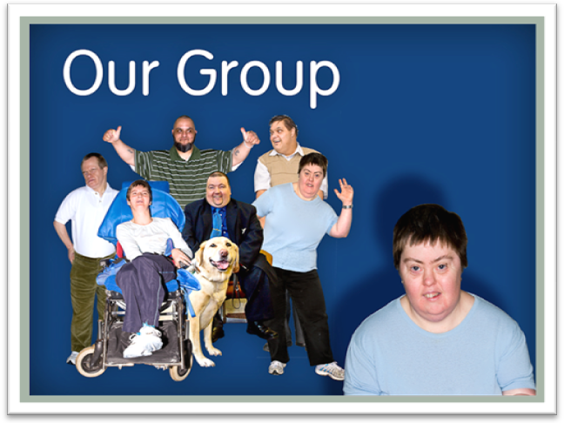

You can have public meeting in your area with your local organisation about disability hate crime. Just ask your local disabled people’s organisation to hold this event.

You also ask the council to fund this public meeting as part of their work on preventing harassment against disabled people. Invite local councillors, MPs, social services, police and guest speakers to start a discussion on disability hate crime.

This sort of meeting could help more disabled people to get included in various police groups on disability hate crime and other local policing issues.

Equality and Human Rights Commission (EHRC) Inquiry

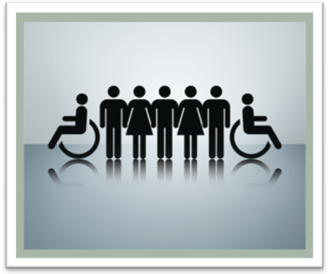
The Equality and Human Rights Commission is now carrying out a formal inquiry into disability related harassment in England, Scotland and Wales. This inquiry will look at how public authorities are protecting disabled people’s human rights to live free from violence and abuse.

This announcement came on the United Nations ‘International Day of Persons with Disabilities’ last December 2009. The Commission is the United Nations accredited human rights body for Great Britain with specific responsibilities to promote and monitor implementation of the United Nations Convention on the Rights of Persons with Disabilities.
The Equality and Human Rights Commission plans to use its legal powers to investigate the true extent of disability related harassment and take appropriate action based on the evidence uncovered.
At the end of the Inquiry, public authorities found not to be doing enough to tackle the problem and to protect the human rights of disabled people could face legal action to force them to comply with their legal obligations.
Evidence already gathered by the Commission indicates that targeted violence or hostility towards disabled people is widespread in Britain. People with learning disabilities or mental health conditions in particular experience high levels of victimisation.
A report on the safety and security of disabled people published by the Commission earlier this year found that disabled people are four times more likely to be the victim of a crime than other people and are twice as likely to be the victim of a violent attack.
The EHRC is now calling for evidence from individuals and organisations on their experiences of disability related harassment. This includes disability hate crime, bullying, and any harassment as we have defined in this guide. The dates for providing evidence can found at the EHRC website:

http://www.equalityhumanrights.com
info@equalityhumanrights.com

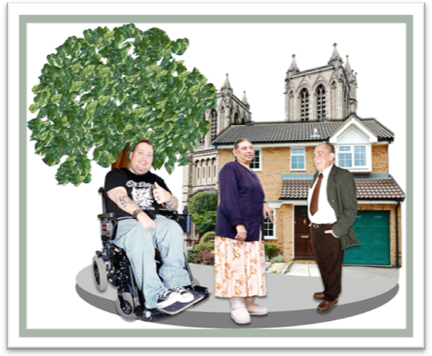
Other Useful Organisations

Hate Crime Research Group is a group of people who work on all types of hate crime. Look at their website for research papers, articles and relevant events at:

http://www.lancaster.ac.uk/fass/groups/hate-crime/index.php

Hate Crime Blog
Talk about your views and experiences to leaders in the Equality and Human Rights Commission, campaigners, activists and other individuals about disability hate crime and developments. You can do this by going to: http://hatecrimeblog.wordpress.com/

Crown Prosecution Service http://www.cps.gov.uk/publications/prosecution/disability.html or:
http://www.idea.gov.uk/idk/core/page.do?pageId=8799050

MIND
http://www.mind.org.uk/campaigns_and_issues/current_campaigns/another_assault/hate_crime
Police and Local Authority Reporting Sites

To find it how to report hate crime in your area, just search online, using any search engine with the words such as ‘reporting disability hate crime in ………….’ and also type in the name of the area in which you live.

You should get links such as these ones below.

Northern Ireland Police
http://www.psni.police.uk/index/advice-and-legislation/advice_hate_crime/advice_hate_crime_disability.htm

Derbyshire Police
http://www.derbyshire.police.uk/contact/19.html

Wales
http://news.bbc.co.uk/1/hi/wales/south_west/8135066.stm

Leicester
http://www.leics.police.uk/advice/5_support_for_victims/85_disability_hate_crime/

Dyfed Powys
http://www.dyfed-powys.police.uk/en/news/2010/1/3/

Cambridge http://www.eastcambs.gov.uk/docs/publications/corpservices/openoutdis.pdf

Bedfordshire
http://www.bedfordshire.police.uk/crimeinfo/hateincident/disability.htm

Kent
http://www.kent.police.uk/Diversity/Report%20Hate%20Crime.html

West Yorkshire
http://www.westyorkshire.police.uk/section-item.asp?sid=12&iid=9266
Birmingham
http://www.birmingham.gov.uk/cs/Satellite/hatecrime?packedargs=website%3D1&rendermode=live

Loughborough
http://www.inloughborough.com/news/095667/Police%20in%20Loughborough%20urge%20people%20to%20report%20disability%20hate%20crime

Kirklees
http://www.kirklees.gov.uk/community/care-support/keepingsafe/keepingsafe.shtml/pages.asp

Plymouth
http://www.plymouth.gov.uk/homepage/socialcareandhealth/adultsocialcare/learningdisabilities/opentoall/otayourlife/otahatecrime.htm

Cumbria
http://www.cumbria.gov.uk/equalities/hate_crime.asp

Greater Manchester Police
http://www.gmp.police.uk/mainsite/pages/hatecrimediv08.htm


Please remember that some of the contact methods above may not be accessible, so request an accessible service if you need it.

Our Contact Details



If you would like to request this pack in any other format then please contact us at:

UK Disabled People’s Council

27 Old Gloucester Street, London, WC1N 3AX
0208 522 7433
www.ukdpc.net
info@ukdpc.net


