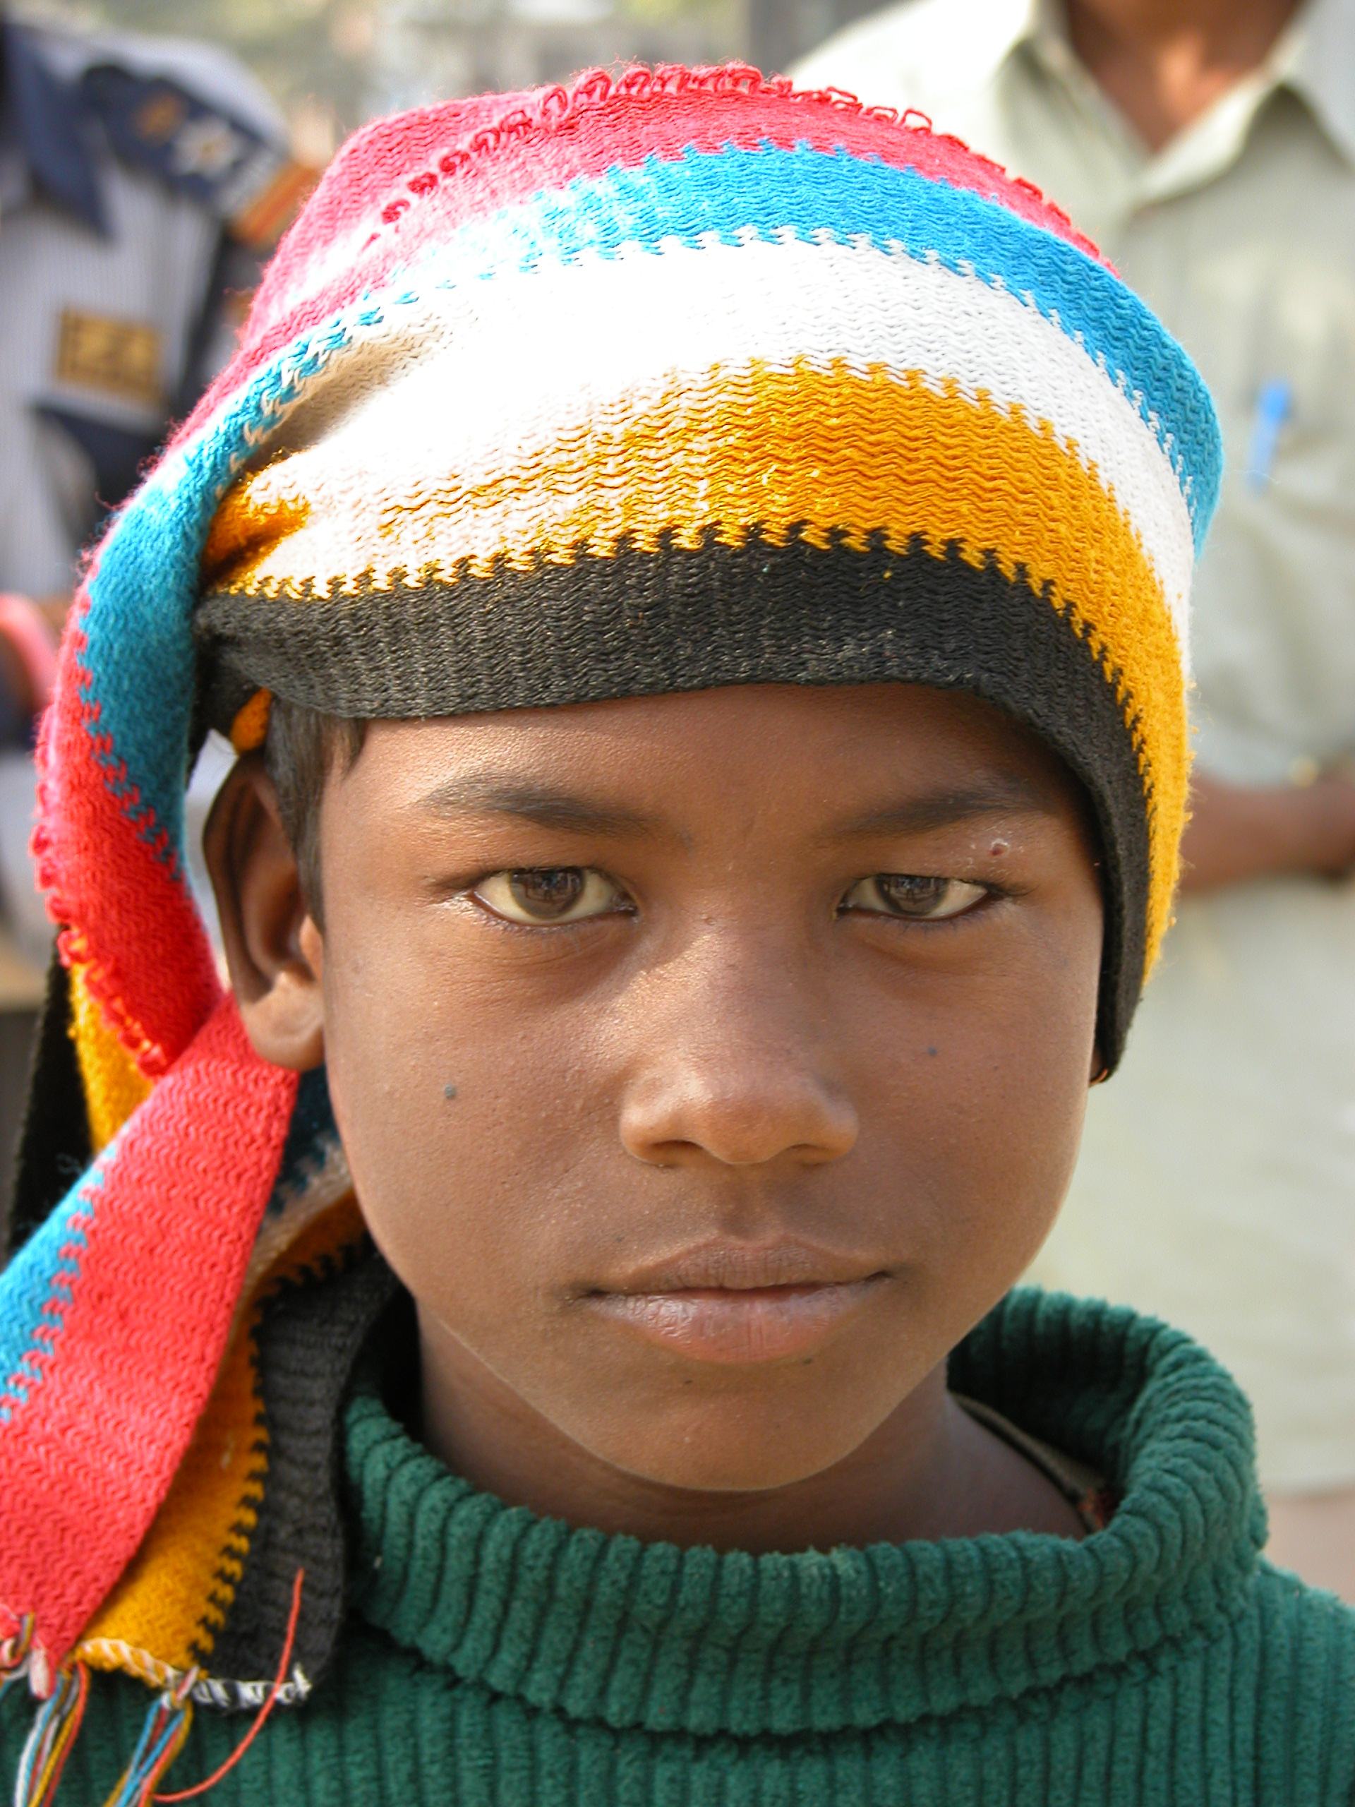
The Great Generation is a young and forward thinking organisation set up to maintain the momentum and spirit of giving following the Tsunami in the Indian Ocean on 26 December 2004.
We are currently seeking volunteers to engage with an innovative programme of activity which celebrates the skills, strength and vitality of individuals and communities across the world. We aim to unlock the full entrepreneurial potential of individuals and communities, through projects which promote sustainable business as a means of alleviating poverty.
What does the programme include?
- A unique 2 week participatory programme with host community
- Microfinance education and support in setting up local enterprise schemes
- International and community development education and experiential learning
- Joining a network to continue the spirit of giving

Volunteering outcomes:
- Practical, intercultural experience
- Increased sense of entrepreneurship and innovation
- Social and practical business skill development
- Increased awareness and understanding of International Development and Corporate Social Responsibility

Forthcoming project:

Delhi Community Arts Project 2008
Project Date: 11th - 25th October 2008
Team size: 8 to 10 people
Sponsorship: £1,000 (includes flights, food, accommodation & local transport as well as a contribution towards the infrastructure investment and microfinance fund)

Project details: This project will involve spending two weeks at an inner-city community arts school and centre which aims to create a society where all people with disabilities learn through, participate in and enjoy the arts. The centre is open to underprivileged children and young adults as well as physically and intellectually disabled young people. The aim of this project is to complement the work they are already doing, by sharing new and different creative arts ideas with the children and teachers, inspiring the kids and the community. Project activities may include mural painting, puppetry, Western dance as well as teaching English. Time will be spent exploring the issues facing financially disadvantaged communities and people with disabilities in developing countries. Volunteers will work alongside local people, and supported by The Great Generation staff and our expert partners, gain an in depth knowledge of the use of grass roots business and finance tools to alleviate poverty.

Next steps:
For further details about this and other projects and to register your interest please visit www.thegreatgeneration.org or contact Juliet.rroberts@thegreatgeneration.org.

