Booking Form

Name |  | Title:
Job title
Organisation
Address
Postcode
Phone number
Email
Dietary / special
requirements
In which language will you be contributing to the event? |  |  | Welsh English
Will you require translation equipment to understand any contribution made in Welsh? |  |  | Yes  No
Which language would you prefer your delegate pack in? |  |  | Welsh English

Fees (Prices include VAT) Please tick 
Member | £135
Non-Member | £156
Person with a learning disability | £51
Parent or unpaid carer of disabled person or a paid carers supporting someone to attend. | £51

Please return this completed booking form with a cheque made payable to Learning Disability Wales, alternatively you can be invoiced but note there will a £6.00 administration charge per invoice.

I would like to book a place on Delivering Better Services for People with a Learning Disability on 21 September in Cardiff 19 September 2012 in Carmarthen 10 October in Wrexham

Signed |  | Date

Cancellation Policy: Cancellations must be made at least 10 working days before the start of the event. Failure to do so will result in the full fee being charged.
Your details: Learning Disability Wales would like to keep your details on record for future events and training. If you do not wish to receive any further information from us please tick the box 

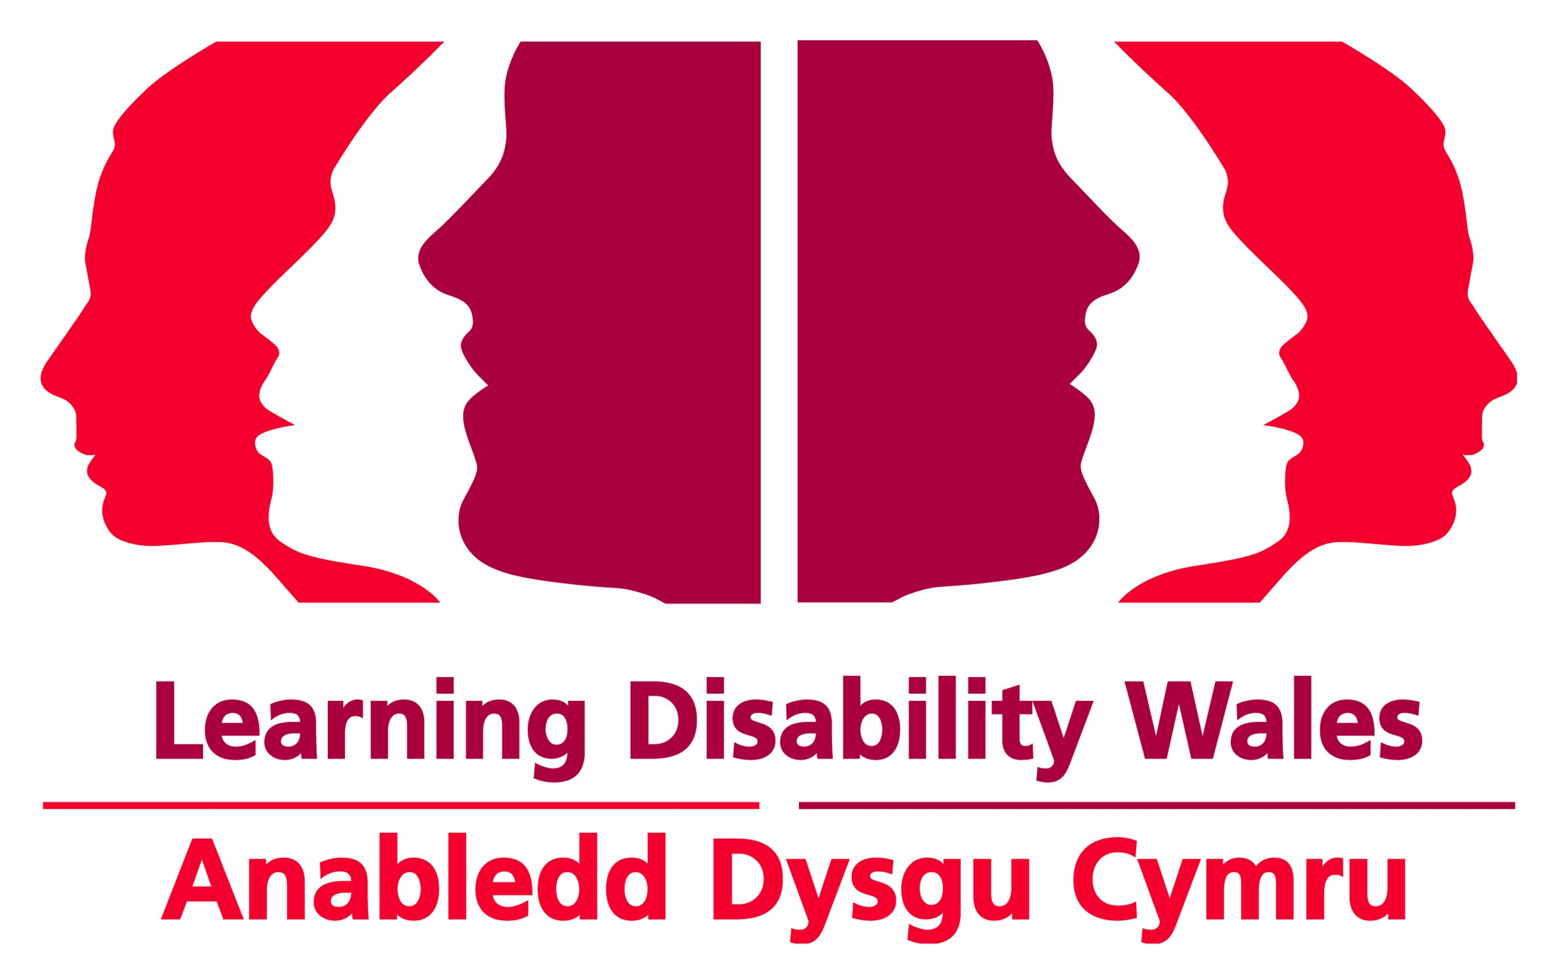
Delivering Better Services for People with a Learning Disability

www.learningdisabilitywales.org.uk



Wednesday, 19 September 2012
Carmarthen

Friday, 21 September 2012
Cardiff

Wednesday, 10 October 2012
Wrexham

21 October 2010
Cardiff

10 November 2010
Wrexham

27 January 2011
Port Talbot

www.learningdisabilitywales.org.uk

Delivering Better Services for People with a

7th May 2009, 9.30am – 4.30pm, Swansea
2nd September 2009, 9.30am – 4.30pm, Cardiff

Learning Disability

Course Aims
This training course looks at how valuing people with a learning disability is key to delivering better services. It will look at how this can be achieved while achieving value for money, thereby resulting in positive outcomes for all. It will develop participants understanding of how people with a learning disability have been, and continue to be, devalued by society and the impact that this has. Devaluation leads to exclusion, segregation and a denial of basic human rights.
The course enables delegates to consider and answer the question “Are the ways in which services are currently delivered making a positive impact on improving the quality of life of those who receive the service, or actually a barrier to improving quality of life outcomes”.

Course includes
- An understanding of how people with a learning disability are devalued and how it can affect them.
- An insight into how history can repeat itself and the lessons we need to learn.
- An examination of how the delivery of services can have a positive or negative impact.
- How the quality of services delivered or commissioned can be measured.

Designed for
Anyone who has a role supporting or caring for someone with a learning disability. Individuals delivering services to people with a learning disability and individuals commissioning services for people with a learning disability.



Booking & Fees
Members £135
Non members £156
Parents / Carers / Person with a learning disability £51

Please return completed forms to:

Fax: 029 2075 2149
Post: Learning Disability Wales, 41 Lambourne Crescent, Llanishen, Cardiff. CF14 5GG Email: training@learningdisabilitywales.org.uk

If you have any questions please do not hesitate to contact us on 029 20681174

