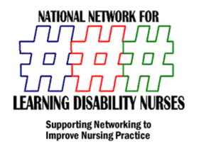
ANNUAL Continuing Practice Development Day
& NNLDN AGM
University of Hertfordshire July 2nd 2012
COSTS
£100.00 per delegate
£50.00 per student
Exhibition Stands
£500 Private & Corporate
£250 Charity
Inserts for Delegate packs
£50
Event Sponsorship Available Please contact Mark Gray on 07970369827
Please book using booking form attached and send to mark@markgrayassociates.co.uk

