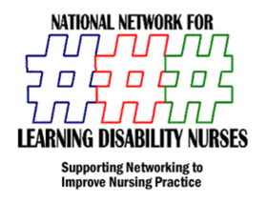
ANNUAL Continuing Practice Development Day
& NNLDN AGM
University of Hertfordshire July 2nd 2012
Booking Form
Name

Booking Address | Postcode
Invoice Address If Different | Postcode
Email

Contact Phone

Booking Level
Delegate £100.00
Student £50.00
Exhibitor £200.00
Dietary Requirements

Access Requirements

Email or post this form to
mark@markgrayassociates.co.uk
Post to
Mark Gray Associates LTD
NNLDN CPD bookingS
5 Kirkland Drive
Chilwell
Nottingham
NG9 6LX

