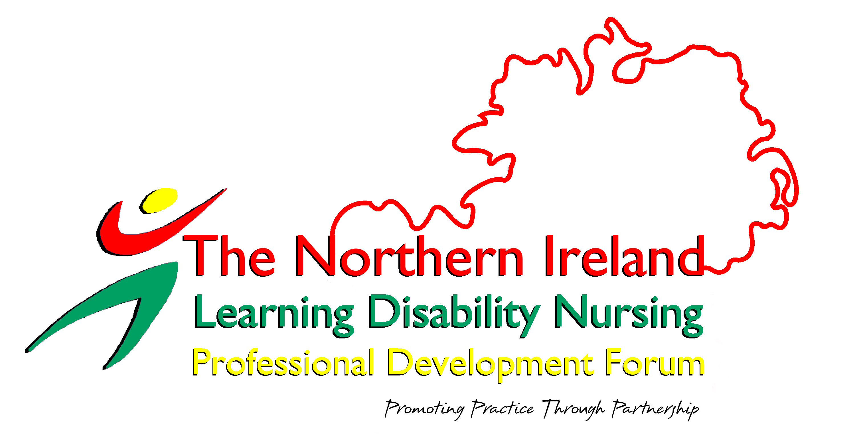

CONTACT DETAILS:

ROSALIND PATTERSON
LEARNING DISABILITY TEAM
10 RUGBY AVENUE
COLERAINE
BT52 1JL

TEL: 028 70347871

EMAIL: Rosalind.patterson@northerntrust.hscni.net

3rd CELEBRATING AND PROMOTING
ALL IRELAND BEST PRACTICE IN LEARNING
CONFERENCE DISABILITY NURSING 2007
3RDALL IRELAND

CONFERENCE

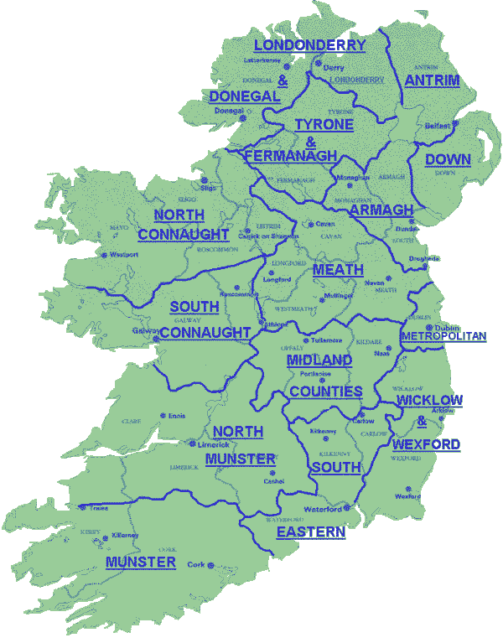

DATE: FRIDAY 12TH OCTOBER 2007

VENUE: CARRICKDALE HOTEL

RAVENSDALE
DUNDALK

