

Community Learning Disability Team
William Molson Centre
Kent Street
Grimsby
NE Lincs
DN32 7DJ.
Tel. 01472 325323


Dear

From July you may receive a letter to take part in
the Bowel Cancer Screening Programme.

Do not worry, it is available to everyone between the ages of 60-69 who are registered with a GP.

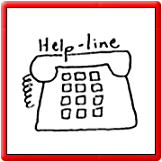
The test may not be suitable if you have, or have had problems with your bowels.

If you are not sure, you should ring 0800 7076060.

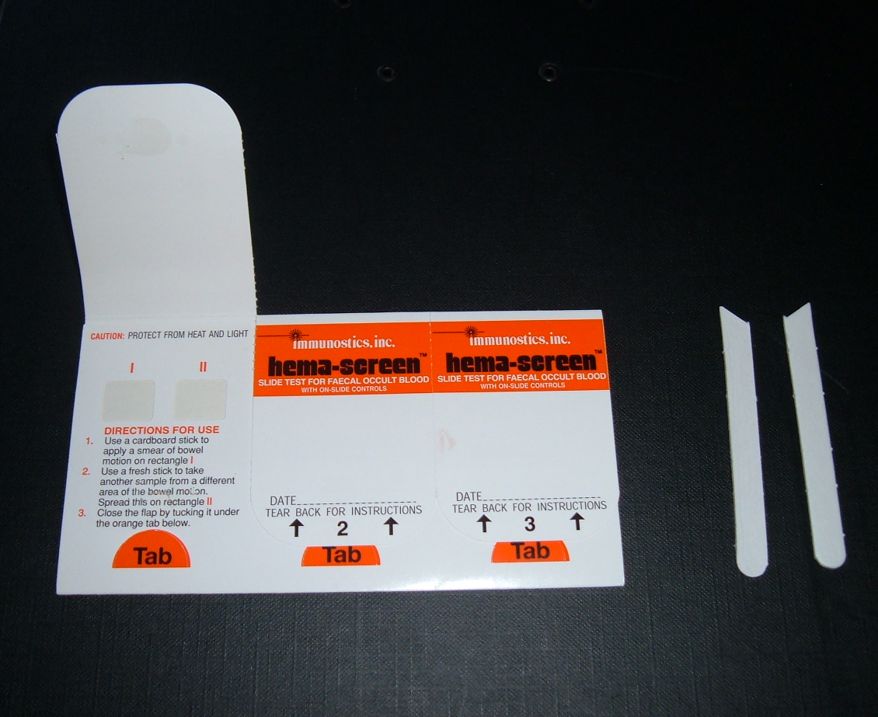
You will be sent a cardboard test kit, with a leaflet explaining what to do.
You can send the completed kit back in the freepost envelope, and should receive your results within a week.

You may be called for more tests.

If you need any further information, please call the freephone number:

0800 7076060

NHS BOWEL CANCER SCREENING PROGRAMME

Your kit must be completed and received for testing within 14 days of the first sample. (Kits will not be tested on weekends).
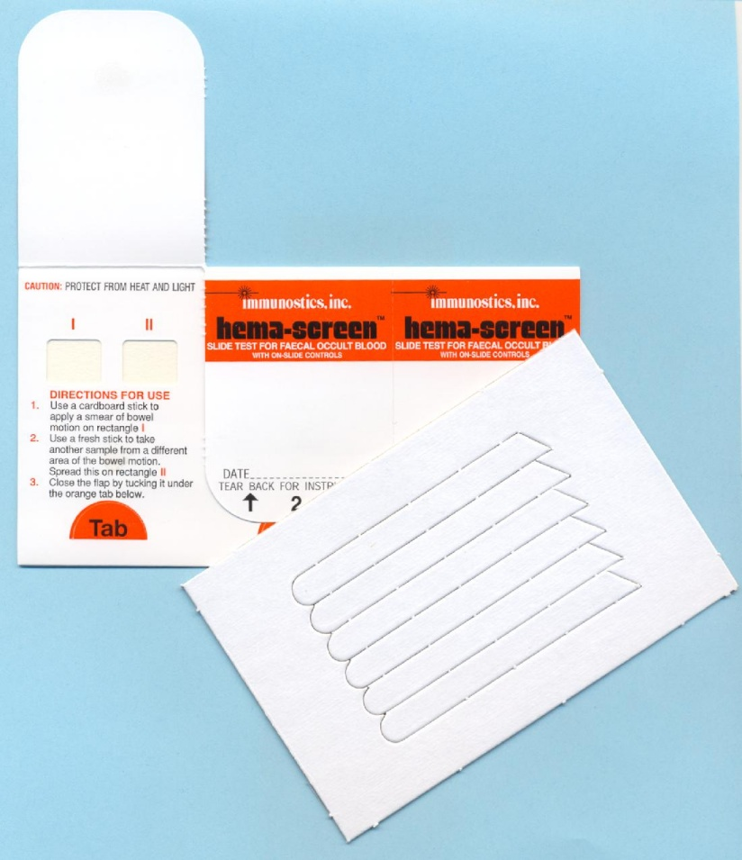
Your kit has 3 flaps, for 3 separate poos.
Only open one at a time.

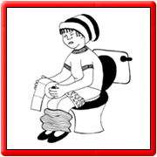
COLLECTING THE SAMPLE
It is important the poo does not go into the toilet bowl. You could catch it using folded pieces of tissue or in a clean disposable container.

GET READY
Take two cardboard sticks and the test kit out of the envelope.
Write the date on the flap.
Open one flap.

DOING THE TEST
Catch your poo before it goes into the toilet bowl.
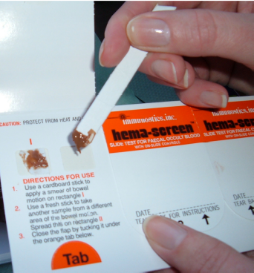
Use a cardboard stick to spread a small amount over the first window in the test kit.
Take a second cardboard stick and spread another small amount over the second window.
Close the flap, tucking it into the orange tab.

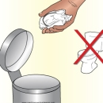
AFTERWARDS
Wrap the cardboard sticks in tissue and throw them in the bin. Do not flush the cardboard sticks down the toilet.
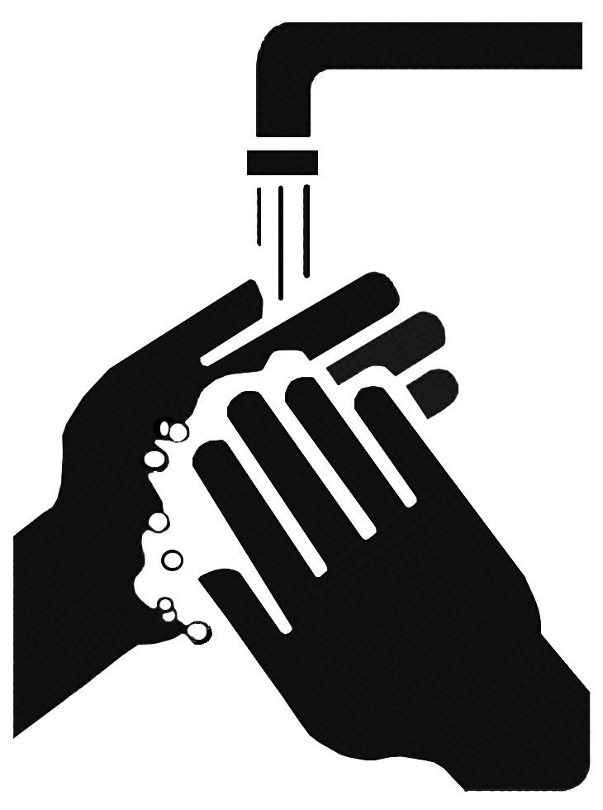
Leave the kit somewhere cool, and away from sunlight.

Wash your hands.

Repeat the test when you have another poo, using the second flap and then again for another poo, using the third flap.
14
days

Make sure you have returned your kit for testing within 14 days of your first poo. Use the prepaid envelope.

If you have any questions, you can telephone, free,

0800 7076060.

