Building Bridges Training 2012 events at Austin Court  Birmingham  Making a difference to people’s lives through delivering training | 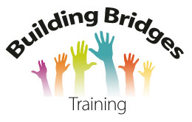

Building Bridges Training 2012 events at Austin Court
Date | Event | Room at Austin Court
Thursday 12th January | Supporting people through loss and bereavement | Crompton room
Friday 27th January | Making a difference for parents with a learning disability training | Crompton room
Thursday 9th February | Working with people with a learning disability to develop a social enterprise | Crompton room
Thursday 23rd February | Right support people with a learning disability from the BME community | Crompton room
Friday 27th April | Making a difference for parents with a learning disability training | Crompton room

For more information please contact
mail@building-bridges-training.org
www.building-bridges-training.org
Tel and Fax 0121 559 9197
Building Bridges Training Community Interest Company 6916509

