What is asthma?

Asthma affects the airways in your lungs.
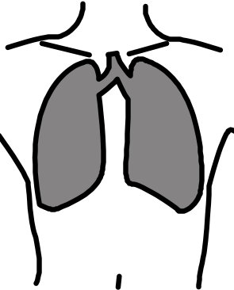

If something irritates these airways, they become narrower so it’s harder to breathe. This gives you your asthma symptoms.


A person without asthma has airways like this.

A person with asthma has a sensitive lining in their airways.

In an asthma attack, the lining swells up, the muscles tighten and mucus is made.

What are the symptoms of asthma?

These usually are:

- Coughing

- Wheezing or whistling in your chest

- Shortness of breath

- Tightness in your chest.

What triggers asthma?


Everyone has different triggers for their asthma. Common triggers are:

- Colds or flu

- Allergies e.g. to animals, pollen or dust mites.






- Irritants like cold air, tobacco smoke or chemical fumes.


- Exercise

  - Exercise is good for everyone.
  - Make sure you have your reliever inhaler with you.
  - Good exercises are swimming, team games like football and fitness classes (they have short bursts of exercise then time to rest) and yoga.

Treatments for Asthma

There is no cure for Asthma but there are treatments to help your symptoms.

Preventers

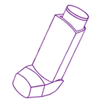
Preventer inhalers are taken every day and
they are usually brown, red or orange.

They help to control the swelling in the airways and stop them being so sensitive.

Don’t miss taking your inhaler even if you feel well. Every day you take them, they become better at helping your asthma.

Spacers help the medicine get straight to your lungs. They make your inhaler easier to use.

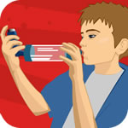

Relievers

Reliever inhalers are only taken if you are feeling any asthma symptoms (coughing, wheezing, tight chest).



They relax your muscles and make it easy to breathe again.

They are usually blue.



If you are using your reliever inhaler three or more times a week, you need to tell your asthma nurse. You may need extra preventer medicines to keep your symptoms under control.

Asthma Attack

Taking your reliever inhaler is all you usually need to do if your symptoms are getting worse.

You are having an asthma attack if:

- Your reliever inhaler does not help

- Your symptoms are getting worse

- You are too breathless to speak, eat or sleep.

What to do:

- Take your blue reliever inhaler immediately.

- Sit down.

- If you do not feel better, take one puff of your reliever inhaler every minute for five minutes or until you feel better.

- If you are worried, or you do not feel better after five minutes, call your Doctor or 999.

- Continue to take one puff of your reliever inhaler every minute till help arrives.

Let your asthma nurse or doctor know you had an attack.

